Requirements and challenges in the design and potential of smart and efficient winch assisted forestry machinery
S Leitner^{1,2*}, M Perez¹, G Carabin¹, M Renzi¹, F Mazzetto¹ and R Vidoni¹
¹Faculty of Science and Technology, Free University of Bozen-Bolzano (unibz), Bz (I), (*corresponding: stefan.leitner@natec.unibz.it); ²Leitalpin SRL, Piazza Fiera 1, Bz (I).

Keywords. Forestry-mechatronics, smart forestry, electrification, hybridization.
Abstract.
Recent regulations on greenhouse emissions and pollutants are forcing forestry machinery companies to target new solutions for limiting emissions while maintaining performance through electrification or hybridization. Moreover, thanks to the availability of new and affordable mechatronic and IoT technologies, concepts such as sustainable, smart and precision forestry are gaining credit. The desire for new advanced equipment is further driven by the need to harvest more timber in alpine regions to meet the objectives of sustainable forest management and operations [1]. In this work, the activities on winch assisted forestry machinery carried out at the First and AFI labs of the unibz are reported. These are firstly revised in terms of requirements and constraints. Then, with electrification being still in its infancy in this sector, design challenges for electrification/hybridization are discussed focusing on duty-cycle studies, understanding autonomy requirements, ideal drivetrain and control architectures. Finally, mechatronic solutions for making them ready for smart and precision forestry are presented. The analysis includes several winch/rope assisted systems for applications in steep terrain, including sled winches, self-driving skyline cranes (e.g. see Fig.1) and tower yarder systems. Results clearly demonstrate the huge potential for: (i) energy efficiency improvement with consequent fuel savings and emission reductions, (ii) significantly improved uptime due to few parts requiring service and generally longer maintenance intervals, (iii) the implementation of a real-time performance and operational monitoring system as well as (iv) the enabling of optimized working strategies.
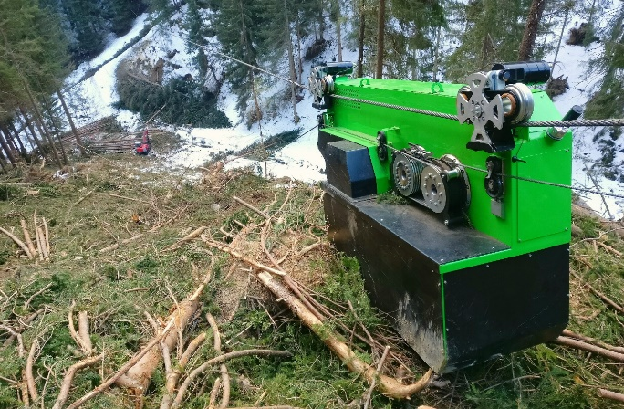
Fig. 1 Leitalpin self-driving carriage prototype
References
- https://docplayer.org/60933333-Ermittlung-der-moeglichen-innovation-im-bereich-der-seilbringung.html

