A facilitating machine for silkworm rearing

Gubiani Rino*, Zucchiatti Nicola

*Department of Agricultural, Food, Environmental and Animal Sciences(D4IA), University of Udine, Via delle Scienze 208, 33100 Udine (Italy).*

[*rino.gubiani@uniud.it*](mailto:rino.gubiani@uniud.it)*; phone 3204365747*

**Keywords.** silk, silk machinery, machine design, silkworm breeding

**Abstract.** Silkworm breeding is an activity that was formerly practised in China and began in Friuli and Veneto between 1400 and 1500. It expanded rapidly in the Friuli and Veneto countryside declining after 1950 and all attempts to revive this industry have subsequently failed for various reasons, not least the lack of adequate technology. The problem of producing silk today is in fact linked to the design and construction of machinery to facilitate silkworm rearing so as to make it attractive to farms in terms of both working conditions and production. The SILK project financed by the Friuli Venezia Giulia region under the 2014_2020 RDP was conceived within this framework with the aim of relaunching silk production. The agricultural mechanisation research group of DI4A of the University of Udine took charge of the design and construction of a prototype of a facilitating machine for the first larval ages of the silkworm.

The objectives conceived for the prototype machine were to allow the silkworm rearer to easily and relatively quickly manage the cleaning of the bedding with the aid of stainless steel trays fitted with mesh or perforated paper, and also to have the possibility of keeping the silkworms on stackable shelves so as to rationally exploit the surface area of the available rooms.

The design phase was done in CAD and then the machine was built, assembled and brought to a silkworm farmer where the first tests were carried out to check the advantages compared to the manual operations adopted up to that moment.

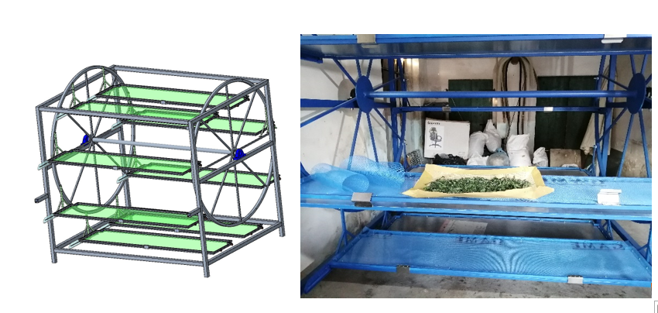

Figure 1- Silkworm machine