Experimental validation of IRRILAB software for a sloped microirrigation sector

Mustafa Elfahl1*, Giuseppe Provenzano2, Samuel Palermo3,

Giorgio Baiamonte4

1*Dipartimento di Scienze Agrarie, Alimentari e Forestali, viale delle Scienze, 90128 Palermo, Italy. NRC Egypt. Email: mustafa.youssif@gmail.com.

2Dipartimento di Scienze Agrarie, Alimentari e Forestali, viale delle Scienze, 90128 Palermo, Italy. Email: giuseppe.provenzano@unipa.it.

3Dipartimento di Scienze Agrarie, Alimentari e Forestali, viale delle Scienze, 90128 Palermo, Italy. Email: samupalermo.sp@gmail.com.

4Dipartimento di Scienze Agrarie, Alimentari e Forestali, viale delle Scienze, 90128 Palermo, Italy. Phone ​+39 091 23897054, Email: giorgio.baiamonte@gmail.com

**Keywords.** IRRILAB software application, microirrigation, sloping fields, non-pressure compensating emitters.

**Abstract.** Recently, the IRRILAB software application to design microirrigation units for sloping fields and for non-pressure compensating (NPC) emitters was developed (Baiamonte, 2018). This software does not require iterations since it based on analytical solutions, however, it can be applied to rectangular shapes of the microirrigation units. The objective of this paper is to test the output parameters for a sloped irrigation sector (15%) by using NPC emitters (Fig. 1), which usually are not suggested for sloping fields. However, NPC is cheaper, simpler, providing higher durability, than pressure compensating emitters. Applications were performed by neglecting and by considering minor losses due to the emitter connections. Results showed that IRRILAB provides good performance of the design parameters, with uniformity coefficients close to 90%. A slight improvement was obtained by considering the effect of local losses according to a method recently introduced, which links the kinetic head coefficient to the equivalent drip lateral length to be considered.

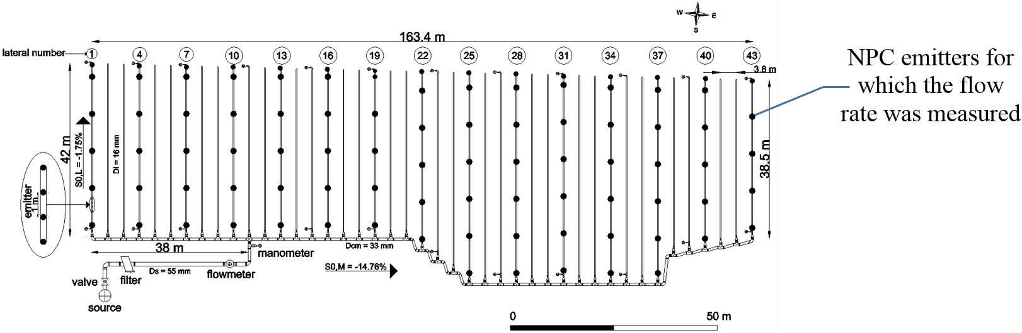

Fig. 1 – Sloped microirrigation unit designed by IRRILAB.

**References**

Baiamonte, G. 2018. Explicit relationships for optimal designing rectangular microirrigation units on uniform slopes: The IRRILAB software application. Comput. El. Agric., 153, 151-168.