An Innovative Bioengineering Work by Waste Materials: the RiVite Project

Giorgio Baiamonte1*, Roberta Calvo2,

Gianluigi Pirrera3, Samuel Palermo4, Francesco D’Asaro5

1*Dipartimento di Scienze Agrarie, Alimentari e Forestali, viale delle Scienze, 90128 Palermo, Italy. Phone ​+39 091 23897054, Email: giorgio.baiamonte@gmail.com 2Dipartimento di Scienze Agrarie, Alimentari e Forestali, viale delle Scienze, 90128 Palermo, Italy. Email: roberta.calvo@yahoo.it.

3Biocity Engineering s.r.l. - Palermo. Email: jl.mine@libero.it.

4Dipartimento di Scienze Agrarie, Alimentari e Forestali, viale delle Scienze, 90128 Palermo, Italy. Email: samupalermo.sp@gmail.com.

5Dipartimento di Scienze Agrarie, Alimentari e Forestali, viale delle Scienze, 90128 Palermo, Italy. Email: franco.dasaro@gmail.com.

**Keywords.** Bioengineering Work, vine shoots, vine pruning, Posidonia oceanica residues.

**Abstract.** This paper describes the RiVite project granted by the Italian Ministry of Economic Development according to the JUMP (Joint Universities Program for PoC) program for patents enhancement, proposed by Sant'Anna School, Scuola Normale and the University of Palermo. The patent (MISE, n. 102017000141369 on 27/02/2020, inventors F. D’Asaro, R. Calvo, G. Baiamonte) consists of an advanced bioengineering work providing anti-erosion function, consolidating and stabilizing of slopes, thus for land protection. The technique is based on modular elements construction (Roll Modular Fascine, RFM, 40 cm x 60 cm) made with the residues of vine pruning collected with specialized agricultural machines (Fig. 1a). The RFMs are filled with a pre-seeded cultivation substrate, consisting of a mixture of beached Posidonia oceanica, seeds of autochthonous species and coolant fluids. The wooden part of the work resists only for the time to rooting and development of the native species, after which the resistant action will be exerted by the root systems. The final work (Fig. 1b) was realized connecting longitudinally the RFMs with cables or wire meshes (Fig. 1c). Differently from the common works, thanks to the assembling system, the proposed patented work is less time consuming, and reduces CO2 emissions because of reusing waste materials. The project was based on different prototypes, and the JUMP program made it possible to realize all prototypes in two areas near Etna volcano (Nicolosi, Giarre).

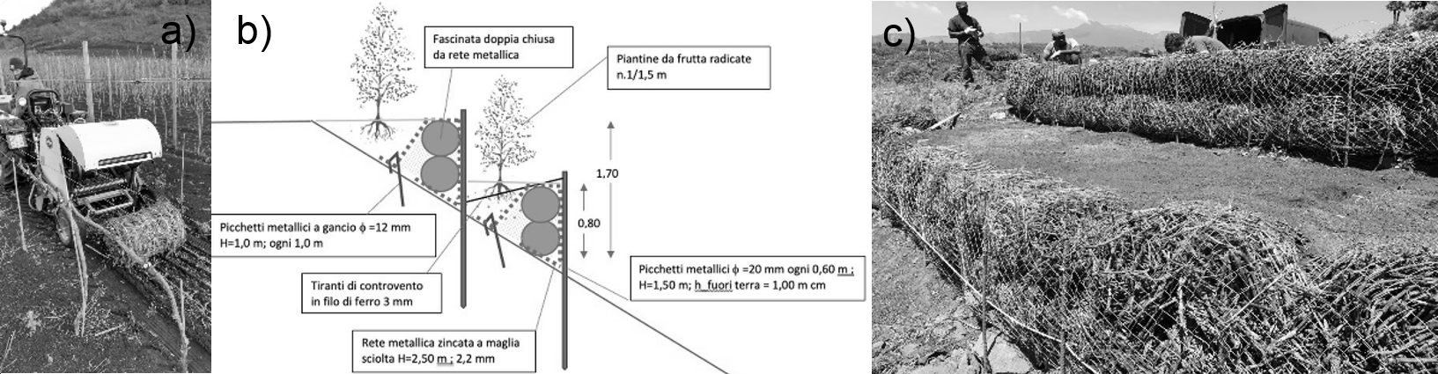

Fig. 1 – a) RFM collecting, b) example of a designed prototype and c) the realized work.