Experimental tests to validate a simple procedure to design dual-diameter drip laterals on flat fields

Giorgio Baiamonte1*, Mustafa Elfahl2, Samuel Palermo3

1*Dipartimento di Scienze Agrarie, Alimentari e Forestali, viale delle Scienze, 90128 Palermo, Italy. Phone ​+39 091 23897054, Email: giorgio.baiamonte@gmail.com

2Dipartimento di Scienze Agrarie, Alimentari e Forestali, viale delle Scienze, 90128 Palermo, Italy. NRC Egypt. Email: mustafa.youssif@gmail.com.

3Dipartimento di Scienze Agrarie, Alimentari e Forestali, viale delle Scienze, 90128 Palermo, Italy. Email: samupalermo.sp@gmail.com.

**Keywords.** Dual-diameter drip laterals, tapered lateral, flow rate experimental measurements, analytical solutions.

**Abstract.** Multiple-diameter laterals reduce the total cost in microirrigation systems, however, the length of each sublateral should be determined carefully to assure appropriate performance of emitter flow rates. The most accurate method is the numerical trial and error, which is time-consuming. A series of research efforts have been made to propose simple analytical design procedures. By using the power-law form of the Darcy-Weisbach formula, and equal emitters spacing for the sublaterals, Sadeghi et al. (2016) extended a previously introduced design solution for one-diameter laterals to tapered laterals. Recently, a simplified procedure to design dual-diameter drip laterals (Fig. 1) has been introduced, providing relative errors in pressure heads less than 0.5%, and allowing to set different Hazen-Williams coefficients, flow rates and emitter interspaces for each sublaterals. Moreover, this analytical procedure easily detects the required commercial emitter characteristics. According to drip laterals ( = 16 mm and  = 20 mm) made by IRRITEC, where the emitter characteristics are imposed, the objective of this paper is to experimentally test this solution for drip sublaterals with different lengths, flow rates and emitter interspaces.

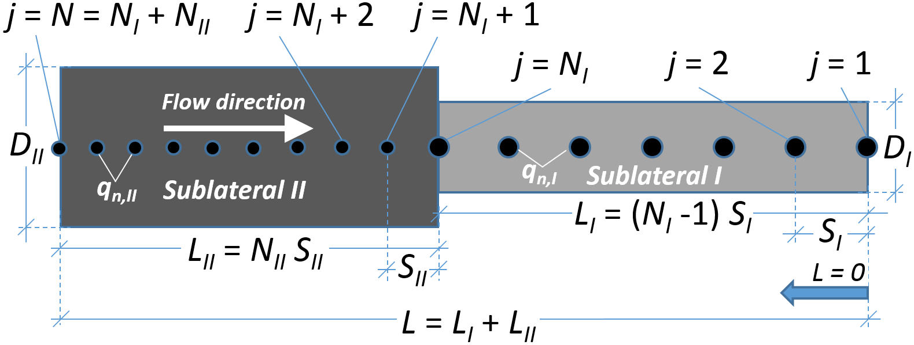

Fig. 1 – Sketch of the considered dual-diameter drip lateral.

**References**

Baiamonte, G. (2022). Dual-diameter drip laterals laid on flat field. Submitted to Biosyst. Eng.

Sadeghi, S.H., Peters, T., and Shelia, V. (2016). Energy Grade Line Assessment for Tapered Microirrigation Laterals, J Irrig Drain E-ASCE, 142(7): 04016020.