Critical CO₂ Carnot Engine for Industrial Waste Heat Recovery and Utilization
Sarah Makuc¹, Eldred Chimowitz²
1,2 University of Rochester Chemical Engineering Department, Rochester, NY
Highlights
- Critical CO₂ Carnot cycle maximizes low-grade heat harnessing and utilization
- Small (~1.5 L) engines can utilize waste heat, generating power
- Increased energy savings, decreased energy bills, and environmental emissions

1. Introduction
Industrial processes regularly discard large volumes of low-grade waste heat to the environment. Harnessing this heat and transforming it into usable power would be environmentally and economically advantageous for industries. An overlooked solution to utilizing this waste heat is the use of a Carnot cycle to generate work with supercritical CO₂ as the working fluid. Supercritical CO₂ is a novel working fluid for a Carnot engine as its critical temperature (31.1$°$C) is much lower than the boiling point of water. This allows for the lower isotherm of the Carnot cycle to be constructed at the critical temperature, resulting in a sizable Carnot cycle with a near flat lower isotherm and upper isotherm just below the temperature of the low-grade heat. Thus, this type of Carnot cycle encompasses a larger area on a P-V diagram than any other thermodynamic conditions, thereby optimizing the amount of work that can be converted to power using a relatively small engine. We describe this approach of waste heat harnessing and illustrate ideas for utilizing the waste heat from an industrial toluene process. The impact of compression ratio, upper isotherm temperature, and pressure in the engine are investigated. Resulting savings amount to hundreds of thousands of kWh/year, thereby reducing cooler loads, electricity bills, and environmental emissions.
2. Methods
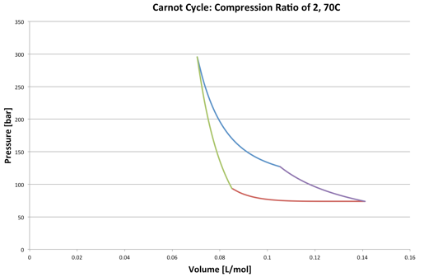
The developed and validated Excel program can analytically calculate the work of the Carnot cycle using the following equations derived from the Van der Waals equation of state and the critical parameters for CO₂. The calculated work is then used to find the size/frequency of an engine necessary to harness all of the available work and transform it to usable power.
$Q_{H}=\int_{V_{1}}^{V_{B}}{\frac{RT_{H}}{V-b}=RT_{H}ln(\frac{V_{B}-1}{V_{1}-b})}$ where $b=\frac{1}{8}\frac{RT_{c}}{P_{c}}$ Equation 1
$W=Q_{H}(1-\frac{T_{C}}{T_{H}})$ Equation 2
Figure 1. Typical Carnot Cycle Program Output

Required program inputs include cooler size, isotherm temperatures, compression ratio, frequency, and starting volume. Outputs include work available, engine size, pressure, and, if applicable, the necessary cooler size still required. An alternative program takes in the engine size and outputs the required frequency. Reversible adiabatic and isothermal steps have been assumed.
3. Results and discussion
Program outputs for specific examples found in the disproportionation of toluene process indicate a large potential for utilizing waste heat. With a decrease in upper isotherm temperature, the work available, and thus power, increases and engine size decreases, but the analogous increase in pressure is a limiting factor. With the increase in engine size, the required frequency of the engine, measured in Hertz, decreases. Process specific findings include the ability to harness 135.49kW from one stream in the toluene process, cooling it roughly 39$°$C. This leads to a net annual production of 975,528 kWh of energy, amounting to over $50,000/year in cost savings.
Upper Isotherm ($°$C) | Work (J/mol) | Power (kW/mol) | Maximum Volume (L/mol) | Engine Size (L) | Pressure (bar)
60 | 224.14 | 11.21 | 0.141 | 2.01 | 266
70 | 264.00 | 13.20 | 0.141 | 1.45 | 296
100 | 270.56 | 13.53 | 0.141 | 0.644 | 386

Table 1. Data for a 135.48 kW Power Production.
Electricity Source | Price [*U.S. EIA estimates] | Cost Savings per Year ($)
U.S. National Average | $0.0724/kWh | 70,628
Conventional Coal | $98.7/MWh | 96,285
Biomass | $95.3/MWh | 92,968
Onshore Wind | $48/MWh | 46,825
Solar Thermal | $126.6/MWh | 123,502
Table 2. Annual Energy Savings from a 135.49 kW Engine
4. Conclusions
It is found that with a relatively small engine and frequency, on the order of 1.5 L and 50 Hz, moderate upper isotherm temperature, and a compression ratio of 2, almost 1 million kWh can be saved each year from the integration of a single Carnot cycle into the disproportionation of toluene process. Considering various electricity sources, the production of 1 million kWh of electricity can save the industrial plant over $50,000/year and decrease environmental emissions. Carnot cycles therefore represent an underutilized resource to harness low grade waste heat present in numerous industrial processes.
References
- J.T. Banchero, B.D. Smith (Ed.), R.J. Hengstebeck. Disproportionation of toluene, 1969.
- Eldred H. Chimowitz Madeleine R. Laitz, F. Douglas Kelley. Critical CO₂ Carnot Cycle for Waste Heat Utilization, 2017.

