Experimental Influence of Thermodynamic Inhibitors on the Phase Equilibria of Carbon Dioxide Hydrates Above the Q₂ Point
Jose Carlos Cordeiro Jr.¹, Moisés A. Marcelino Neto¹*, Rigoberto E. M. Morales¹,
² Amadeu K. Sum
¹NUEM Multiphase Flow Research Center, Graduate Program in Mechanical and Materials Engineering, Federal University of Technology - Paraná (UTFPR), Curitiba, PR, Brazil;
² Hydrates Energy Innovation Laboratory, Colorado School of Mines, 1500 Illinois Street, Golden, CO, USA
*Corresponding author: mneto@utfpr.edu.br
Highlights
- Some oilfields can have very high concentrations of CO₂.
- Experimental data for condensed CO₂ hydrates are scarce in literature.
- New data for CO₂ hydrates above the Q₂ point with MEG and NaCl is presented.

1. Introduction
Due to high pressures and low temperatures achieved in oil and gas industries, the formation of hydrates can block pipelines, causing damage and preventing normal operations. Hydrates are a solid non-flowing phase that forms by the combination of water molecules that trap a molecule of a second type. A common practice in the industry is the use of thermodynamic inhibitors, such as Monoethylene Glycol (MEG), which can change the conditions at which hydrates form, preventing their appearance. In offshore oil and gas extraction, the water that accompanies the production is naturally inhibited by the presence of salts. These salts, such as sodium chloride (NaCl), acts similarly to MEG, lowering the activity of water and consequently causing the conditions for the formation of hydrates to be more severe [2]. Some oilfields, for instance in the Brazilian pre-salt region, can have very high concentrations of carbon dioxide (CO₂), changing the conditions at which hydrate formation occurs. Due to these high CO₂ concentrations, the condensation of the vapor phase becomes possible. This causes the appearance of an upper quadruple point (Q₂) in the phase equilibria, which is characterized by the presence of four phases: Liquid CO₂ / Vapor CO₂ / Liquid Water / Hydrate [3]. This work presents new experimental data for carbon dioxide hydrates above Q₂ formed with the presence of MEG, NaCl and their mixtures in the aqueous phase. For validating the experimental procedure, data for CO₂ hydrates with pure water was obtained and compared with data available in literature with good agreement.

2. Methods
To determine the hydrate equilibrium temperature for a given pressure, an isobaric experimental procedure was performed. A stainless steel equilibrium cell was connected to a syringe pump, which added or removed CO₂ in order to keep a constant pressure. The formation was induced by lowering the temperature of the cell; next, the temperature was increased, promoting hydrate dissociation. Data for the change in volume of the pump and the temperature inside the cell were collected and the equilibrium temperature was determined graphically. The equilibrium conditions for a given pressure was determined as the temperature of which hydrates no longer exist.
3. Results and discussion
Experimental results obtained in this work are shown in Figure 1. For evaluating MEG (blue symbols), mass concentrations of 10%, 20% and 30% were used. For NaCl, mass concentrations of 5% and 10% were considered. The concentrations of 5% NaCl and 10% of MEG were found to be practically equivalent. In addition, the mixture of 5% of NaCl + 10% of MEG had an inhibition effect slightly higher when compared to the single inhibitors concentrations.

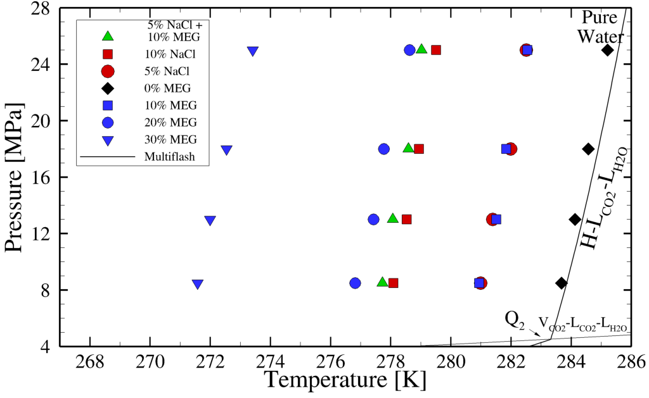
Figure 1. Liquid water-liquid carbon dioxide-hydrate equilibrium condition. The line is prediction done using Multiflash [3]. Blue symbols are data for MEG. Red symbols are for NaCl. Green symbols are for the 5% NaCl + 10% MEG mixture. All concentrations are in mass base.

4. Conclusions
In order to evaluate the influence of thermodynamic inhibitors, NaCl and MEG aqueous solutions were prepared and the equilibrium for carbon dioxide hydrates was experimentally determined above the upper quadruple point. As expected, higher concentrations of inhibitor caused a higher decrease in the equilibrium temperature. Lastly, the mixture of NaCl and MEG resulted in a higher inhibition effect than the simple sum of the temperature decrease caused by the aforementioned single inhibitors concentrations.
References
- E.D. Sloan, C.A. Koh, Clathrate Hydrates of Natural Gases, CRC Press/Taylor & Francis, 2008.
- Melo, C. L.; Thedy, E. A.; Rocha, P. S.; Almeida, A. S. De; Paula, A., The challenges on the CCGS monitoring in the development of Santos Basin Pre-salt Cluster. Energy Procedia., 4, 3394–3398,2011.
- Multiflash 6.1, KBC Processing Technologies Products, 2017.

