Recombinant Mut⁺ P. pastoris GS115 hepatitis B virus core-antigen (HBcAg) obtainment in methanol PID-controlled fed-batch process
Oskars Grigs¹, Emils Bolmanis^{1,2}, Vytautas Galvanauskas³
1 Latvian State Institute of Wood Chemistry, Dzerbenes str. 27, Riga, LV-1006, LATVIA
2 Latvian Biomedical Research and Study Centre, Ratsupites str. 1, Riga, LV-1067, LATVIA
3 Kaunas University of Technology, Studentu 50-162, Kaunas, LT-51368, LITHUANIA
*Corresponding author: oskars.grigs@edu.rtu.lv
Highlights
- Methanol feeding rate PID-control
- P. pastoris DCW of 100 g/L
- HBcAg yield 3.5 mg (protein)/g (cell wet weight)

1. Introduction
Hepatitis B virus core-antigen (HBcAg)-made capsids are being intensively investigated for various biomedical applications [1]. Industrially-applied recombinant protein expression host of methanotroph P. pastoris GS115 is well suitable for obtaining HBcAg. Characteristic methanotroph P. pastoris host property is utilization of methanol as a carbon and energy source, while methanol presence in the medium ensures induction of recombinant protein synthesis. Although methanol concentration (MC) influence on recombinant protein synthesis level is well known, this factor is not studied on HBcAg obtainment with P. pastoris. If on-line MC measurements are available, PID-control algorithm can be applied for pre-set MC control by manipulating methanol feeding rate to the bioreactor. Screening results of various MC levels of “methanol-limited (≈0 g/L)”, 1, 3 and 5 g/L for improved HBcAg obtainment, will be analyzed within the Postdoctoral research project (Project Agreement No. 1.1.1.2/16/I/001, Research Application No. 1.1.1.2/VIAA/1/16/186).
2. Methods
Methanol PID-control algorithm, adapted from Cos O. et al. [2], was programmed in Matlab. Laboratory bioreactor (5 L) communication architecture of DCU-SCADA-(OPC)-Matlab is well described in the previous research [3]. Detailed information on recombinant host and HBcAg downstream processing is available [4]. Cultivation conditions selected regarding Invitrogen co. protocol (Pichia Fermentation Process Guidelines) for Mut⁺ strains. On-line methanol was measured with BCP-EtOH off-gas analyzer (Bluesens).
3. Results and discussion
Results of methanol 1 g/L set-point control process are shown in Figure 1. Characteristic methanol peak appears at the beginning of methanol feed start phase (peak height around 3 g/L). During culture adaptation to methanol (30-42 h), methanol limited conditions are obtained. Afterwards, automatic methanol feeding for set-point control of 1 g/L was activated. Around 2-hours-long methanol peak of 2 height g/L appears at the beginning of the automatic methanol control phase. Further methanol control resulted in close process MC to the set-point value, where at the process end phase, due to process disturbance from operator's side and achievement of culture maximum capacity, methanol deviation from set-point occurs. Finally, culture dry weight biomass of 100 g/L was obtained. HBcAg accumulation dynamics was analyzed from “methanol-limited” process: HBcAg yielded in 2.8 mg (protein)/g (wet cell weight) at 48 process h, and 3.5 mg (protein)/g (wet cell weight) at process 75 h. The following identified PID control parameters: Kp=0.05 L*L/g*h (proportional gain) and t_pid=10 min (integral time constant) were used.
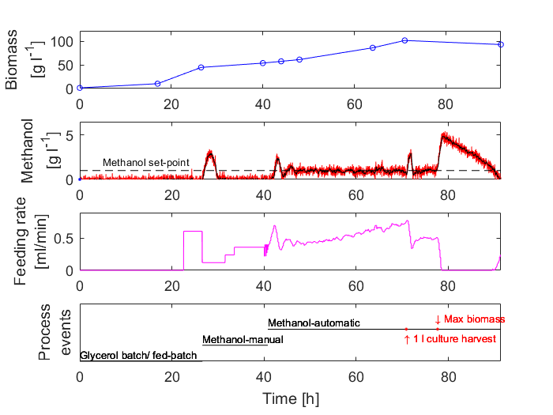
Figure 1. Biomass: off-line dry weight measurements (circles); Methanol: on-line signal (red line), filtered signal (black line), set-point (dashed line); Feeding rate: bioreactor variable; Process events: control, events and observations.
4. Conclusions
Implemented MC PID-control is capable for on-line MC close control to set-point of 1 g/L. Further process optimization with set MC of 3 and 5 g/L should be performed. HBcAg accumulation dynamics in these processes should be analyzed.
References
- A. Dishlers, D. Skrastina, R. Renhofa, I. Petrovskis, V. Ose, I. Lieknina, J. Jansons, P. Pumpens, I. Sominskaya. Molecular Biotechnology. 57 (2015) 1038–1049.
- O. Cos, R. Ramon, J.L. Montesinos, F. Valero. Biotechnology and Bioengineering. 95 (2006) 145–154.
- O. Grigs, V. Galvanauskas, K. Dubencovs, J. Vanags, A. Suleiko, T. Berzins, L. Kunga. Chem. Biochem. Eng. Q. 30 (2016) 47–60.
- J. Freivalds, A. Dislers, V. Ose, P. Pumpens, K. Tars, A. Kazaks. Protein Expression and Purification. 75 (2011) 218–224.

