Development of a new process for preparing polymeric membranes without the use of organic solvent
K-W. Li¹, J-P.Mericq¹, C. Faur¹, D. Quemener¹, A. Deratani¹, D. Bouyer*¹
¹ Institut Européen des Membranes, IEM – UMR 5635, ENSCM, CNRS, Univ Montpellier, Montpellier, France
*Corresponding author: denis.bouyer@umontpellier.fr
Highlights
- Green membranes (without organic solvent)
- New process for preparing polymeric membranes
- Coupling thermally induced phase separation and cross-linking
1. Introduction
Phase separation using non-solvent coagulation bath of a polymer solution is the most widespread industrial process to manufacture membranes. During the industrial process, large quantities of organic solvent are used that may lead to crucial environmental and health problems. Our objective in this work was to develop a novel process for membrane mass production in agreement with the principles of green chemistry. HydroxyPropyl Cellulose (HPC), a biosourced and water-soluble polymer was therefore used in this work, thus preventing the use of classical organic solvent, such a NMP, DMAc, DMF etc. Mastering this phase separation process was very appealing, but needed the following requirements:
- Fully understand how phase separation proceeds in water as temperature is above LCST
- Establish the relationship between PS, evaporation and crosslinking mechanism
- Determine the permeation performances of the obtained membranes
2. Methods
Starting from a polymer solution composed pf HPC and water (weight ratio 20%/80%) a phase separation was induced by increasing the temperature above the lower critical solution temperature (LCST) (Fig. 1). Then, a chemical crosslinking using Glutaraldehyde (GA) was performed to prevent the re-solubilization of the membrane during further use for water filtration. A porous morphology was finally obtained and observed by SEM. The membranes were fully characterized (stability, porosity, mechanical properties…) and the filtration properties were tested using a dead-end filtration system.
3. Results and discussion
The flat membrane obtained using the original phase separation process used in this work (LCST-TIPS process) showed porous morphologies, showing a phase separation by spinodal decomposition (Fig. 1). After several weeks in water, the membrane exhibited a perfect stability, i.e. no re-solubilization was observed.
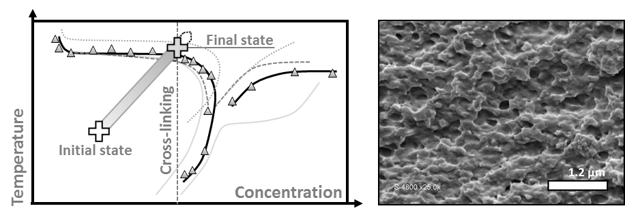
Figure 1. Phase diagram of HPC and behavior during membrane elaboration process; SEM of HPC membrane section.
A first filtration stage exhibited a flux was between 0 and 40 L.h⁻¹.m⁻² at 3.5 bar. After a thermal treatment, a flux up to 160 L.h⁻¹.m⁻² was obtained (Figure 2a). Hysteresis filtration experiment was then performed: the transmembrane pressure was raised slowly until it reaches the maximum value of 3 bars, then it was decreased to its initial value. Figure 2b represents normalize flux versus pressure, showing that the transmembrane flux was unchanged after the conditioning step.
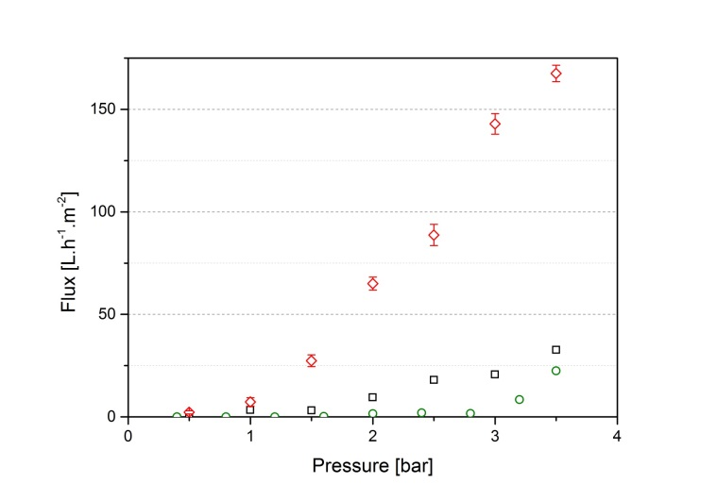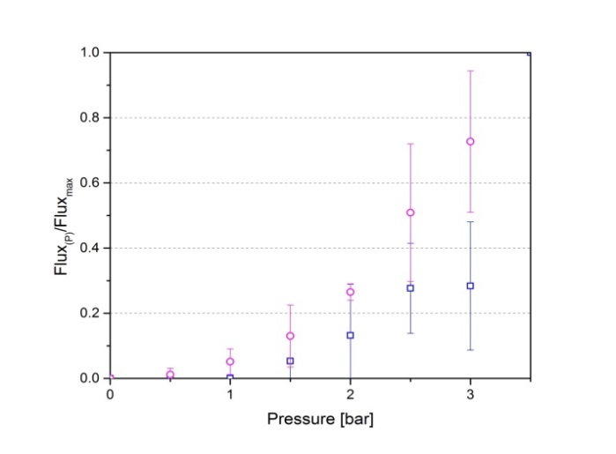
Conditioning
Filtration 1
Filtration 2
After thermal treatment
Filtration flux (rise-drop) Hysteresis
Figure 2. Flux measurement for HPC membrane, conditioning, filtration at room temperature and second filtration after a thermal treatment.
4. Conclusions
This work demonstrated that a porous and stable membrane can be obtained from water-soluble and biosourced polymer, i.e. without organic solvent in the formulation. An original phase inversion process was developed, based on a LCST-TIPS process coupled to chemical cross-linking.
References
- Guido, S. (1995). Phase behavior of aqueous solutions of hydroxypropyl cellulose. Macromolecules, 28 : 4530-4539.
- Larez-V, C., & Crescenzi, V. (1995). Phase separation of rigid polymers in poor solvents 1 : hydroxypropyl cellulose in water. Macromolecules, 28 : 5280-5284.
- Makarova, V.-V., & Kulichikhin, V. (2012). Application of interferometry to analysis of polymer-polymer and polymer-solvent interaction. Interferometry - Research and Application in Science and Technology, 426.
- Vshivkov, S.-A., Adamova, L.-V., Rusinova, E.-V., Safronov, A.-P., Dreval, V.-E., & Galyas, A.-G. (2007). Thermodynamics of liquid-crystalline solutions of hydroxypropyl cellulose in water and ethanol. Polymer science series A, 49 : 5, 578-583.

