Mild fractionation of hydrophilic and hydrophobic components from Neochloris oleoabundans using ionic liquids.
Michel Eppink¹, Corjan van den Berg¹, Rene Wijffels^{1,2}
1 Bioprocess Engineering, Wageningen University, 6700 AA, Wageningen, The Netherlands; 2 Nord University, N-8049, Bodø, Norway
*Corresponding author: michel.eppink@wur.nl
Highlights
- Cyphos 108 is able to permeabilize the cells.
- Lipids are extracted from intact cells.
- Proteins and carbohydrates are recovered after cell disruption
- Hydrophobic and hydrophilic compounds can be efficiently separated.

1. Introduction
Microalgae are promising feedstocks for biofuel production. These photosynthetic microorganism have high lipid productivity and do not compete for arable land when compared to terrestrial oleaginous crops. Microalgae have a very tough cell wall and thus require energy intensive unit operations to break open the cell and release the intracellular content. Apart from lipids, microalgae are also good sources for proteins, carbohydrates and pigments. Utilization of these value added co-products for food, cosmetics, health and chemicals would help in making the process economically feasible.
The primary objective of this article is to fractionate the algal biomass into a hydrophobic fraction (lipids) using mild pre-treatment at low temperature with an aqueous solution of ionic liquid and keep the microalgae intact followed by cell disruption to obtain the hydrophilic fraction (proteins, carbohydrates) in their functional state. [Calibri 11].
2. Methods
N. oleoabundans cells ~10 mg of cells (freeze dried and/or fresh cells) were treated with 1.5 ml of aqueous solution of IL at 45°C for 30 minutes. Fresh and freeze dried cells used in the study were from different batches. The studies were conducted with 2 different ILs BMIM DBP and TBP SO4 (see Table 1). The influence of IL concentrations (40, 80) % w/w on extraction efficiency of lipids was investigated. The amount of lipids extracted in the IL phase was determined by measuring the residual amount of lipids remaining in the cells. [Calibri 11].
Sr. No. | Ionic Liquid Names | Abbreviations
1 | Tributylmethylphosphonium methyl sulfate (Cyphos 108) > 95 % | TBP SO4
2 | 1-Butyl-3-methylimidazolium dibutylphosphate 97 % | BMIM DBP
3. Results and discussion
Two classes of ILs (see Table 1) were studied. Pre-treatment with imidazolium (BMIM DBP) based ionic liquid showed better lipid extraction efficiency and phosphonium (TBP SO4) based ionic liquids showed low extraction efficiency but could have impact on the cell wall and hence selected for further studies. Lipid extraction efficiency of aqueous IL solutions at different concentrations (40, 80) % w/w were studied at temperature of 45°C (see figure 1). In this study, lipids represent the fatty acid methyl ester content that could be converted to biodiesel. As the concentration of IL increases from 40% w/w to 80% w/w at 45°C, the amount of lipid extracted increases from 2.61% to 9.89% per mg of biomass for BMIM DBP and from 1.28% to 3.27% per mg of biomass for TBP SO_{4.} This increase in extraction capacity could be attributed to the increase in hydrophobicity of the IL solution. IL solutions under mild conditions were able to extract lipids from intact microalgae cells. Based on the results in figure 3, BMIM DBP could permeabilise the cells and extract lipids better than TBP SO4 indicating that the cation and anion influences the extraction efficiency, but to a different degree. Although, TBP SO4 shows low lipid extraction efficiency, it might still have an influence on the cell wall. The hypothesis is that the hydrogen bonding network of the cell wall is disrupted leading to the formation of pores through which lipids can leak-out. ILs are known to solubilize natural polymers such as cellulose and pectin by direct IL interaction. [Calibri 11].
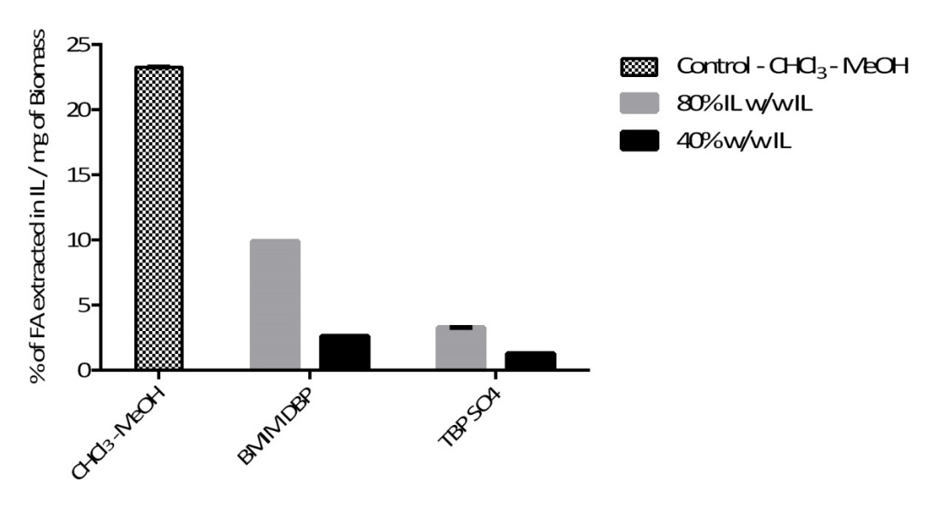
Figure 1. Effect of IL concentration on extraction of lipids at 45°C Caption. [Calibri 9].
4. Conclusions
In this article, pre-treatment of N. oleoabundans using ILs and subsequent fractionation into hydrophilic and hydrophobic components was studied for both fresh and freeze dried biomass. Additionally, the lipid extraction efficiency of aqueous IL solution under different concentration conditions were studied. We have demonstrated that aqueous solution of imidazolium and phosphonium based ILs was able to extract lipids from intact microalgae, albeit to a different degree. We have also shown that pre-treatment of microalgae with BMIM DBP and TBP SO4 at low concentration (40% w/w) results in permeabilisation of cells. The biomass can then be fractionated into hydrophilic and hydrophobic components whereby the proteins were recovered without losing their nativity. The recovery of total fatty acids was ~68% and that of proteins and carbohydrates was ~ 80% and 77% respectively of the total amount present in the cells, after pre- treatment of fresh biomass with TBP SO4. [Calibri 11].
References [Calibri 10]
[1] Wijffels, R. H., Barbosa, M. J., An outlook on microalgal biofuels. Science 2010, 329, 796-799.
[2] Wijffels, R. H., Barboas, M. J., Eppink, M. H. M., Microalgae for the production of bulk chemicals and biofuels. Biofuels, Bioprod. Bioref., 2010, 4, 287-295.
[3] Vanthoor-Koopmans, M., Wijffels, R. H., Barbosa, M. J., Eppink, M. H. M., Biorefinery of microalgae for food and fuel. Bioresource Technology 2012, 135, 142-149.
[4] Desai, R. K., Monteillet, H., Li, X., Schuur, B., et al., One-step mild biorefinery of functional biomolecules from microalgae extracts. Reaction Chemistry & Engineering 2018, 3, 182-187.
[5] Desai, R. K., Streefland, M., Wijffels, R. H., Eppink, M. H. M., Novel astaxanthin extraction from Haematococcus pluvialis using cell permeabilising ionic liquids. Green Chemistry 2016.
[6] Desai, R. K., Streefland, M., Wijffels, R. H., Eppink, M. H. M., Extraction and stability of selected proteins in ionic liquid based aqueous two phase systems. Green Chemistry 2014, 16, 2670-2679.

