Methane conversion to ethylene in nanosecond-pulsed discharge reactors
Evangelos Delikonstantis, Marco Scapinello, Georgios D. Stefanidis*
Process Engineering for Sustainable Systems, Department of Chemical Engineering, KU Leuven, Belgium
*Corresponding author: georgios.stefanidis@kuleuven.be
Highlights
- Methane can be directly converted to ethylene at 20% yield and 2020 kJ/mol_{C2H4} energy consumption in nanosecond pulse discharges at >3 bar without use of catalyst.
- 25.7% ethylene yield at 1642 kJ/mol_{C2H4} can be attained from a two-step non-oxidative methane coupling process in a hybrid plasma-catalytic reactor.

1. Introduction
Ethylene, one of the most important commodity chemicals, is mainly produced by thermal cracking of long hydrocarbons but can also be formed from methane via non-oxidative coupling (NOMC). In view of crude oil depletion and abundant reach-in-methane gas reservoirs discovery, NOMC becomes an appealing route for ethylene formation. Processes, other than thermocatalytic ones, operating at lower temperatures and utilizing low-CO₂ electricity instead of heat are currently investigated for methane-to-ethylene conversion. Among them, non-thermal plasma can activate methane coupling reactions at lower temperatures, overcoming thermal losses in gas heating, while green electricity can be utilized for plasma ignition thereby avoiding fuel burning [1]. However, plasma is usually (i.e., at most common operating conditions) not very selective to ethylene since the energetic thresholds of the electron impact reactions of CH₃, CH₂ and CH (precursors of C₂H₆, C₂H₄ and C₂H₂, respectively) are comparable.
The present work focuses on ethylene production via NOMC in a nanosecond pulsed spark discharge. In this context, two process alternatives are developed and optimized: 1) a single-step selective conversion of methane to ethylene in plasma without use of catalyst; 2) a two-step process in which mainly acetylene is produced in the plasma zone and, subsequently, undergoes selective hydrogenation to ethylene in a catalyst zone downstream of the discharge, in a single reactor volume, using heat and H₂ produced in the discharge itself.

2. Methods
Plasma-assisted NOMC experiments were carried out in a tubular reactor comprising an inner, axial (2.2 mm diameter) copper-made wire (high voltage electrode) and an outer, co-axial (7 and 10 mm internal and external diameter, respectively) stainless-steel tube (ground electrode). The discharge gap was 2.4 mm wide while the coaxial plasma reactor length was 25 cm. The plasma reactor was powered by a nanosecond pulsed power supply (NPG-24/3000, Megaimpulse Ltd.,) triggered by a waveform generator (33220A, Keysight Technology) at 3 kHz pulse frequency. A commercial Pd-based catalyst supplied by Johnson Matthey was used in the two-step process.
3. Results and discussion
High ethylene yield in a single step without catalyst use is attained in the discharge. At moderately elevated pressures (5 bar) and H₂ cofeeding (CH₄:H₂=1:1), acetylene formation is suppressed, and ethylene is produced at ~20% yield [2] per pass (Figure 1-left), consuming 2020 kJ/mol_{C2H4}. A reaction mechanism that explains the C₂ product distribution in this case has been suggested in Ref. [3]. Ethylene production at lower energy cost can be attained in a hybrid plasma-catalytic reactor system in which methane is first converted to acetylene in a nanosecond pulsed spark discharge, reaching up to 23.5% yield per pass, and, subsequently, acetylene is hydrogenated to ethylene by a Pd-based catalyst, which is placed in the post-plasma zone. Overall, ethylene is formed as major product at 25.7% yield per pass (Figure 1-right), consuming 1642 kJ/mol_{C2H4}. The two-step process is carried out in a single reactor volume that aside from the discharge energy does not require any additional heat or H₂ input since both are provided by methane cracking in the plasma zone itself.
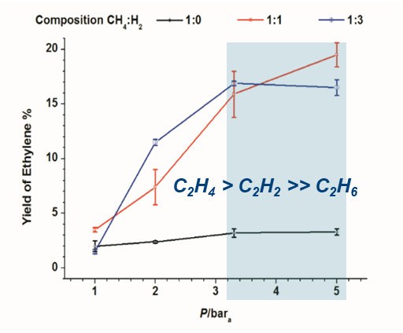
Figure 1. Ethylene formation as major product from methane in nanosecond pulsed discharges: left: single-step process operating at overpressure; right: two-step process operating at atmospheric pressure.
4. Conclusions
Ethylene can be produced as major product in nanosecond pulsed spark discharges via NOMC either in a single-step process at elevated pressures (>3 bar) without using catalyst, or in a two-step plasma-catalytic process operated at ambient pressure. 25.7% ethylene yield was attained in the two-step process at an energy consumption of 1642 kJ/mol_{C2H4}. This performance is relatively close to the recently published state-of-the-art using conventional thermal catalysis (23.4% ethylene yield at 1363 K) [4]. Compared to the latter work though, the advantages of the plasma process reported herein are that the exit bulk gas temperature is relatively low (650–750 K) and the technology is directly compatible with the emerging concept of powering chemical reactors with renewable electricity.
References
[1] E. Delikonstantis, M. Scapinello, G.D. Stefanidis, Processes. 7 (2019) 68.
[2] M. Scapinello, E. Delikonstantis, G.D. Stefanidis, Fuel. 222 (2018) 705–710.
[3] M. Scapinello, E. Delikonstantis, G.D. Stefanidis, Chem. Eng. J. 360 (2019) 64–74.
[4] X. Guo et al. Science. 344 (2014) 616–620.

