Analysis of gas-liquid mass transfer around ascending microbubbles
Audrey Devatine¹, Carine Julcour¹, Anne-Marie Billet¹
¹Laboratoire de Génie Chimique, Université de Toulouse, CNRS, INPT, UPS, Toulouse, France
*Corresponding author: audrey.devatine@ensiacet.fr
Highlights
- Experimental device that generates a chain of individual sub-millimeter bubbles
- Coupled experimental techniques: ombroscopy and optical recording of dissolved oxygen concentration
- Mass transfer model accounting for the composition variation of the rising bubbles
- Evaluation and analysis of the liquid-side mass transfer coefficient associated to microbubbles

1. Introduction
Gas-liquid transfer using micro bubbles (i.e. smaller than 1 mm) is a specific operation which is encountered for instance in wine processing or for oxygenation of stress sensitive cell culture. However, mass transfer performance obtained with a swarm of microbubbles has been rarely studied (Chiciuc et al., 2010; Devatine et al., 2013) and available correlations for millimeter-sized bubbles are usually extrapolated to this case. In this work, we have designed a dedicated device allowing studying mass transfer around a single ascending microbubble. The liquid-side mass transfer coefficient is then obtained by interpreting the experimental results with a convenient model. The resulting values of the liquid-mass transfer coefficient are compared with conventional correlations for mass transfer around a rigid sphere.

2. Methods
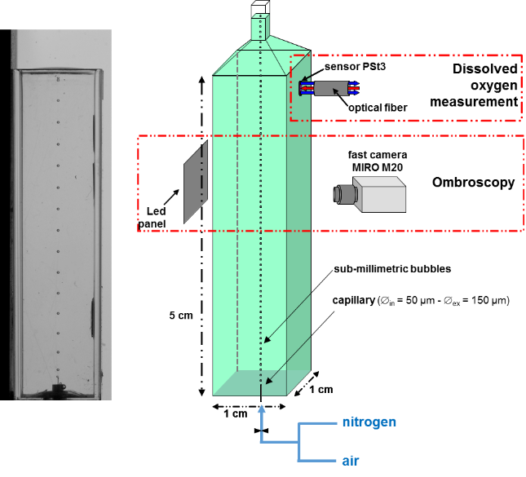
The experimental device is illustrated in Figure 1. It consists in a square transparent column of 1cm wide by 5cm high. Pure nitrogen or air is injected at the bottom, via a capillary (50 µm inner diameter) with a beveled cut orifice to generate sub-millimeter bubbles. The size and generation frequency of the ascending microbubbles are determined from image analysis of video records using a fast camera (Micron M20 – frame rate = 200 Hz). Oxygen absorption or desorption experiments are performed and the time evolution of the dissolved oxygen concentration is determined using a non-intrusive optical sensor located at the top of the column (Presens – Pst3: 0-45 mg.L⁻¹).
Figure 1. Experimental device.
3. Results and discussion
A quasi-steady state one-dimensional model evaluates the evolution of the bubble composition during its rise, thus the axial variation of the interfacial concentration. The average value is then accounted for in the mass balance describing the time-evolution of dissolved oxygen (DO) in the liquid bulk, which is considered perfectly mixed.
This approach gives access to the liquid-side mass transfer coefficient k_{L} according to the following equation:
with k_{L} liquid-side mass transfer coefficient (m.s⁻¹)
H_{c} Henry’s constant (referring to concentrations)
V_{L} liquid volume in the cell (m³)
A_{b} bubble area (m²)
H_{L} liquid height (m)
ν_{b} bubble velocity (m.s⁻¹)
V_{b} bubble volume (m³)
r_{b} bubble frequency (s⁻¹)
m slope of the regression line of ln(C_{i}/C) = f(t) for desorption experiment
where C_{i} DO concentration at initial time (kg.m⁻³)
C DO concentration (kg.m⁻³) during desorption
An example of time evolution of DO concentration is given in Figure 2 in the case of desorption by nitrogen bubbles. Figure 3 shows the linear regression of the DO data that gives the slope m for use in the above equation.
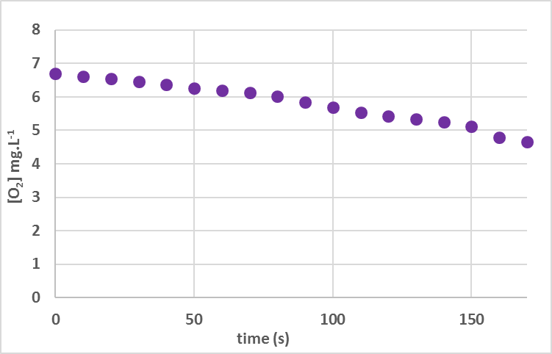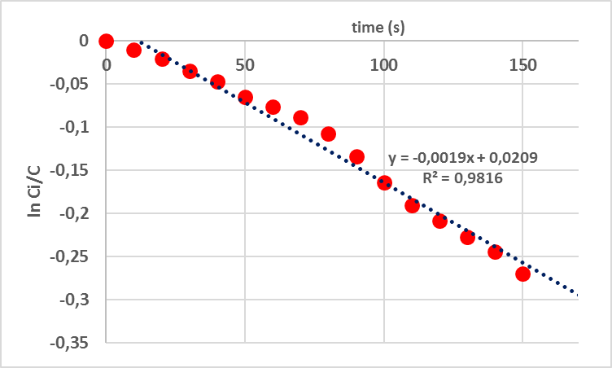
Figure 2. Oxygen desorption by nitrogen bubbles. Figure 3. Mathematical processing of desorption data.
4. Conclusion and perspectives
The liquid-side mass transfer coefficient of individual ascending bubbles has been determined, showing a good agreement with that measured for a swarm of bubbles in our previous works (Devatine et al., 2013). Moreover, these values are well fitted by conventional mass transfer correlations established for rigid spheres.
References
- I. Chiciuc, V. Farines, M. Mietton-Peuchot, A. Devatine, Int. J. Food Eng., Vol. 6 (6), 9, 2010
- A. Devatine, I. Chiciuc, P. Guiraud, G. Hebrard, M. Mietton-Peuchot, SFGP congress, Lyon (France), 2013

