Systematic System Identification and Analysis of Operability for Surfactant Containing Multiphase Reaction Media
Markus Illner^{1*}, Volodymyr Kozachynskyi¹, Erik Esche¹, Jens-Uwe Repke¹
1 Process Dynamics and Operations Group, Technische Universität Berlin, Straße des 17. Juni 135, D-10623
*Corresponding author: markus.illner@tu-berlin.de
Highlights
- Microemulsion systems as enabler for homogeneous catalysis
of long-chained substrates
- Soft sensor implementation to access immeasurable states
- Long-term mini-plant operation
- Moving horizon state estimation and dynamic optimization

1. Introduction
Homogeneous catalysis provides highly desirable reaction performance features, such as high chemo- and regio-selectivities and is thus widely applied in process industry¹. To allow for recycling, applied valuable catalysts are often reallocated to an aqueous phase via ligand modification. However, for the conversion of long-chained substrates this triggers contradicting design features of the reaction system. On the one hand, perfect miscibility of substrate and catalyst phase is required for the reaction. On the other hand, perfect separability for downstreaming and catalyst recycling is desired. To this end, surfactant containing multiphase system can be applied to overcome this hurdle. Surfactants are used as phase transfer agents to enable efficient conversion of nonpolar substrates. Moreover, the specific phase separation behavior of these microemulsion systems can be exploited for catalyst recovery and product separation. Due to their complexity, such novel process concepts pose a variety of operational challenges and reliable plant operation is only possible by applying model-based advanced process control. Especially for microemulsion systems, profound theoretical descriptions are absent and thus a detailed experimental investigation is inevitable to obtain suitable models to aid process operation. Regarding this, we present a systematic approach for the efficient identification and operability analysis of such systems to enable the fast track development of semi-empiric models to be used in process control.
2. Methods
As a case study, the hydroformylation of 1-dodecene in a microemulsion system formed with an aliphatic nonionic surfactant is applied and tested in a fully automatized mini-plant, holding a high-pressure reactor-settler setup and 3 individual recycles². The systematic system identification and analysis firstly focusses on the reaction itself. Here, a mechanistic microkinetic model is adapted regarding relevant influences of the component system on reaction performance. Secondly, the dynamic phase separation behavior of the microemulsion is systematically studied to identify the relevant set of influencing factors and suitable operation regions for plant operation. Additionally, the controllability of the system regarding monitoring of relevant states is analyzed. From this, an updated experimental series is conducted gaining the relevant results for the modeling the three phasic separation of the microemulsion system. This information is merged into a fully dynamic mini-plant model and used within optimal control strategies comprising moving horizon state estimation and dynamic real-time optimization.
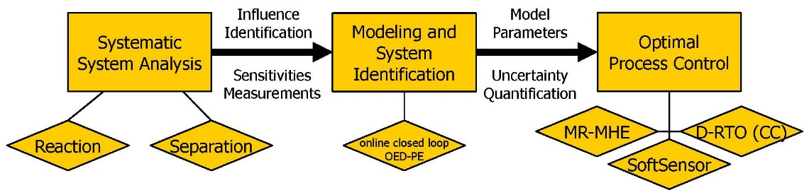
Figure 1. Workflow for systematic system analysis and development of advanced process control
strategies for reactions in microemulsion systems
3. Results and Discussion
The systematic system analysis was successfully applied. A new macrokinetic model was derived and parameterized, which is able to describe undesired byproduct formation induced by local concentration changes in the microemulsion system. Furthermore, the analysis of the phase separation system revealed that the surfactant concentration, the most sensitive influence factor on the separation state, is immeasurable and a stable process operation is not possible. To cope with this, a model-bases soft-sensor was developed, which is based on optical observation of the phase evolution in the microemulsion system. The applicability of developed optimal process control strategies was then tested in long-term continuous mini-plant campaigns of up to 200 h. Control of the critical phase separation step was tested for different operation modes and overall good oil phase purities of up to 99,5 % (amount of oily components in the separated oil phase) were observed. The reaction performance was validated against preliminary lab-scale investigations, wherein a product yield of 40 % and an overall selectivity of 95 % were achieved.
4. Conclusions
Within this contribution, a procedure for the systematic system identification and operability analysis of surfactant containing multiphase systems has been proposed. Based on this, semi-empiric models have been formulated to describe the system dynamics and applicable operation regions. Especially, the identification of immeasurable states has been enabled by a model-based soft sensor. From the application of developed models for state estimation and the calculation of plant trajectories from a dynamic optimization a stable mini-plant operation with successful reaction and separation was achieved.
Acknowledgment
This work is part of the Collaborative Research Center "Integrated Chemical Processes in Liquid Multiphase Systems" (subproject D2, D4) coordinated by the Technische Universität Berlin. Financial support by the German Research Foundation (Deutsche Forschungsgemeinschaft, DFG) is gratefully acknowledged (TRR 63).
References
- F. Franke, D. Selent, A. Börner, Applied Hydroformylation, Chem. Rev, 2012, 112 (11), 5675-5732.
- M. Illner, D. Müller, E. Esche, T. Pogrzeba, M. Schmidt, R. Schomäcker, G. Wozny, J.-U. Repke, Ind. Eng. Chem. Res, 55 (31) (2016) 8616−8626.

