**Selective recovery of nickel and copper from spent acids by chelating resins**

Laura Ulloa*, Eugenio Bringas, María Fresnedo San Román

*Chemical and Biomolecular Engineering Department*

*ETySIIT, University of Cantabria, Avda. De los Castros, 39005, Santander, Spain*

*\*Corresponding author: laura.ulloa@unican.es*

**Highlights**

* Chelating resins are able to separate and recover Ni and Cu from acid media
* Equilibrium is described by the Langmuir model
* pH allows to control the selectivity of Ni/Cu separation
* Selective recovery of both metals is achieved by using H2SO4 and NH3

**1. Introduction**

The management of metal-containing acidic effluents is usually performed by conventional treatment methods which exhibit some limitations such as the lack of selectivity, limited efficiency to reach the required concentration limits, waste generation, etc.; therefore, novel technologies are needed not only to overcome the aforementioned limitations, but also to recover valuable metals for further use. Generally, spent acids are complex wastes that contain high concentrations of metals and mineral acids, usually sulfuric or hydrochloric acids. In this work, spent acids containing nickel, copper and iron in sulphate media were provided by a local waste management industry. The selective removal and recovery of nickel and copper was experimentally analyzed using the chelating resin MTS9600® (bis-picolylamine functionalization) (Purolite). After describing the adsorption equilibrium, the influence on the process kinetics of different operation variables namely pH and solid/liquid (S/L) ratio was analyzed. Finally, the regeneration of the loaded resins allowing the independent recovery of both metals was assessed using H2SO4 and NH4OH as regeneration agents.

**2. Methods**

In the adsorption equilibrium experiments, a certain amount of resin was contacted during 24 hours and constant temperature (25ºC) with spent acids with the following average composition: [Ni2+]=9 g/L, [Cu2+]=3 g/L, [Fe2+]=24 g/L and pH≈1). The equilibrium concentrations of nickel, copper and iron in the aqueous phase were analyzed by Plasma-Atomic Emission Spectrometer (4210 MP-AES, Agilent Technologies®) being the values fitted to theoretical equilibrium isotherms. Kinetic experiments were carried out at 25oC in a flask with continuous stirring during 3 hours under uncontrolled and controlled pH conditions using NaOH 5M. The S/L to liquid ratio varied from 1/10 to 1/2.5 mg/mL and the pH set point was set to values in the range between 1.5 to 3. Samples were taken at different times during the process and metal concentrations were measured. Regeneration was performed by contacting during 1 hour loaded resins with H2SO4 and after NH3 at different concentrations and S/L ratio.[1],[2]

**3. Results and discussion**

Equilibrium data for both metals, nickel and copper, followed the Langmuir equilibrium model with values of the maximum adsorption capacity (qmax) of 50761 mg Ni/Kg dry resin and 97087 mg Cu/kg dry resin. However, the equilibrium constant for copper (KL=0.063 L/mg) is more than 40 times higher than the value for nickel (KL=1.47 10-3 L/mg) thus confirming the preferential affinity of the resin towards copper ions. On the other hand, Figure 1 shows the influence of pH on nickel and copper kinetics. In the case of copper, it is observed that kinetics and removal percentages at equilibrium conditions, near 100%, do not depend on the pH. However, in the case of nickel, removal yields decreased from 90% at pH≥2 to values lower than 50% at pH<2. By varying the S/L ratio it is concluded that the lower the ratio, the slower the nickel kinetics and the smaller the extraction percentages (20% for S/L=1/2.5 and 90% for S/L=1/10). However, copper kinetics are only affected at low values of the S/L ratio. The results from the regeneration experiments proved the selectivity of the proposed methodology, since only nickel was found in the stripping solution after one step of regeneration with H2SO4 1 M (43% recovery, 957,81 mg/L solution) and only copper was detected after the second regeneration stage with NH3 2 M (45% recovery, 614,06 mg/L solution).

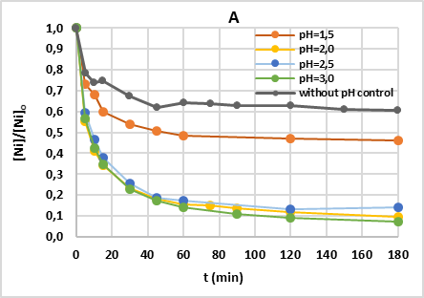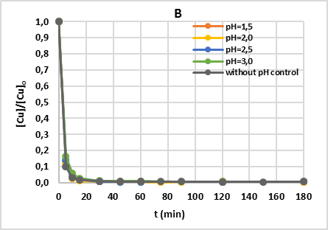

**Figure 1.** Time profiles for the removal of nickel (A) and copper (B) from spent acid wastes with MTS9600® resin.

**4. Conclusions**

From the experimental results it is concluded that the chelating resin MTS9600® is a suitable separation agent to recover transition metals from aqueous industrial wastewater at low pH values, since it reports removal percentages of nickel and copper of≈90% and ≈100% . It was also proved that the methodology proposed can lead to two high purity solutions of each metal after two in series regeneration stages with H2SO4 1 M and NH3 2 M.

**References**

1. Liebenberg, C.J. *et al.* (2013). The recovery of nickel and cobalt from a sulphate bioleach solution using Dow M4195. *The Southern African Institute of Mining and Metallurgy Base Metals Conference 2013*, pp. 269 – 282.
2. Wolowitcz, H. (2012). The use of the chelating resin of a new generation Lewatit Monoplus TP-220 with the bis-picolylamine function. *Chemical Engineering Journal*, 197, pp. 493 – 508.