Hollow Fiber Membrane Bioreactor for the Liver Tissue Engineering
Loredana De Bartolo¹, Haysam Mohamed Magdy Ahmed^{1,2}, Simona Salerno¹, Antonella Piscioneri¹, Shervin Khakpour^{1,2}, Lidietta Giorno¹ and Enrico Drioli^{1,2}

¹Institute on Membrane Technology, National Research Council of Italy, ITM-CNR, via P. Bucci cubo 17/C, ²Department of Chemical Engineering and Materials (DIATIC), University of Calabria, Rende, Italy
*Corresponding author: l.debartolo@itm.cnr.it
Highlights
- Liver microtissue spheroids were cultured in a HF membrane bioreactor
- Membrane bioreactor enabled the maintenance of cell functions up to 25 days
- O₂ concentration profiles into the spheroids and bioreactor were evaluated
- A proper oxygenation was proven by oxygen uptake and mass transfer

1. Introduction
The development of bioartificial devices that are able to favour the liver reconstruction is still challenging¹. Our strategy was to create human liver microtissue spheroids metabolically active by using an optimized crossed HF membrane bioreactor whose design and structural features ensure a uniform microenvironment and adequate oxygenation². When culturing large spheroids, the lack of a perfusing vascular network, as occurs in vivo, could imply a reduced supply of oxygen and nutrients leading to impairment of cell viability and functions. The bioreactor consists of two bundles of hollow fiber (HF) polyethersulfone (PES) membranes cross-assembled in alternating manner. One bundle of HF membranes provides cells nutrients and metabolites whereas the other HF bundle removes catabolites from cell compartment mimicking in this way the in vivo arterious and venous blood vessels. The combination of these two fiber set creates three compartments: two intraluminal compartments of PES HF in which the medium flows and one extraluminal compartment represented by extracapillary network formed by the fibers in which spheroids are cultured.
2. Methods
The bioreactor consists of two bundles of PES HF membranes cross-assembled in alternating manner and potted with polyurethane adhesive within glass housing. The membranes were characterised in order to establish the physico-chemical, structural and transport properties. The bioreactor fluid dynamics were characterized in terms of cumulative residence time distribution (RTD). Spheroids of primary human hepatocytes were realized in agarose mold and then cultured in the extralumen compartment of the bioreactor. The oxygen uptake, urea synthesis and albumin production rates as well as biotransformation functions were evaluated with time. The oxygen concentration profile inside the spheroids and in the extra-capillary space was determined through mathematical modelling of the mass and momentum transfer under steady-state conditions. A periodic unit element (750×750×500 μm) representative of the perfusion system in the bioreactor was chosen to decrease the computational complexity of the model. The equations were numerically solved using COMSOL Multiphysics®.
3. Results and discussion
Human hepatocyte spheroids with uniform size and shape were formed through self-assembling and cultured into the bioreactor (Fig.1). Adjacent spheroids fused, giving rise to larger microstructures around the fibers forming liver-like tissue, which retained functional features in terms of urea synthesis, albumin production, and diazepam biotransformation up to 25 days. The metabolic function data strongly corroborates that within the bioreactor a proper oxygenation and supply of nutrients were provided to the cells ensuring a physiological amount even in the spheroids core. The oxygen uptake rate and the mathematical modelling of the mass transfer directly elucidated that liver microtissue spheroids are not exposed to any oxygen mass transfer limitation. The minimum oxygen concentration reached at the center of multiple spheroids with diameter of 200 μm is significantly higher than the one of the perivenous zone in vivo (42-49 μmol/L), while for larger microtissues (400 μm diameter) the oxygen concentration drops to values that are equal to the maximum concentration found in the liver periportal zone (Fig. 1). Both experimental and modelling investigations led to the achievement of significant results in terms of liver cell performance. Indeed, the creation of a permissive microenvironment inside the bioreactor supported the formation and long-term maintenance of functional human liver microtissues.
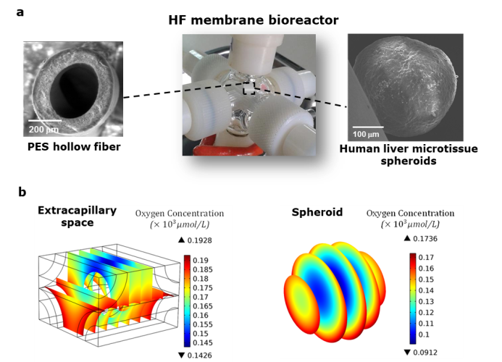
Figure 1. a) Hollow fiber membrane bioreactor used for culture of liver microtissue spheroids; b) oxygen concentration profiles in a large spheroid within a unit element of the bioreactor and in the extra-capillary space in the element.
4. Conclusions
The bioreactor provided a well-controlled microenvironment at molecular level thanks to the selective permeable properties of the membranes and fluid dynamics conditions. The oxygen concentration profiles into the spheroids and in the extracapillary space giving a microscopic view over the cellular microenvironment confirmed the capability of the bioreactor to provide adequate oxygenation to the microtissues.
References
- HMM. Ahmed, S. Salerno, S. Morelli, L. Giorno, L. De Bartolo. Biofabrication 9 (2017) 025022A.
- S. Khakpour, A. Di Renzo, E. Curcio, F. Paolo Di Maio, L. Giorno, L. De Bartolo. J. Memb. Sci 544 (2017) 312-322.

