Textile-Immobilized (Bio-) Catalysts.
Klaus Opwis¹, Katharina Courth¹, Thomas Mayer-Gall¹, Jochen S. Gutmann¹
¹ Deutsches Textilforschungszentrum Nord-West gGmbH, Adlerstr. 1, 47798 Krefeld, Germany
*Corresponding author: opwis@dtnw.de
Highlights
- Textiles were identified as new and innovative catalyst carrier materials.
- Various permanent immobilization strategies were developed successfully.
- Immobilization products are reusable at least 30 times.
- Results on textile-fixed organic catalysts promise huge economic success.

1. Introduction
The efficiency of most chemical processes is based on the use of catalysts. For many applications the catalysts are embedded in a solid matrix, which allows the recycling of the catalysts and the separation of the products. Such immobilizations offer the multiple or even permanent use. Common carrier materials are from polymeric or mineral nature. But their production and the charging with the catalysts are often complex and high-prized. In contrast, textile carrier materials made of cotton, polyamide or polyester are considerably inexpensive. The flexible construction of fabrics enables reactor constructions of arbitrary geometry and a quick removal of the catalyst without any residues after the reaction. Moreover, their open structure guarantees an optimal substrate turnover and the active surface is easily adjustable by the fiber diameter.
2. Methods
For the catalysts immobilization various fiber-specific wet chemical and photochemical processes were used [1-5]. The methods are summarized schematically in Figure 1. The (bio-) catalytic activity of the immobilized enzymes and organic catalysts were determined by typical enzymatic assays and model reactions.
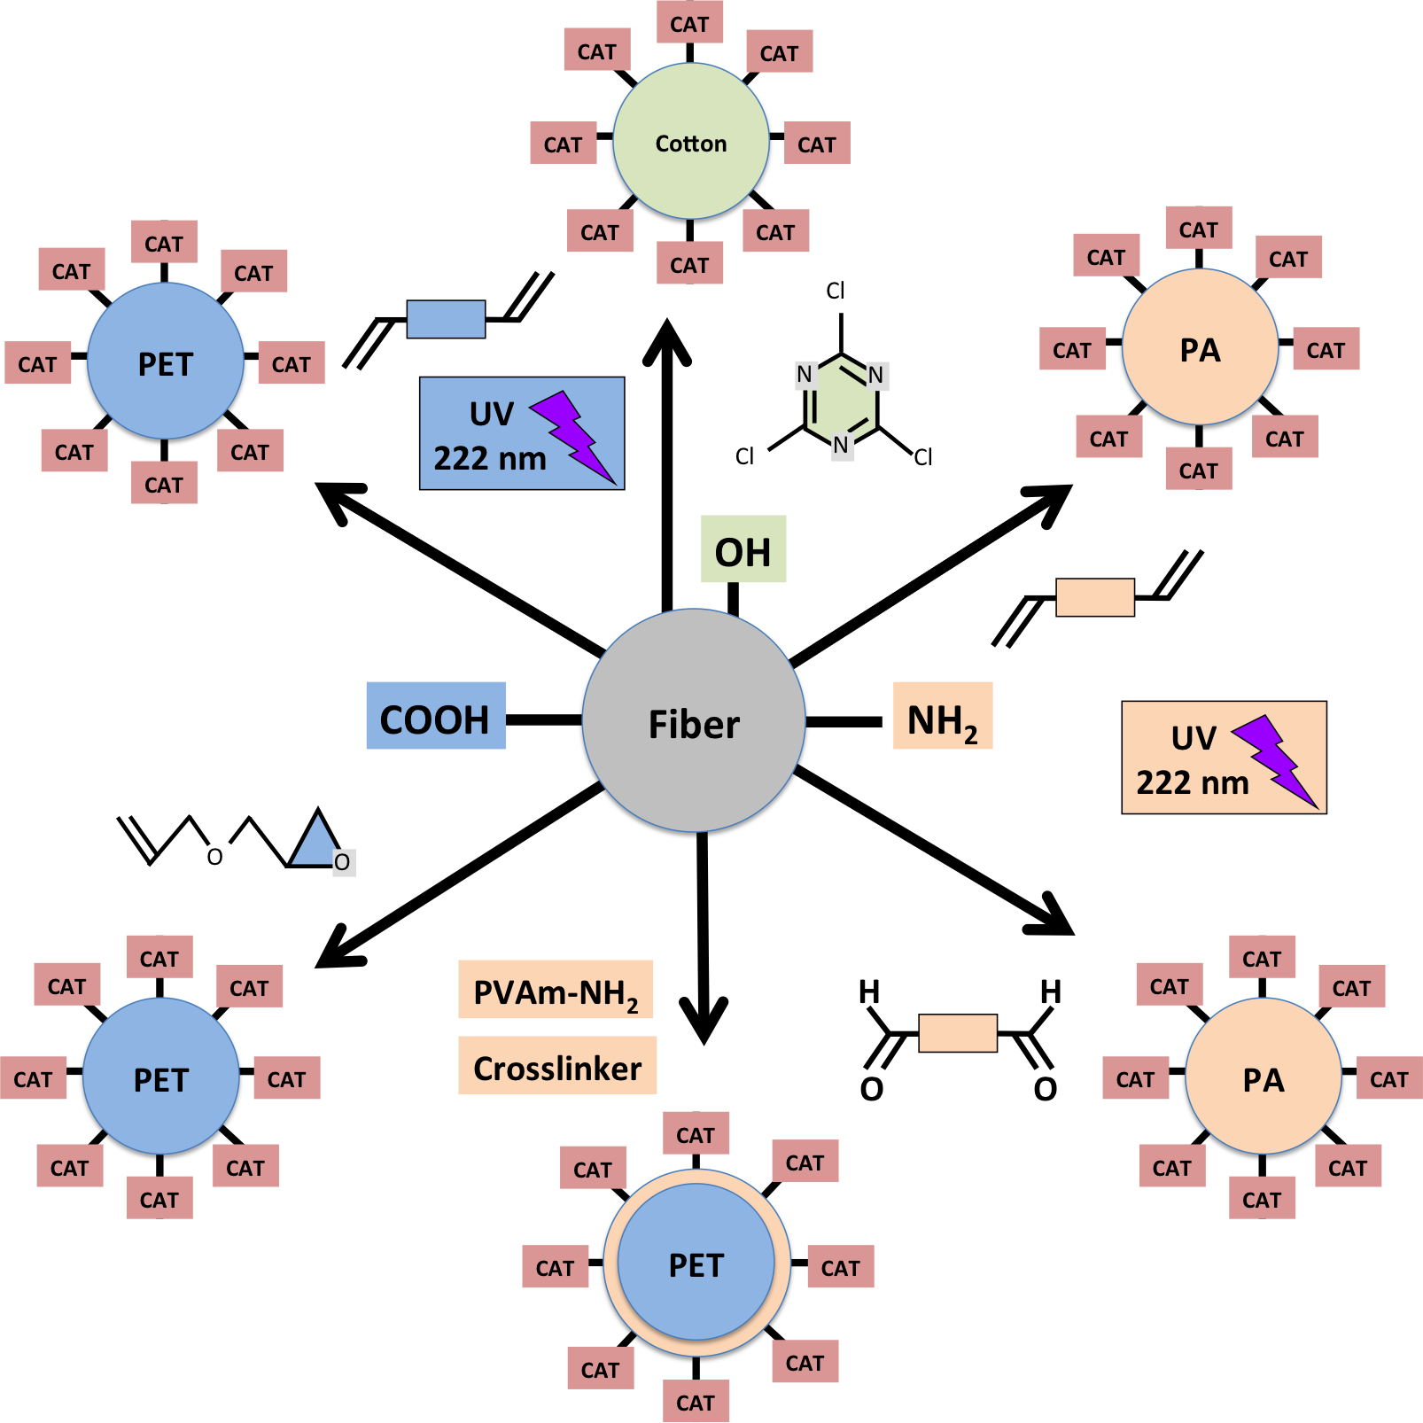
Figure 1. Catalase immobilized on Polyamide Fibers.

3. Results and discussion
We report various successful wet-chemical and photochemical techniques for the immobilization of different types of catalysts (enzymes, organic catalysts) on textile carrier materials. Figure 1 shows a SEM of textile-fixed catalase.
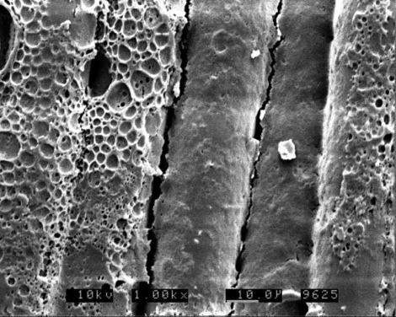
Figure 1. Catalase immobilized on Polyamide Fibers.
Beyond, we provide information on the (bio-) catalytic activity of the immobilized catalysts in repeated use, and explain various relevant applications, e.g., the use of immobilized peroxidases in the bleaching of whey from dairy processes (food industry) and the use of textile-fixed cinchona alkaloids for asymmetric syntheses of pharmaceutical products. For example, the desymmetrization of cyclic anhydrides runs for more than 250 cycles without a significant loss of its catalytic activity and an impressive enantiomeric ratio of 97:3.
4. Conclusions
In summary, we have identified low-cost textiles as alternative carrier materials for catalysts. With a low preparative and economic expense fabrics with a high load, a high catalytic activity and excellent permanence against desorption can be produced. Therefore, our textile-fixed catalysts represent a totally new tool for heterogeneous catalysis with widespread potential applications in pharmaceutics, chemistry and eco-friendly white biotechnology.
References
- J.-W. Lee, T. Mayer-Gall, K. Opwis, C.E. Song, J.S. Gutmann, B. List, Organotextile Catalysis, Science 341 (2013) 1225-1229.
- K. Kiehl, T. Straube, K. Opwis, J.S. Gutmann, Strategies for the permanent immobilization of enzymes on textile carriers, Engineering in Life Sciences 15 (2015) 622-626.
- T. Mayer-Gall, J.-W. Lee, K. Opwis, B. List, J.S. Gutmann, Textile Catalysts - An unconventional approach towards heterogeneous catalysis, ChemCatChem 8 (2016) 1428-1436.
- K. Opwis, K. Kiehl, J.S. Gutmann, Immobilization of Peroxidases on Textile Carrier Materials and their Use in Bleaching Processes, Chemical Engineering Transactions 49 (2016) 67-72.
- K. Opwis, K. Kiehl, T. Straube, T. Mayer-Gall, J.S. Gutmann, in: Textile Finishing: Recent Developments and Future Trends, K.L. Mittal, T. Bahners (Eds.), Wiley-Scrivener, Beverly, MA, 2017, pp 345-361.

