Process Analytical Technology Implementation for Protein Refolding: GCSF as a Case Study
Vishwanath Hebbi, Garima Thakur, and Anurag S. Rathore*
Department of Chemical Engineering, Indian Institute of Technology, 110016, Hauz Khas, India
*Corresponding author: asrathore@biotechcmz.com
Highlights
- Implementation of Doe and PAT is demonstrated in refolding operation
- Real-time data of redox, temperature and pH was used to build SPC charts
- MVDA based statistical charts were used to monitor and control refolding of GCSF

1. Introduction
Process analytical technology is gaining interest in the biopharmaceutical industry as a means to enable consistency in processing and thereby in product quality via process control. Protein refolding is known to be significantly impacted by critical process parameters and feed material attributes including composition and pH of the solubilization and refolding buffers. Hence, in order to achieve robust process control and product quality, these attributes and parameters need to be monitored[1]. This paper presents an approach towards statistical process control and monitoring of protein refolding utilizing the measurements of online redox potential, temperature, and pH for development of a statistical model. The model has then been integrated with LabView to permit real time monitoring of the refolding process.
2. Methods
Refolding operations were conducted at lab scale in 50 mL and 500 mL glass beakers for solubilisation and refolding, respectively. Real-time data was collected using online probes of redox, ph and temperature. Critical variables were varied in design space and operating space and their implications on critical quality attributes were analysed using HPLC. Real-time data were used to build statistical control charts using multivariate data. The model was tested for operation in design space, operating space and potential deviations.
3. Results and discussion
Continuous measurements of ORP, pH, and temperature were performed during buffer preparation and protein addition steps. The ORP signal was found to be highly sensitive to each subsequent addition, as is evident from the changes to its profile as a function of time. Temperature and pH signals provide complementary measures of process changes. Simultaneous use of multiple sensors makes the PAT tool more robust as it effectively deals with issues that otherwise arise during commercial installation including signal-to-noise variability, drifting, and unexpected failure.
Characterization of time profiles of process variables within design space
The authors defined the design space for refolding to deliver refolding yield greater than 70%, oxidized impurities below 15%, and protein concentration above 0.18 mg/mL [2]. In the present study these findings have been utilized for design of a suitable PAT application. Eight control runs were conducted around design space and were validated through HPLC analysis.
Detection and identification and implementation of deviations with SPC charts
Figure 1 shows the Hotelling’s T2 plots of the deviation batches plotted using the training model. For the solubilisation buffer, the urea deviation appears at zero minutes and the DTT deviation appears at 46 minutes. In the refolding buffer, pH deviation appears at 37 minutes, and deviations caused due to the addition of improperly solubilized IBs (due to low urea or DTT) appear when the SIB is added at 40 minutes. Once a deviation is present in the system, errors in the SPC charts persist for future time intervals, as the changes in the online measured variables of ORP, pH and temperature persist in future stages of the batch. The overlay of analytical RP-HPLC profiles corresponding to the deviations has been shown in Figure 1(c).
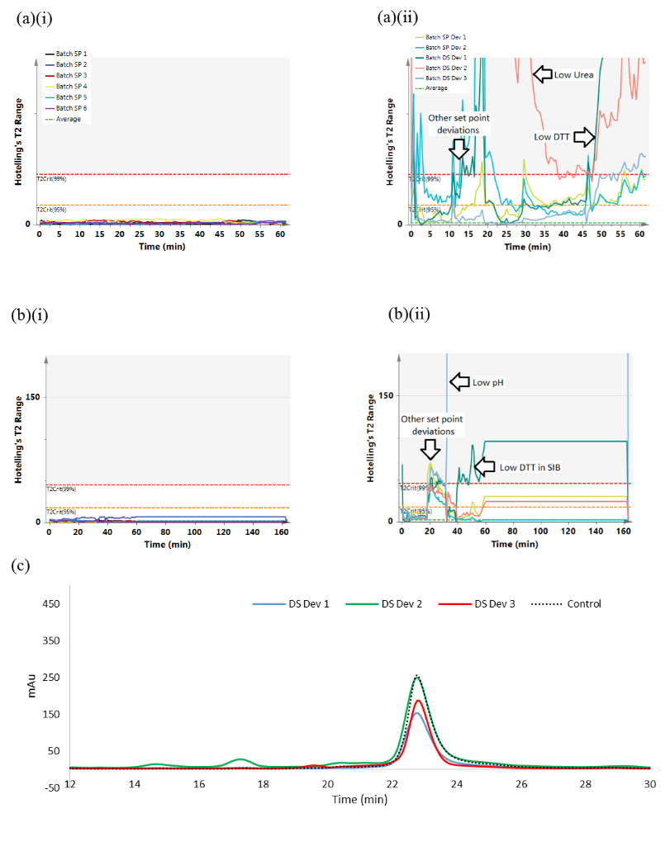
Figure 1 Hotelling’s T2 charts for (a) solubilisation and (b) refolding for (i) control batches and (ii) deviation batches, (c) overlay RP-HPLC chromatograms of deviation runs and control run.
4. Conclusions
This study describes a PAT tool to monitor a complete refolding unit operation, from preparation of the solubilisation and refolding buffers to quenching of the refold. Data from online ORP, pH, and temperature probes are used to create a fingerprint of a typical refolding batch within the pre-defined design and operating spaces. A database of successful runs about a set-point is then created and used to develop statistical process control charts to monitor the evolution of the batch with respect to the addition of each subsequent component and are used in real-time monitoring for process deviations.
References
[1] M. Pathak, S. Dixit, S. Muthukumar, and A. S. Rathore, "Analytical characterization of in vitro refolding in the quality by design paradigm: Refolding of recombinant human granulocyte colony stimulating factor," Journal of pharmaceutical and biomedical analysis, vol. 126, pp. 124-131, 2016.
[2] P. D. Bade, S. P. Kotu, and A. S. Rathore, "Optimization of a refolding step for a therapeutic fusion protein in the quality by design (QbD) paradigm," Journal of separation science, vol. 35, pp. 3160-3169, 2012.

