**Protein Crystallization Kinetics  
– Determination by a Through-flow Small-Angle X-ray Scattering Method**

Izabela Poplewska1,*, Andrzej Łyskowski2, Michał Kołodziej1, Piotr Szałański3,

Wojciech Piątkowski1, Dorota Antos1

*1 Department of Chemical and Process Engineering, Rzeszów University of Technology,*

*2 Department of Biotechnology and Bioinformatics, Rzeszów University of Technology*

*3 Faculty of Chemistry, Rzeszów University of Technology*

*Powstańców Warszawy Ave. 6, 35-959 Rzeszów, Poland]*

*\* ipoplewska@prz.edu.pl*

**Highlights**

* Protein crystallization kinetics was determined using a modified SAXS technique.
* Results obtained were comparable to those measured in a seeded tank crystallizer.
* The modified SAXS setup can support development stage of bulk crystallization.

**1. Introduction**

Determination of the process kinetics and development of adequate kinetic rate equations for design of bulk crystallization is based on measurements of time-dependent concentration profiles. Typical experimental setups for acquisition of kinetic data consist of a small-volume tank, in which the supersaturated solution is stirred. Samples of the solution are collected at different time intervals and subjected to the concentration analysis. This procedure is laborious and consumes a large amount of often valuable protein solution. Therefore, in this work we propose another approach for the characterization of crystallization kinetics of proteins in situ, which is based on a modification of small-angle X-ray scattering (SAXS) technique. The kinetic data acquired in the SAXS setup were compared to those taken from a stirred-tank crystallizer (STC) setup, in which unseeded (uSTC) and seeded (sSTC) crystallization was analyzed [1].

**2. Methods**

The model protein for the study was lysozyme (LYZ), which was crystallized from supersaturated aqueous solutions of ammonium sulfate. The kinetic measurements were performed in SAXS, uSTC and sSTC for the supersaturated protein solutions with the same compositions.

In the SAXS system a small amount of the protein solution (1.5 mL) was forced to recirculate within the setup. The SAXS intensity curves were measured at different time intervals and converted into kinetic profiles using a calibration factor. The diffraction images of the sample taken at the end of the kinetic experiments were recorded to confirm the presence of the crystalline phase (Fig. 1).

In the STC setup the crystallization kinetics of LYZ was measured in a 10 mL tank. In the uSTC setup the protein solutions were stirred with a magnetic stirrer at 400 rpm. In the sSTC setup, the experiments were repeated under the same conditions, but the solutions were seeded with 1.6 mg of the seed crystals.

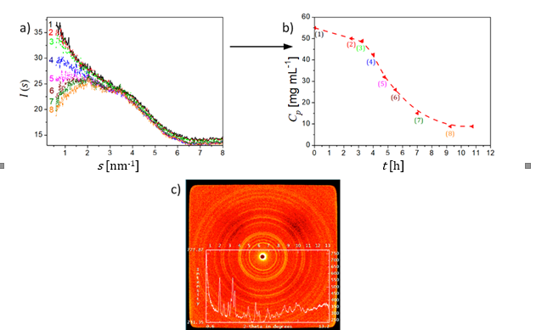

**Figure 1.** Course of the crystallization in SAXS. (a) Time evolution of the scattering intensity curves plotted against the modulus of the momentum transfer, *s*; (b) the corresponding kinetic curve; dashed line - guide to the eye;  
(c) typical diffraction image recorded at the end of the experiment

**3. Results and discussion**

The analysis of the experimental data indicated that the kinetic rate accelerates with increasing the supersaturation degree, and decelerates with increasing ammonium sulfate concentration (*Csalt*) in both systems (Figs 2a, 2b). The seeded crystallization is accomplished significantly faster than the unseeded one (Fig. 2a). Moreover, the hydrodynamic conditions in the SAXS setup could be adjusted for which a quantitative agreement between the kinetic data acquired from both systems was achieved (Fig. 2b).

To predict the time evolution of concentration profiles of the protein in the liquid phase and quantify the crystallization kinetics, a population balance model was used, which consisted of kinetic rate equations of nucleation and crystal growth [1]. The same kinetic equations could be used to describe the course of crystallization in both systems. The results of the measurements and numerical simulations were compared (Figs 2a, 2b).

|  |  |
| --- | --- |
| a) | b) |

**Figure 2.** Comparison of the kinetic curves measured in the (a) sSTC and uSTC; (b) sSTC and SAXS setups

**4. Conclusions**

The modified SAXS setup can be applied to support kinetic measurements for bulk crystallization. The implementation of flow motion in the SAXS setup enhances the rate of crystallization kinetics and reduces the time of measurements. The method allows online monitoring the presence of the crystalline phase as well as acquiring kinetic profiles using very small volumes of valuable protein solutions.

**References**

**[1]** I. Poplewska, A. Łyskowski, M. Kołodziej, P. Szałański, W. Piątkowski, D. Antos, Chem. Eng. Res. Des. (2019), 141, 580-591