Mixed-trophies biofilms for high-cell-density cultivation of Synechocystis sp. PCC 6803 in capillary reactors for continuous cyclohexane oxidation
Ingeborg Heuschkel, Anna Hoschek, Andreas Schmid, Bruno Bühler, Rohan Karande*, Katja Bühler
Department of Solar Materials, Helmholtz-Centre for Environmental Research, UFZ Permoserstrasse 15, 04318 Leipzig, Germany
*Corresponding author: rohan.karande@ufz.de
Highlights
- O₂ producing Synechocystis was combined with O₂ respiring Pseudomonas using proto-cooperation to achieve HCDs of up to 51.8 g_{BDW} L⁻¹.
- This concept was coupled to the challenging C-H oxyfunctionalization of cyclohexane to cyclohexanol with a remarkable conversion of >98% and selectivity of 100 % (KA oil).
- HCD of the photoautotrophic biocatalyst were established and resulted in a productivity of 3.76 g_{cyclohexanol} m⁻² day⁻¹, which was maintained for at least one month.
1. Introduction
In Nature, almost 385 billion tons of CO₂ are fixed annually by photosynthesis. This power of photosynthesis will be key to make inorganic carbon available for the production of value-added chemicals and fuels and reduce future dependency on fossil resources. Despite photo-biocatalysis developing remarkably and the huge potential of photoautotrophic microorganisms for eco-efficient production scenarios, photo-biotechnology is still in its infancy. The lack of scalable photobioreactors that provide efficient light transmission, CO₂ supply, and O₂ degassing and thus enable high cell densities (HCD), constitutes a key bottleneck, especially if cost-sensitive bulk chemicals are the product of choice. Commercialized tubular photobioreactors with 100 to 600 mm inner diameter offer a surface area to volume ratio (SA/V) of over 100 m² m⁻³ enabling the efficient capturing of incident solar radiation.¹ Here we introduce a new generation of photobioreactors based on capillary biofilm reactors. They have a high surface to volume ratio, and thus enhanced light availability, enabling HCDs of photo-autotrophic microorganisms.
2. Methods
For biomass determination mixed-trophies as well as single species Synechocystis sp. PCC 6803 biofilms were cultivated for 5 weeks in the biofilm format, either supplied with or without air segments and with or without citrate. Finally dissolved oxygen in the aqueous phase as well as the oxygen content in the gas phase was measured and the biomass removed and quantified.
For the biotransformation the mixed-trophies biofilms were cultivated without citrate and under segmented flow conditions. After 5 weeks of biofilm cultivation the biotransformation was induced and product concentrations as well as oxygen in the gas phase were measured.

3. Results and discussion
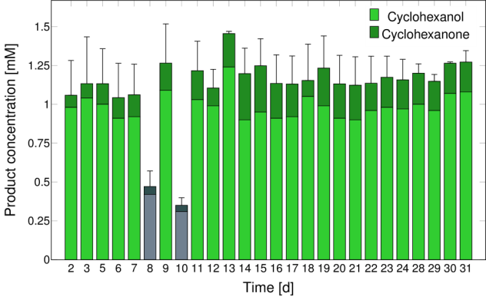
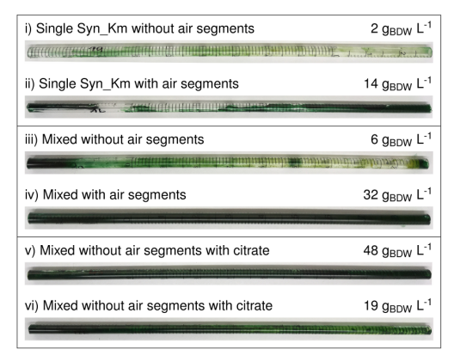
Figure 1. Images of the biofilm capillary reactors 5 weeks after inoculation. i) and ii) Syn_Km: monoseptic biofilm cultures of Synechocystis sp. PCC 6803 (pAH032) without and with air segments, respectively. iii) and iv) Dual species biofilm cultures of Syn_Km and P. taiwanensis VLB120 (pAH032) operated iii) without and iv) with air segments. v) and vi) correspond to iii) and iv) with citrate in the aqueous medium feed. Final biomass concentrations are given on the right of the respective image. BDW, biomass dry weight. | Figure 2. Biocatalytic cyclohexane oxyfunctionalization reaction performed by a dual-species mixed trophies biofilm consisting of recombinant Synechocystis sp. PCC 6803 (pAH050) and P. taiwanensis VLB120 (pAH050). Biotransformation (started day 0 in Fig.2) was initiated after 5 weeks of biofilm cultivation. The light was switched off for 24 hours during days 8 and 10, respectively. Green and gray bars represent product formation under light and dark conditions, respectively. Light and dark colors refer to the formation of cyclohexanol and cyclohexanone, respectively.

The flow reactor concept for phototrophic biofilm cultivation was coupled to the challenging C-H oxyfunctionalization of cyclohexane to cyclohexanol with a remarkable conversion of >98% and selectivity of 100 % (KA oil). High photoautotrophic biocatalyst concentrations were established and resulted in a productivity of 3.76 gcyclohexanol m⁻² day⁻¹, which was maintained for at least one month.³
4. Conclusions
This work demonstrates prototrophy as a biological strategy for the cultivation of photobiocatalysts in a stable and high cell density format up to 51.8 g_{BDW} L⁻¹, thereby overcoming a key-bottleneck in photo-biotechnology. The crucial problem of O₂ accumulation and thus toxification/inhibition of the photoautotrophic biocatalyst was overcome by utilizing O₂ respiring P. taiwanensis VLB120, O₂ extracting air segments and by O₂ dependent biotransformation. Mixed trophies biofilms in capillary reactors were able to produce 3.76 g m⁻² day⁻¹ cyclohexanol for over a month with conversion, and KA oil selectivity values of 98% and 100%, respectively, a milestone in cyclohexane-based chemistry.
References
- Posten, C. Eng. In Life Science. (2009) 165-177
- Karande R., Hoschek A., Heuschkel I., Bühler K., Schmid A. Patent: PCT/EP2018/074746
- Anna Hoschek, Ingeborg Heuschkel, Andreas Schmid, Bruno Bühler, Rohan Karande*, Katja Bühler. Biores. tech. (2019) (submitted)
- Karande R., Salamanca D., Engesser K.-H., Buehler K. and Schmid A. Patent. WO/2018/046104

