An in Situ FTIR and Raman Study of MOF MIL-53(Al) Formation Under Solvothermal Conditions
Heidemarie Embrechts^{1,2}, Martin Kriesten³, Wolfgang Peukert^{1,2}, Martin Hartmann³, Monica Distaso^{1,2}
¹ Department of Chemical and Biological Engineering, Institute of Particle Technology, Cauerstr. 4, 91058 Erlangen, Germany *heidemarie.embrechts@fau.de
² Interdisciplinary Center for Functional Particle Systems, FAU Erlangen-Nürnberg, Haberstr. 9a, 91058 Erlangen, Germany
³ Erlangen Catalysis Resource Center, Egerlandstr. 3, 91058 Erlangen, Germany

Highlights
- The formation steps of the MOF MIL-53(Al) are studied with in situ FTIR and Raman spectroscopy in a specially designed solvothermal reactor.
- The formation of prenucleation building units, MIL-53 nuclei, MIL-53 formation, and the decomposition of the solvent DMF to formic acid are observed in situ.
- The MIL-53 particle size is linked to the accumulation of prenucleation building units which influences the supersaturation of MIL-53 prior to particle formation.

1. Introduction
Metal-organic frameworks (MOFs) are a class of porous coordination polymers formed by the self-assembly of polydentate bridging ligands and metal-oxo clusters.[1] Due to their remarkably high surface areas, highly-ordered microporous networks, and structural diversity, MOFs exhibit great promise in the fields of catalysis, sensing, drug delivery, gas separation, and gas storage.[2]
Although there has been much research on the properties of metal-organic frameworks and numerous novel structures have been synthesized to date, there are only few reports focusing on the MOF formation steps prior to precipitation. Optimization of MOF synthesis protocols has, in consequence, been largely governed by serendipity. An understanding of the individual formation steps would allow for the development of improved strategies for the targeted engineering of MOF materials with defined crystal structures tailor-made to fit a variety of specific applications.
2. Methods
Such mechanistic understanding is achieved by monitoring MOF synthesis with Raman and FTIR spectroscopy in a 1.5 L solvothermal reactor specially designed to enable in situ monitoring of the reaction solution.[3] MIL-53(Al), one of the most-studied MOFs with interesting breathing behaviour and high thermal stability, serves as a model system.[4] MIL-53(Al) is synthesized in N,N-Dimethylformamide/water mixtures from aluminum salts and terephthalic acid. In situ observations are complemented with detailed ex situ analysis of the synthesized MOFs with N₂ sorption, x-ray diffraction, SEM imaging, thermogravimetric analysis, and solid state FTIR measurements.
3. Results and discussion
The formation of prenucleation building units (PNBUs) consisting of one linker molecule and one aluminum atom, MIL-53(Al) nuclei, crystalline MIL-53(Al) and the decomposition of DMF to formic acid is followed over time.[3] By comparing the kinetic profiles of the PNBUs [Al(H₂O)₄–HBDC]²⁺ and the solid MIL-53(Al) phase at various synthesis temperatures, the rearrangement of the PNBU to form the metal-organic framework is identified as the rate-limiting step of synthesis. The calculated activation energy of formation of the PNBU (65.5 kJ mol⁻¹) is significantly lower than that of MOF formation (90.4 kJ mol⁻¹). This information is used to contruct a proposed MIL-53 formation pathway (Figure 1).

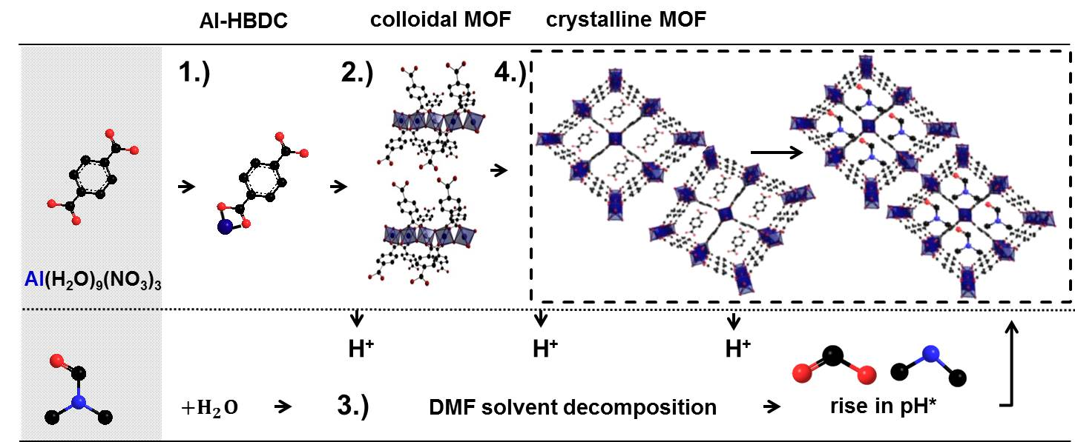
Figure 1. Proposed MIL-53 formation mechanism with reaction steps observed in situ.

The synthesized MIL-53 particle size is found to depend on the accumulation of prenucleation building units in solution prior to precipitation of the solid MIL-53(Al) phase. PNBU accumulation preferentially occurs when both the metal center and linker precursors are initially free to coordinate. A larger accumulation of prenucleation building units prior to MIL-53 precipitation results in a higher supersaturation, larger burst of nucleation, and the formation of nanoMOFs. Conditions less favorable to PNBU accumulation result in the formation of micron-sized particles.
4. Conclusions
This information gained from this study can be used as a tool to rationally understand the effect of various parameters on the MOF MIL-53(Al) formation process. The methodology described here could also be applied to rationally understand the formation of other MOF structures.
References
[1] A. Schneemann, V. Bon, I. Schwedler, I. Senkovska, S. Kaskel, R. A. Fischer Flexible metal–organic frame-works. Chem. Soc. Rev. 43 (2014) 6062.
[2] G. Férey. Chem. Soc. Rev. 37 (2008) 191–214.
[3] H. Embrechts, M. Kriesten, K. Hoffmann, W. Peukert, M. Hartmann, M. Distaso. J. Phys. Chem. C. 122 (2018) 12267-12278.
[4] Maurin, G.; Serre, C.; Cooper, A.; Férey, G. Chem. Soc. Rev. 46 (2017) 3104–3107.

