Crystal engineering strategies to ensure the quality of particulate products for the food and pharmaceutical industries
Elena Simone^{1*}
1 School of Food Science and Nutrition, University of Leeds, Leeds, United Kingdom
*Corresponding author: e.simone@leeds.ac.uk
Highlights
- Crystal shape and polymorphism of lactose and ortho-aminobenzoic acid were tailored with combinations of solvents and structurally related additives.
- Temperature cycling was used to manipulate crystal shape of succinic acid without affecting its purity.
- Process analytical technology for online monitoring and control of crystallization.

1. Introduction
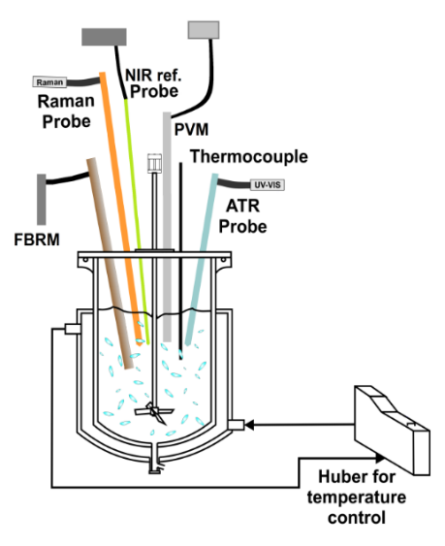
Crystallization is an important unit operation used in the pharmaceutical, agrochemical and food industries. Crystal size, shape and lattice structure (polymorphism) have a profound effect on the properties of the final particulate product as well as on the efficiency of the downstream operations (filtration, washing, drying, tableting etc.). Crystals can be engineered by opportune choice of crystallization conditions. Here, examples of how these processing conditions can affect crystal polymorphism, purity and size/shape distributions are presented [1-3]. The implementation of process analytical technology (PAT) tools during the development stage of APIs has largely helped in better understanding and optimizing crystallization processes. Specific instrumentation can be used to monitor on-line, in situ, crystal size and shape (focused beam reflectance measurement, FBRM, particle vision and measurement, PVM), polymorphism (Raman, spectroscopy) and liquid phase composition (Attenuated total reflectance, ATR, UV/VIS) [3]. Furthermore, feedback control strategies based on PAT tools signal can be implemented to specifically tailor the characteristics of the produced crystals. This work shows few examples of application of PAT tools for the study and control of crystallization processes.
2. Methods
Three examples of crystal engineering strategies to control crystal polymorphism and shape are shown here. Cooling crystallization experiments were carried out at 400 mL scale in a jacketed vessel equipped with temperature control. Ortho-aminobenzoic acid (OABA), lactose and succinic acid were used as model compounds for the experiments. The shape and polymorphism of OABA were tailored via crystallization in different solvent mixtures (water and isopropyl alcohol, IPA) and with the addition of a structurally related additive (benzoic acid, BA). Lactose polymorphism and size distribution were controlled via crystallization in water/acetone mixtures. Finally, succinic acid was crystallized from water and its crystal shape was controlled via applying heating (dissolution) and cooling (growth) cycles. The array of PAT tools shown in Figure 1 was used to monitor experiments online, while offline microscopy, X-ray and laser diffraction as well as chromatography were used to measure size, shape, purity and crystal polymorphism of the obtained crystals after filtration and drying.
Figure 1. Schematic of the rig used for the experiments.
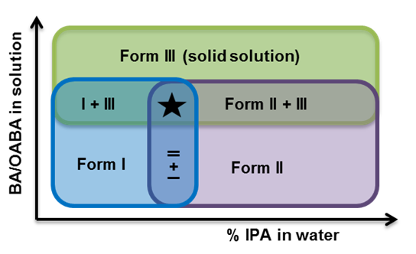
3. Results and discussion
3.1 Polymorphic control using solvents and additives
Figure 2 shows the results obtained for the polymorphic control of OABA. Increasing the amount of IPA in water induced the formation of the metastable form II while high water concentrations favoured the nucleation of stable form I [2]. Introducing BA generated nucleation of the metastable form III regardless of the solvent used. BA was found to be easily incorporated in form II and III of OABA, generating solid solutions. Lactose crystallization was instead performed in solvent mixtures at different ratios of acetone and water. High concentrations of acetone determined faster nucleation and growth rate but poor control of polymorphism, with β-lactose crystals nucleating together with the desired α-monohydrate form. In water only the α-monohydrate form was obtained but with slow growth kinetic, leading to poor recovery yields [1].
Figure 2. Polymorphic control of OABA.
3.2 Shape control using temperature cycling
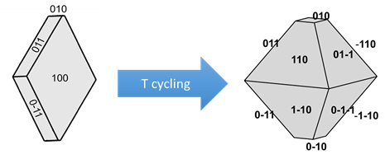
Temperature cycling was used to modify the morphology of succinic acid crystals in water, exploiting the different rates of growth and dissolution for each specific facet (Figure 3). The shape of crystals moved from plate-like, with a dominant (100) face, to diamond-like. Because of the different facet-specific kinetics of growth and dissolution it was possible to completely eliminate the (100) facet in favour of the growth of the (110), (011), (-110) and (01-1) facets. This strategy allowed shaped manipulation without the introduction of additives of impurities [3].
Figure 3. Shape control of succinic acid.
4. Conclusions
In this work different examples of crystal engineering approaches for the design of crystallization processes and their online monitoring and control are illustrated. Crystal properties could be fine-tuned by selecting opportune operating conditions.
References
[1] Simone, E., Tyler, A.I.I., Kuah, D., Bao, X., Ries, M.E., Baker, D. (2019) Org. Process Res. Dev., 23, 220-233. [2] Simone, E., Steele, G., Nagy, Z. K. (2015) CryEngComm, 17, 9370-9379.
[3] Simone, E., Klapwijk, A.R., Wilson, C.C., Nagy, Z.K. (2017) Cryst. Growth Des., 17 (4), 1695–1706.

