Multidimensional classification of quantum dots: Investigation of flock properties during selective agglomeration for process design
Christina Menter¹, Doris Segets²
¹ Institute of Particle Technology (LFG), Friedrich-Alexander-University Erlangen Nürnberg (FAU), Germany;
² Process Technology for Electrochemical Functional Materials and Center for Nanointegration Duisburg-Essen (CENIDE), University Duisburg-Essen (UDE), Germany
*Corresponding author: doris.segets@uni-due.de

1. Introduction
Quantum confined semiconductor nanoparticles (quantum dots, QDs) are highly interesting materials due to their unique electronic and optical properties and are used for various applications, such as dye sensitized solar cells and light-emitting devices. Within the relevant size range of a few nanometers, QDs exhibit pronounced and unique structure-property relationships. Hence, a narrow particle size distribution (PSD) becomes one of the most important factors to tailor product performance. Size selective agglomeration has already been proven to be an efficient post processing strategy for ZnS QDs [1,2]. It is based on the titration of a poor liquid into an already existing stable dispersion, which leads to a reduction of the particles’ steric stabilization. Therefore, larger ZnS particles with larger van der Waals attraction flocculate first while smaller structures stay dispersed as primary particles. Finally, the flocculates have to be separated from the continuous phase. While on lab scale, the formed flocks of several 100 nm can be easily separated by centrifugation from the fine fraction that stays as primary particles in the supernatant, for larger scale preparation using continuous processes, new concepts are urgently needed. Herein, the objective was to develop a filtration process to achieve continuous flock removal by two alternating filtration units without affecting the separation efficiency governed by the microprocesses. Noteworthy, this is the first time that a scalable classification strategy for such small entities below 10 nm is reported. Key to reach this ambitious goal is to know how the properties of the flocks can be controlled and how stable the generated flocks are against shear forces.
2. Methods
For the synthesis of 3-mercapto-1,2-propanediol capped ZnS QDs a method of Nanda et al. was applied[3]. Via analytical centrifugation (AC) the sedimentation profiles of the flocculated dispersions were recorded to determine the sedimentation equivalent diameter distribution of the flocks. AC measurements were performed with a LUMiSizer LS 651 (LUM GmbH, Berlin, Germany). Absorbance spectra of ZnS QDs were recorded using a SPECORD Plus UV/Vis spectrophotometer (Analytik Jena AG, Germany) with quartz glass cuvettes of 0.2 mm optical path length. Absorbance measurements were analyzed with respect to their volume PSDs by means of a previously published and carefully validated deconvolution algorithm [4].
3. Results and discussion
In Figure 1 the classification procedure is summarized. After the flocculation of larger particles by the addition of a poor liquid to a stable ZnS dispersion, the complete separation of the flocks from the dispersed particles is fundamental. Entering of flocks to the fines would lead to a significant degradation of the classification result. Since separation by centrifugation is restricted to lab scale, our objective was to develop a filtration process for the separation of larger quantities. Continuous operation can then be achieved by using alternating filtration units.
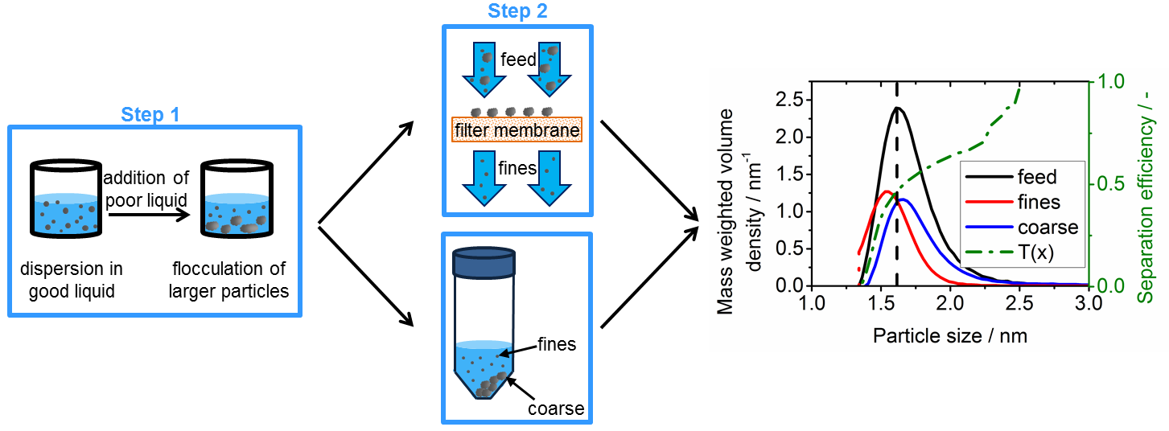
Figure 1: Summary of the two-step classification procedure (left and middle) and classification result with separation efficiency (right).
For filtration process design it is indispensable to know how stable the generated flocks are and how the flocks properties can be controlled. In a systematic parameter study we found out that the flocks are comparatively stable against shear forces generated at varying energy inputs, weakly affected by solvent polarity and that the flock diameter rises with increasing solid concentration. With this knowledge we designed a filtration process to separate flocks from the primary particles. After the flocculation of larger particles by addition of a poor liquid to a stable dispersion, the flocks were separated by filtration instead of centrifugation. Afterwards, the dried filter cake was proven to be redispersible in water. Thus, we were able to proof that it is possible to replace the separation of flocks from the fines by centrifugation through filtration during a nanoparticle classification experiment without affecting the separation efficiency.
4. Conclusions
Our work demonstrates for the first time the scalable classification of QDs < 10 nm by size selective precipitation. We successfully replaced the classical centrifugation step for flock separation by filtration without affecting the separation efficiency that is determined by the microprocesses. Noteworthy, this process is not restricted to classification by size, but can be extended towards multidimensional separation, e.g. size and composition or surface properties.
References
- D. Segets, S. Komada, B. Butz, E. Spiecker, Y. Mori, W. Peukert, J. Nanopart. Res. 15 (2013) 1486.
- D. Segets, C. Lutz, K. Yamamoto, S. Süß, Y. Mori, W. Peukert, J. Phys. Chem. C 119 (2015) 4009-4022.
- J. Nanda, S. Sapra, D. D. Sarma, Chem. Mater. 12 (2000) 1018-1024.
- D. Segets, J. Gradl, R. Klupp Taylor, V. Vassilev, W. Peukert, ACS nano, 3 (2009) 1703–1710.

