Spray drying of alumina powders – impact of process parameters and powder properties upon final product
Antoine Marie¹, Mallorie Tourbin², Anne-Charlotte Robisson¹, Carine Ablitzer¹, Christine Frances²
1 CEA, DEN, DEC, Cadarache 13108 St Paul les Durance, FRANCE ; 2 Laboratoire de Génie Chimique INP – ENSIACET, 31400 Toulouse, FRANCE
*Corresponding author: antoine.marie@cea.fr
Highlights
- Alumina spray drying was studied under different process conditions
- The spray drying gas temperature impacts the proportion of fines in the product
- The initial powder size distribution has an effect on the spray-dried agglomerates
- Ultrasonic nozzle technology allows producing strong alumina agglomerates
1. Introduction
Spray drying is a quite usual process in powder industry for the production of pharmaceutics, food or ceramics [1]. Concerning ceramic powders, alumina powders for instance can be dried by spraying in order to provide better flow properties [2]. The physical properties of spray-dried product (size distribution, agglomerate shape) depend on several parameters, in particular spray drying conditions (gas temperature or suspension flow rate [3]) and the properties of the initial suspension (particle size distribution, solid content, …). The spray dryer nozzle geometry also may affect the product properties. If bifluid nozzle has been widely used [2] [4], ultrasonic nozzle was less commonly mentioned [5]. The purpose of this study is to evaluate the influence of these main parameters and of the nozzle technology used on the spray-dried powders.
2. Methods
In order to study the aforementioned parameters, several suspensions of alumina were prepared, using 3 different powders supplied by Baikowski (CR6, CR15 and GE15) having different initial specific surface area (respectively 6, 15 and 14 m².g⁻¹) and different median size (respectively 0.5, 0.4 and 8 µm). Several tests were performed with a Büchi Mini Spray Dryer B290, using a bifluid or an ultrasonic nozzle under various operational conditions, varying parameters such as gas temperature, suspension concentration or suspension flow rate. Nozzles mainly differ in the technology used to form the spray: in case of bifluid it is formed by shear forces resulting of contact between liquid and high-speed air flow; with ultrasonic nozzle, by vibration induced by high frequency sonication.
Characterizations were led, pairing size distribution analysis (by laser diffraction) and Scanning Electronic Microscope (SEM) pictures to get the morphology of the dried agglomerates. The device used to evaluate the agglomerate size distribution (Malvern MS3000) was also used to investigate the de-agglomeration and re-agglomeration behavior of the spray-dried powders by changing the air flow pressure used to disperse the particles.
3. Results and discussion
The spheroidization of the particles by agglomeration generated by the spray drying technology was observed by comparing SEM pictures before and after the spray drying process. Size distribution analysis points out the impact of spray-drying on granulometry: the operation tends towards narrowing the size distribution of the powder.
Some results, showing the influence of several parameters: process temperature, suspension concentration and suspension flow rate using a bifluid nozzle on the CR6 particle size distribution, are illustrated on figure 1. If the two last parameters do not seem to have a huge influence upon granulometry, temperature appears to affect the proportion of fine particles (submicronic ones).
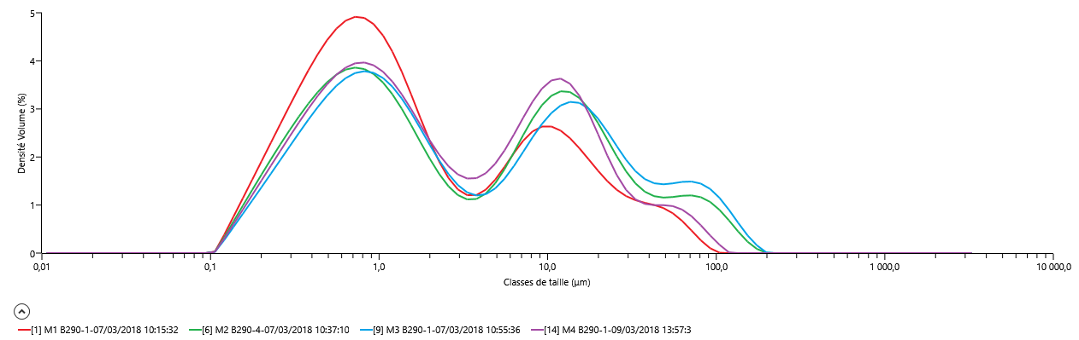
120°C, 60g/L, 0,3L/h

120°C, 33g/L, 0,3L/h
140°C, 33g/L, 0,3L/h
120°C, 60g/L, 0,6L/h
Volume density (%)
Size range (µm)
Figure 1. Size distribution curves depending on some process parameters

It was also found out that initial size distribution has an impact on powder behavior during spray drying since powder GE15, which has a higher median size than the two other powders, was not agglomerated but only dried during the experiments. Indeed, no significant change in morphology before and after spray drying was noticed using the bifluid nozzle for this powder. On the contrary, the ultrasonic nozzle allows GE15 powder to form spherical agglomerates, which let think that this technology is less sensitive to the initial characteristics of the powders.
The de-agglomeration tests performed under air flow pressure variations using the Malvern MS3000 dispersing system show that the agglomerates were more or less strong depending on the initial powders and process conditions. Indeed, some spray-dried powders with the bifluid nozzle tend to de-agglomerate increasing the air pressure while nearly no changes were observed with agglomerated powders produced using the ultrasonic nozzle. The ability of re-agglomeration of powders was also investigated in wet conditions.
4. Conclusions
The impact of some spray drying process parameters such as temperature or suspension flow rate, as well as suspension parameters like alumina concentration or powder initial granulometry, was studied. It appears that temperature has an influence on the proportion of fine particles (and consequently the size distribution) more distinctly than the other process parameters using a bifluid geometry in the spray-drying process. Runs were also performed using a recent nozzle technology (ultrasonic system) showing promising results, especially when an initial coarse powder, not easily agglomerated with a conventional bifluid system is used. More robust alumina agglomerates, not easily dispersed in air flow, were then obtained using the ultrasonic nozzle. The ability of the spray-dried powder to de-agglomeration or re-agglomeration phenomena is also discussed in this work.

References
[1] F. Gomez and K. Saleh, « Mise en œuvre des poudres - Séchage par atomisation. Procédé », p. 19, 2012.
[2] P. Ramavath et al., « Flow properties of spray dried alumina granules using powder flow analysis technique », Adv. Powder Technol., vol. 24, nº 3, p. 667‑673, may 2013.
[3] O. Ozdikicierler et al., « The effects of spray drying process parameters on the characteristic process indices and rheological powder properties of microencapsulated plant (Gypsophila) extract powder », Powder Technol., vol. 253, p. 474‑480, febr. 2014.
[4] S. Poozesh et al, « Assessment of predictive models for characterizing the atomization process in a spray dryer’s bi-fluid nozzle », Chem. Eng. Sci., vol. 180, p. 42‑51, apr. 2018.
[5] R. Rajan and A. B. Pandit, « Correlations to predict droplet size in ultrasonic atomisation », Ultrasonics, vol. 39, nº 4, p. 235‑255, june 2001.

