Reactive crystallization of Ca and Mg carbonates by CO₂ fine bubble injection into concentrated brine –Effects of solution pH and temperature–
Yoshinari Wada¹, Koji Masaoka^{1,2}, Yukikazu Takashima¹, Toshihiko Hiaki¹,
Masakazu Matsumoto^{1*}
1 College of Industrial Technology, Nihon Universiry, 1-2-1 Izumi-cho Narashino, Japan
2 Research Institute of Salt and Sea Water Science, The salt Industry Center, 4-13-20 Sakawa, Odawara, Japan
*Corresponding author: matsumoto.masakazu@nihon-u.ac.jp
Highlights
- Dolomite is selectively crystallized at pH of 5.3–6.8 and temperature of 273–298 K.
- Aragonite with high selectivity is obtained in range over 333 K at pH of 5.3 and 6.0.
- Mg(OH)₂ as by-product is produced besides carbonates in pH range over 7.8 at 298 K.

1. Introduction
So as to build up a utilization system of seawater resources based on the salt production process, a recovery and upgrading method for calcium (Ca) and magnesium (Mg) from the discharge concentrated brine of salt manufactory in Japan was studied. From the viewpoint of solubility of salts, the synthesis of carbonate by reactive crystallization between the dissolved Ca²⁺ and Mg²⁺ in concentrated brine and CO₂ can be considered as an effective separation/recovery method. In this study, the production regions of Ca and Mg carbonates from the concentrated brine were classified for operational parameters during the reactive crystallization using the minute gas-liquid interfaces around CO₂ fine bubbles as novel reaction fields where the crystal nucleation proceeds predominantly. In the regions near the gas-liquid interfaces of CO₂ fine bubbles, the local increase in the concentrations of Ca²⁺, Mg²⁺, and CO₃²⁻ caused by the electric charge on fine bubble surface and the acceleration of CO₂ mass transfer owing to minimizing the bubble diameter [1]. In this paper, we report that the effects of the solution pH and reaction temperature (T_{r}) on the selectivity of Ca and Mg carbonates during reactive crystallization from the concentrated brine with CO₂ fine bubble injection.
2. Experimental
2.1 Concentrated brine The concentrated brine discharged from salt manufacture was used. In Japan, NaCl is manufactured by evaporative crystallization after concentrating seawater through an electric dialysis membrane, and the concentrated brine that removed K⁺ by cooling crystallization is obtained concurrently with KCl. The major components of the above concentrated brine are MgCl₂, NaCl and CaCl₂, which have the concentrations of 2.1, 0.8, and 0.7 mol/L, respectively.
2.2 Experimental apparatus CO₂ fine bubbles were continuously supplied to 300 mL of the concentrated brine, and CaMg(CO₃)₂ was crystallized in a crystallization vessel. CO₂ fine bubbles with an average bubble diameter (d_{bbl}) of 40 µm were generated using a self-supporting bubble generator by increasing the impeller shear rate under reduced pressure [1], with the rotation rate maintained at 1500 min^{–1} and the CO₂ flow rate controlled at 11.9 mmol/(l·min).
2.3 Experimental procedure The initial solution pH in concentrated brine was adjusted at a specified value of 4.3–8.3 by adding 4.0 mol/l–NaOH or 1.0 mol/l–HCl solution, and the solution pH during reactive crystallization was maintained constant at a set value by adding 4.0 mol/l–NaOH solution. T_{r} varied in the range between 278 and 348 K using a thermostat bath, and the reaction time (t_{r}) was controlled within 60 min. After the crystallization progressed for a specified length of time, the suspension was filtered and the reaction products were washed with deionized water and then dried at 373 K in a dryer. The selectivity of solid products was identified by the peak area ratio from X-ray diffraction.
3. Results and discussion
The selectivity of solid products at a t_{r} of 60 min plotted against solution pH and T_{S} is shown in Figure 1. At a pH of 5.3–6.8 and T_{S} of 278–298 K, the dolomite (CaMg(CO₃)₂) crystallization proceeded dominantly. When T_{S} increased to 333 K at pH of 5.3 and 6.0, aragonite CaCO₃ as the dominant product was obtained. At a constant T_{S} of 298 K, aragonite CaCO₃, CaMg(CO₃)₂, and Mg(OH)₂ were simultaneously obtained in the pH range over 7.8, and the selectivity of Mg(OH)₂ became high at a pH of 8.3.
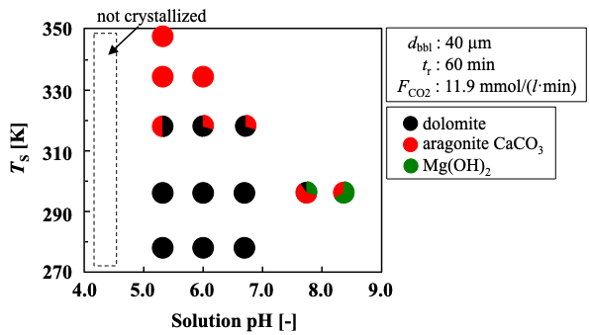
Figure 1. Effects of solution pH and T_{S} on the selectivity of solid products.
4. Conclusions
The production regions of Ca and Mg carbonates from the concentrated brine by fine bubble injection were classified by the solution pH and T_{S}. Consequently, the production of CaMg(CO₃)₂ with high selectivity was confirmed at a pH of 5.3–6.8 and T_{S} of 278–298 K. The aragonite CaCO₃ was preferentially produced in the T_{S} range over 333 K at pH of 5.3 and 6.0. When the solution pH was greater than 7.8 at a constant T_{S} of 298 K, not only CaMg(CO₃)₂ and aragonite CaCO₃ but also Mg(OH)₂ as a by-product was precipitated.
Acknowledgments
This work was financially supported by the Salt Science Research Foundation (Nos. 17A3, 18A3), Japan. We also acknowledge the Naikai Salt Industry Co., Ltd. for provision of Bittern.
References
- M. Matsumoto, T. Fukunaga, K. Onoe, Chem. Eng. Res. Des. 88 (2010) 1624–1630.

