**Selecting concentrated seawater in salt manufacturing process for CaMg(CO3)2 production by CO2 fine bubble injection**

Masakazu Matsumoto1*, Yoshinari Wada1, Yuko Tsuchiya1,

Koji Masaoka1,2, Toshihiko Hiaki1

*1 College of Industrial Technology, Nihon University, 1-2-1 Izumi-cho Narashino, Japan*

*2 Research Institute of Salt and Sea Water Science, The salt Industry Center, 4-13-20 Sakawa, Odawara, Japan*

*\*Corresponding author: matsumoto.masakazu@nihon-u.ac.jp*

**Highlights**

* Fine bubble injection into the removed K brine is well suited for dolomite production.
* Production of dolomite accelerates with an increase in Ca and Mg concentrations.
* High CO2 flow rate accelerates the crystallization of dolomite with higher Mg/Ca ratio.

**1. Introduction**

In the Japanese salt manufacturing process as one of the utilization system of seawater resources, the electrodialysis (ED) brine is obtained after concentrating seawater through an electric dialysis membrane. Thereafter, the concentrated brine is prepared by secondary concentration of ED brine using the evaporation operation up to the crystallization point of NaCl. Finally, NaCl is manufactured by evaporative crystallization from the concentrated brine, and then the removed K brine that separated KCl by cooling crystallization is obtained. In order to streamline the salt manufacturing process, a novel recovery and upgrading method for calcium (Ca) and magnesium (Mg) from the discharge concentrated seawater of salt manufactory is indispensable. In this study, we used the minute gas-liquid interfaces around CO2 fine bubbles as new reaction fields where the crystal nucleation proceeds dominantly and selected the suitable concentrated seawater for synthesizing the dolomite (CaMg(CO3)2) with a high Mg/Ca ratio. Three concentrated seawater as ED brine, concentrated brine, and removed K brine coming from salt manufacture discharge each have a different concentration product of Ca2+ and Mg2+ ([Ca2+][Mg2+]). In this paper, we report the effects of [Ca2+][Mg2+] as one of operational index and *F*CO2 on the reactive crystallization of CaMg(CO3)2.

**2. Experimental**

**2.1 Concentrated seawater** The ED brine, concentrated brine, and removed K brine coming from salt manufacture discharge in Japan was used. The major ion components of each concentrated seawater are shown in **Table 1**. The concentration ratio of Mg2+ for Ca2+ in the ED brine, concentrated brine, and removed K brine was approximately equal to 3.

**2.2 Experimental apparatus** The semi-batch type crystallization apparatus consists a gas flow controller, a pH/EC meter, a self-supporting bubble generator, a crystallization vessel, and a thermostatic bath. CO2 fine bubbles with an average bubble diameter (*d*bbl) of 40 µm were generated using a self-supporting bubble generator by the shear of the impeller and a negative pressure owing to high-rotation [1], with the rotation rate maintained at 1500 min–1 and the CO2 flow rate (*F*CO2) controlled in the range of 5.96 – 23.8 mmol/(*l*·min).

**2.3 Experimental procedure** CO2 fine bubbles with *d*bbl of 40 µm were continuously supplied to 300 m*l* of ED brine, concentrated brine, or removed K brine in a crystallization vessel and the reactive crystallization of CaMg(CO3)2 was performed. The reaction temperature was maintained constant at 298 K using a thermostatic bath, and the reaction time (*t*r) was controlled within 60 min. The solution pH during reactive crystallization was monitored and constantly adjusted to 6.8 by adding 4.0 mol/*l*-NaOH aqueous solution. The selectivity of solid products was identified by the peak area ratio from XRD and the Mg/Ca ratio of CaMg(CO3)2 was estimated from the amount of peak shift between calcite CaCO3 (2θ = 29.4°) and CaMg(CO3)2 (2θ = 30.7°) [1,2].

**3. Results and discussion**

**T**he relationships between [Ca2+][Mg2+] and the production rates of aragonite CaCO3 (*r*aragonite) and CaMg(CO3)2 (*r*dolomite) or the rate of increase in the Mg/Ca ratio of CaMg(CO3)2 (*r*Mg/Ca) as a function of *F*CO2 are shown in **Figure 1**. At a ln [Ca2+][Mg2+] of -6, aragonite CaCO3 and CaMg(CO3)2 were obtained irrespective *F*CO2. *r*dolomite and *r*Mg/Ca increased with an increase of [Ca2+][Mg2+] in the concentrated seawater, and the dependence of [Ca2+][Mg2+] on *r*dolomite and *r*Mg/Ca was increased with an increase in *F*CO2. Consequently, when the removed K brine with a high [Ca2+][Mg2+] was used, the increase in *F*CO2 is effective for the high-yield crystallization of CaMg(CO3)2 with higher Mg/Ca ratio.

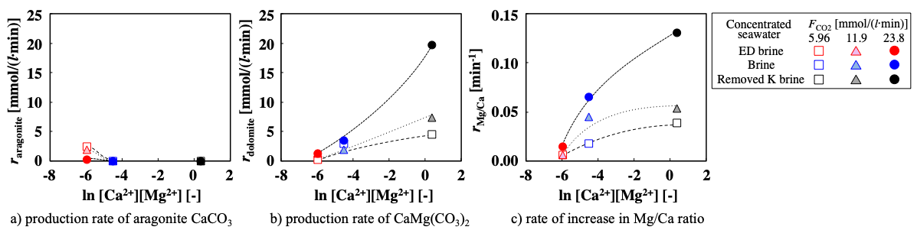

**Figure 1.** Relationships between [Ca2+][Mg2+] and *r*aragonite, *r*dolomite, or *r*Mg/Ca at various *F*CO2 values.

**4. Conclusions**

In order to select the concentrated seawater in salt manufacturing process in Japan for the production of CaMg(CO3)2 with a high Mg/Ca ratio, CO2 fine bubbles were supplied into the three concentrated seawater discharged from salt manufacturing process and CaMg(CO3)2 was crystallized. In the case where the removed K brine with a high [Ca2+][Mg2+] was selected at greater *F*CO2, CaMg(CO3)2 with higher Mg/Ca ratio can be produced by the reactive crystallization with briefer period.

**Acknowledgments**

This work was financially supported by the Salt Science Research Foundation (Nos. 17A3, 18A3), Japan. We also acknowledge the Naikai Salt Industry Co., Ltd. for provision of Bittern.

**References**

1. Y. Tsuchiya, Y. Wada, T. Hiaki, K. Onoe, M. Matsumoto, J. Cryst. Growth 469 (2016) 36–41.
2. T. Oomiri, Y. Kitano, Geochem. j. 21 (1987) 59–65.