**Bio-ethanol a building block of the future.**

Elio Santacesaria*,1, Riccardo Tesser2, Martino Di Serio2

*1 Eurochem Engineering srl, Milano, Italy; 2 Dipartimento di Scienze Chimiche Università di Napoli, Italy*

*\*Corresponding author: info@eurochemengineering.com,www.eurochemengineering.com*

1. **Introduction**

Bio-ethanol production is growing in different countries for the convenience of using it as biofuel. It is well known that an intensive use of a raw material, as a vector of energy, promotes the use of the same material for the production of chemicals as occurred in the past for coal and petroleum originating respectively carbochemistry and petrochemistry. Ethanol can easily be transformed in other useful molecules such as, for example: ethylene by dehydration, acetic acid by oxidation, ethyl acetate or acetaldehyde by dehydrogenation. Bio-ethanol could become, therefore, a building block allowing the production of acetic acid derivatives with simple processes occurring in mild conditions. The mentioned processes require the improvement or development of opportune catalysts able to increase the yields of the desired products.

**2. Methods**

The kinetic runs have been carried out in a packed bed tubular reactor, alternatively filled with 2 or 50 g of catalyst, approximately isothermal, by feeding pure ethanol together with a mixture of nitrogen and hydrogen as carrier gas. Kinetic runs have been made by changing the temperature, in the range of 200-260°C, the pressure between 10 and 30 bars and the space time from 1 to 100 (g.h.mol-1). We have verified, at first, that inter-phase and intra-phase mass transfer limitations were negligible in the adopted conditions.

**3. Results and discussion**

Catalysts promoting ethanol dehydration to ethylene and ethanol oxidation to acetic acid will be reviewed together with the operative conditions and related performances. A particular attention will be devoted to the reaction of ethanol dehydrogenation to obtain ethyl acetate [1], in one step reaction in the presence of the commercial catalyst: CuO/Cu/CuCr2O4/Al2O3/BaCrO4 pre-reduced catalyst (BASF Cu-1234-1/16-3F). The mentioned catalyst has been reduced with hydrogen before the use and tested in a fixed bed laboratory reactor by feeding ethanol in a stream of H2 diluted in N2 (H2/N2=6/94 mol/mol), by exploring a temperature range of 200-260°C and a pressure range of 10-30 bars. This catalyst has shown high activity, selectivity and thermal stability. The best results have been obtained by operating at 220-240°C, 20 bars and 98 (grams hour/mol) of ethanol contact time, corresponding to 65% of conversion and 98-99 % of selectivity to ethyl acetate. The conversion is the maximum obtainable at the equilibrium and the selectivity is the highest value obtained until now for this reaction. Therefore, this catalyst is a good candidate for developing a new process to produce ethyl acetate. It is important to point out that the same catalyst allows to obtain also acetaldehyde in a good yield just reducing the pressure in the reactor [2]. At last, it is worth of mention that this process has the advantage to produce pure hydrogen (exempt of CO) as by-product useful to be employed in the fuel cells [2]. A detailed kinetic [3] approach for this catalytic process has been made giving interesting suggestions about the reaction scheme and mechanism:

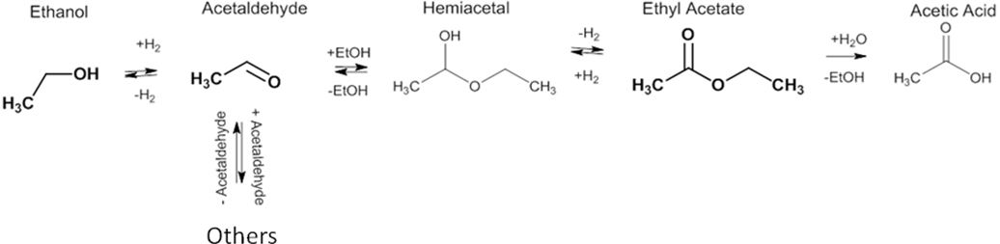



A Langmuir-Hinshelwood-Hougen-Watson kinetic model has been used for interpreting all the experimental data collected. This model corresponds to a mechanism in which the first step is the dissociative adsorption of ethanol on the surface, giving an adsorbed ethoxy group. Then, two other consecutive steps give place to respectively acetaldehyde as intermediate and ethyl acetate. This kinetic model allows a satisfactory fitting of all the performed experimental runs with a standard error below 15% for the runs performed with 2g of catalyst and less than 12% for the runs made with 50 g of catalyst.

1. **Conclusions**

Ethanol can give place to different interesting reactions and become a building block for producing some different commodities provided that its cost as fuel decreases at a competitive level. Clearly catalysis plays a fundamental role in promoting new innovative processes like the ones described in this presentation

**References**

[1] E. Santacesaria, G. Carotenuto, R. Tesser, M. Di Serio; Ethanol Dehydrogenation to Ethyl Acetate by

Using Copper and Copper Chromite Catalysts; Chemical Engineering Journal ; 179 (2012) 209-220.

[2] G. Carotenuto, R. Tesser, M. Di Serio, E. Santacesaria; Bioethanol as feedstock for chemicals such as

acetaldehyde, ethyl acetate and pure hydrogen; Biomass Conversion and Biorefinery (2013) 3, 55-67

[3] G. Carotenuto, R. Tesser, M. Di Serio, E. Santacesaria; Kinetic study of ethanol dehydrogenation to ethyl

acetate promoted by copper/copper-chromite based catalysts; Catalysis Today 203(2013)202-210.