**Coalescence modelling for settler design**

David Leleu, Andreas Pfennig

*University of Liège, Department of Chemical Engineering - Products, Environment, and Processes (PEPs), Quartier Agora, Allée du six Août, 11, Liège, Belgium,]*

*dleleu@uliege.be, andreas.pfennig@uliege.be*

**Highlights**

* single-drop based (ReDrop) concept to predict the settling of liquid dispersion for settler design
* consistent coalescence model for ReDrop, developed on the fundamental analysis of the phenomena
* Settling experiments with iso-optical system used to validate the model

**1. Introduction**

Continuous and batch settlers are used in processes in order to separate liquid-liquid dispersion. Their design can be challenging, e.g. quantitatively predicting the remaining fraction of fine drops found at settler outlet as function of the operating conditions. For batch settler design, a numerical tool has been developed, which is based on considering the behavior if individual representative drops (ReDrop concept) [1]. This tool, which applies a Monte-Carlo method to solve the drop-population balances, allows to simulate the separation of liquid-liquid dispersions and thus to optimize the design of continuous settlers. Sedimentation and coalescence are evaluated for a sufficiently large ensemble of representative individual drops at each time step. The information obtained is then collected to determine e.g. the required settler size. In these simulations, the coalescence modeling is a major challenge due to the complex interactions of drops upon approach and coalescence.

**2. Coalescence model**

As shown in Figure 1, the probability that two drops coalesce depends on three contributions. The first is the frequency with which they meet, defined by the so-called collision rate. The second parameter is the bouncing probability. It characterizes the probability that the drops stay in contact during the time following the collision. If they are not, the collision leads to the direct bouncing without any chance to coalesce. The final variable influencing the coalescence probability is the efficiency with which the drops coalesce once they met. The coalescence efficiency in turn depends on the time, during which the drops stay in contact and the time they would need to coalesce. The developed equation describing the coalescence efficiency is fundamentally different from the model of Coulaloglou and Tavlarides, which is inconsistent at a basic level.

It turns out that solely the fluid dynamics of the regarded equipment determines the frequency with which drops meet, the bouncing probability and the time they stay in contact. The differences in equipment to which this model is applied characterize the fluid dynamics, which thus has to be characterized only once for a given type of equipment. The time the drops need to coalesce on the other hand only depends on the specific material system used [2].

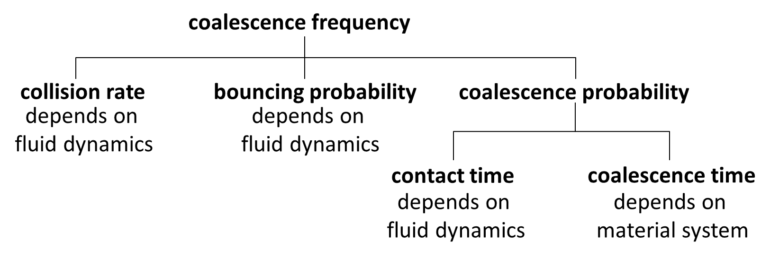

**Figure 1.** Coalescence model developed

**3. Experimental device**

The coalescence time can be evaluated experimentally from any suitable settling experiment. Here the experiments are conducted in the standardized settling cell proposed by Henschke [3]. It consists of a glass vessel with a capacity of 800ml, with 2 shafts for stirring with 4 stirrers on each shaft. A SOPAT probe is used to measure the drop-size distribution in situ. Iso-optical two-phase systems are analyzed and the settling after dispersing followed over the time. A dye present in one of the two phase allows to measure the local holdup. The experimental results are used to validate the model and the numerical approach.

**4. First results and outcome**

First experiments were performed with a system of paraffin oil droplets dispersed in water. The results depicted in Figure 2 show on the right hand side a simulation performed with the ReDrop program. The model parameters were fitted in order to follow the experimental data shown by the black dots. The latter represent the sedimentation and the coalescence curves observed visually from the movie recording of the settling experiment. The initial drop-size distribution used in the simulation was measured with the SOPAT probe. It is represented on the left side of Figure 2.

This results of the ReDrop simulation is in good agreement with the experimental data and shows good basis for the further experiments, detailed evaluation, and model validation using iso-optical systems.

Figure 2. Fitting of experimental results (right) with the initial drop-size distribution measured with the SOPAT probe (left)

**References**

1. J. Ayesteràn, N. Kopriwa, F. Buchbender, M. Kalem, A. Pfennig, Chem Ing. Tech., 38, (2015) 1894-1900.
2. N. Kopriwa, A. Pfennig, Solvent Extraction and Ion Exchange, 34, (2016) 622-642.
3. M. Henschke, L. H. Schlieper, A. Pfennig, Chem. Eng. J., 85 (2002), 369-378.