Considering the Entire Turbulence Spectrum in Breakage and Coalescence Kernel Formulation.
Simone Castellano^{1,2}, Lorenzo Carrillo¹, Nida Sheibat-Othman², Daniele Marchisio³, Antonio Buffo³, Sophie Charton^{1*}
1 CEA, DEN, Research Department on Mining and Fuel Recycling Processes, SA2I, Bagnols-sur-Cèze, France;
2 Université Claude Bernard Lyon 1, CNRS, UMR 5007, LAGEP, 43 b 11 Novembre 1918, Villeurbanne, France
3 Politecnico di Torino, DISAT, Corso Duca degli Abruzzi 24, Torino, Italy
*Corresponding author: sophie.charton@cea.fr
Highlights
- 0D Population Balance Equation model.
- Breakage and Coalescence kernels formulation.
- Second order structure function accounting for the entire turbulence spectrum.

1. Introduction
Liquid-liquid extraction is a common unit operation in the chemical, food, pharmaceutical and nuclear industries. In order to optimize and control this operation, the knowledge of the droplet size distribution or the Sauter mean diameter is needed. These two properties could be determined through the Population Balance Equation (PBE), whose accurate solution depends on the modeling of its source terms, i.e. the breakage and coalescence kernels. The kernels are of fundamental importance since they express the number of droplets breaking or coalescing per unit time. In the case of turbulent dispersions, these models generally assume the droplets to have dimension in the inertial subrange of turbulence, where the Kolmogorov theory applies. Therefore, shear stresses and characteristic times are expressed in agreement with the results of this theory. However, since in a solvent extraction process the droplet diameter varies from microns to millimeters, many droplets will have dimension in other turbulence ranges (Dissipation, Energy-containing). Therefore, general breakage and coalescence models that account for the entire spectrum of turbulence are proposed and experimentally validated.
2. Methods
Coulaloglou and Tavlarides proposed breakage and coalescence kernels considering the droplet to have dimension in the inertial subrange of turbulence. In this work, these models are extended to the entire turbulence spectrum implementing the second-order structure function (SOF) proposed by Davidson [1]:
$$〈{\left[∆u(r)\right]}^{2}〉≈\frac{4}{3}\int_{0}^{∞}{E\left(κ\right)\left\{1-3\left[\frac{\sin\left(κr\right)}{{\left(κr\right)}^{3}}-\frac{\cos\left(κr\right)}{(κr)²}\right]\right\}dκ}$$
The Pope energy spectrum $E\left(κ\right)$ [2] is considered, since it accounts for the eddy energy distribution in the entire turbulence spectrum. This model depends on the continuous phase viscosity and the turbulent dissipation rate ε. This latter is usually not uniform in the liquid-liquid contactor. Therefore, in the employed 0D PBE model, the ε inhomogenenities were considered through a probability density function obtained from CFD simulation [3]. Finally, the proposed kernels were tested on turbulent liquid-liquid dispersion experiments performed in a stirred tank of 1L volume equipped with a Mixel-TT impeller. Distilled water was used as the dispersed phase, while the continuous phase consisted of a mixture of Isane 175 (1.2 cP) and Marcol 82 (12 cP). The experiments were carried out at varying impeller rotation speeds (600-700-800rpm), dispersed phase volume fractions (1-2%) and continuous phase viscosities (1.2 – 4.1 cP).
3. Results and discussion
The results of the general model (Fig. 1, green) were compared to the ones of the previous model (dashed blue) based on the inertial subrange assumption [3]. At 1.2 cP (pure Isane, left), both models were able to predict the time evolution of the Sauter mean diameter. At 2.4 cP (Isane 70%-Marcol 30%, centre) and 4.1 cP (Isane 70%-Marcol 30%, right), while the simulations based on the general model are in good agreement with the experimental data, the original model underestimate the Sauter mean diameter. Indeed, at higher viscosities, the inertial subrange of turbulence is reduced and most of the droplets have dimension in the Dissipation subrange. In this subrange, the dampening effect of the continuous phase viscosity on the eddy turbulent kinetic energy is more and more important approaching the Kolmogorov scale. Therefore, the model based on the inertial subrange assumption, which do not account for the continuous phase viscosity effects, overestimates the turbulent kinetic energy of the eddies and consecutively the breakup rate.
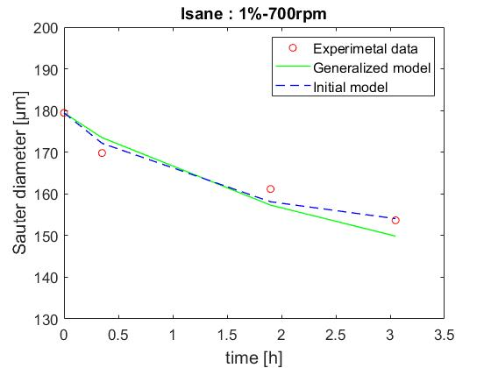 | 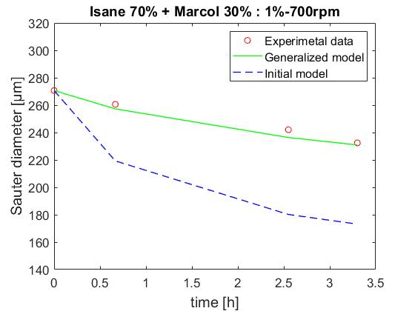 | 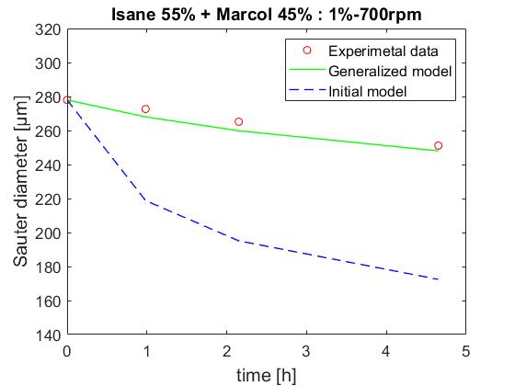
Figure 1. Caption. [Calibri 9].
4. Conclusions
In this work, general breakage and coalescence kernels, accounting for the entire spectrum of turbulence, are proposed. The new model is based on a refined second-order structure function and an energy spectrum considering all the domains of turbulence. The model shows good agreement with experimental data measured in liquid-liquid dispersions at increasing viscosity.
References
- A. P. Davidson, Turbulence: an introduction for scientists and engineers, Oxford University Press, 2004.
- S. B. Pope, Turbulent flows, Cambridge University Press, 2000.
- S. Castellano, N. Othman, D.L. Marchisio, A. Buffo, S. Charton, Chem. Eng. J. 354 (2018), pp. 1197-1207.
- S. Castellano, L. Carrillo, N. Othman, D.L. Marchisio, A. Buffo, S. Charton, Chem. Eng. J. (2019), accepted

