Efficiency and durability of a bioactive coating in formaldehyde degradation
Cristiana C. Castro¹, Tangi Senechal², Julian Viseur¹, Ducoulembier Aline², Driss Lahem², Anne-Lise Hantson¹
¹ Chemical and Biochemical Process Engineering Unit, UMONS, Mons, Belgium; ² Materia Nova, Materials Science Unit, Mons, Belgium
*Cristiana C. Castro: cristianacordeirodecastro@umons.ac.be
Highlights
- Bacterial cells immobilized in sol-gel coatings were able to degrade formaldehyde.
- Sol-gel coatings containing PEG enhanced the enzymatic degradation of formaldehyde.
- Formaldehyde was efficiently degraded by coatings kept at room temperature during 5 weeks.
- Coatings storage at 37°C decreased formaldehyde degradation ability.

1. Introduction
After the energy crisis of the 90’s, new energy conservation measures were adopted in peoples’s lifestyles at home and work places. Energy-efficient housing rapidly brought new building materials, interior decoration and consumer products, such as composite wood, foams and plastics, synthetic carpets and households products. These changes have increased the diversity and concentration of pollutants in the indoor air [1], mainly the volatile organic compounds (VOCs) [2]. Formaldehyde is an oxygenated-VOCs, widely used in construction materials, wood processing, furniture, textiles, carpeting, and chemical industries. It is classified as a human carcinogen and it has been given more attention in particular of its adverse effect in health [3], and so, its removal is of widespread interest. The development of bioactive coatings incorporating biomolecules able to capture and degrade this toxic compound is of major interest. It is herein presented the study of the efficiency of hydrophilic sol-gel coatings, easily prepared at low-temperature, incorporating PEG in the formulation to retain a large content of water, and so, improve cells viability and maintain enzymes activities [4]. The conservation of enzymes stability throughout time is of great importance for industrial application of the bioactive coatings.
2. Methods
Hydrophilic sol-gel coatings were prepared using a mixture of 3-glycidoxypropyltrimethoxysilane (GPTMS) and tetraethoxysilane (TEOS) and freeze-dried bacterial cells of Pseudomonas putida ATCC 47054. Different ratios of precursors and cells were tested in the presence or absence of the hydrogel polymer polyethylene glycol (PEG) in the coating. Eight coatings formulations were prepared (Table 1). Coatings were applied by spraying to a surface of a thin-layer chromatography (TLC) paper. After 24 h the paper was stored at room temperature and 37°C to evaluate formaldehyde efficiency throughout storage time. Every week, during 5 weeks, the coated paper was put in contact with the reactional mixture in aqueous solution containing formaldehyde and a co-factor NAD⁺. Formaldehyde degradation was quantified by a colorimetric method using the NASH reagent during 48 h.
3. Results and discussion
After 48 h of reaction with the formaldehyde, bacterial cells incorporated in the sol-gel matrices were able to degrade formaldehyde in the surface (Figure 1). Series 1, 2, 7 and 8 obtained the best degradation yields (85, 80, 78 and 85%, respectively) after 24 h of deposition, compared to the others (30%, in average). After 5 weeks of storage at room temperature, formaldehyde degradation yields for the same series were 94, 53, 75 and 45% and the remaining series obtained 13.5% in average. A small decrease was generally verified, except for serie 1 that kept the highest degradation yield. The presence of PEG in serie 1 allowed the retention of large contents of water that improved the activity of formaldehyde-degrading enzymes, which were present in high concentration (40% (w.w⁻¹) of cells). After 5 weeks of storage at 37°C, formaldehyde degradation yield was about 10% in average for all the series. Storage temperature decreased the enzymatic activity needed for the transformation of formaldehyde.
 | Sol-gel | PEG (g) | Cells conc. (% w.w⁻¹)
Serie 1 | 90-3 | 8 | 40
Serie 2 | 90-3 | 0 | 40
Serie 3 | 90-1 | 8 | 30
Serie 4 | 90-1 | 0 | 30
Serie 5 | 90-3 | 0 | 30
Serie 6 | 90-1 | 0 | 40
Serie 7 | 90-3 | 8 | 30
Serie 8 | 90-1 | 8 | 40
Table 1. Sol-gel coatings formulations
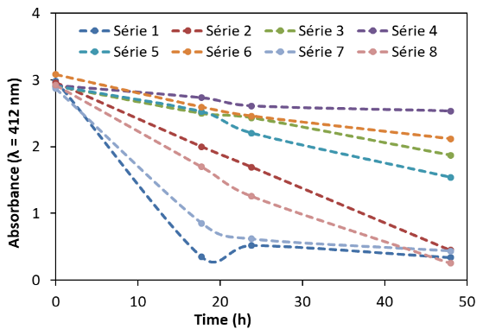
Figure 1. Enzymatic degradation of formaldehyde by coated paper.
4. Conclusions
Bioactive coatings containing freeze-dried bacterial cells were efficient in formaldehyde degradation in solution. The presence of PEG in the sol-gel improves the enzymatic degradation of the pollutant. Formaldehyde degradation efficiency can be kept by storing sol-gel coatings at room temperature.
References
- B. Guieysse, C. Hort, V. Platel, R. Munoz, M. Ondarts, S. Revah, Biotechnol. Adv., 26, 2008, 398-410.
- T. Salthammer, S. Mentese, R. Marutzky, Chem. Rev., 110(4), 2010, 2536-2572.
- A. Roca, J.J. Rodríguez-Herva, E. Duque, J.L. Ramos, Microb. Biotechnol., 1, 2008, 158–169.
- V.B. Kandimalla, V.S. Tripathi, H. Ju, Crit Rev Anal Chem., 36, 2006, 73-106.

