A Manganese Modified Fe₃O₄ Microsphere Catalyst with Effective Active Phase of Forming Light Olefins From Syngas.
Yi Zhang* and Yi Liu
1 ªState Key Laboratory of Organic-Inorganic Composites, Beijing University of Chemical Technology, Beijing, 100029, China
*Corresponding author: yizhang@mail.buct.edu.cn
Highlights
- The MnOx dispersed on the surface of Fe3O4 microsphere.
- The unique promoter-on-iron structure of obtained catalyst.
- The θ-Fe3C phase plays crucial roles in enhancing the light olefins selectivity.

1. Introduction
Light olefins (C₂-C₄) are key building blocks of the chemical industry and typically produced by steam cracking naphtha [1]. The direct conversion of syngas into light olefins via the Fischer-Tropsch synthesis (FTS) process is a promising route to meet the increasing demand for chemical feed-stocks [2]. It is well know that iron carbide is recognized as the active phase for the FTS reaction [3]. Herein, a manganese modified Fe₃O₄ microsphere catalyst was developed as illustrated in Figure 1A, where the MnOx dispersed on the surface of Fe₃O₄ microsphere to avoid the porous structure and solely modify the carburization of the catalysts.
2. Methods
The Fe₃O₄ microspheres were prepared by a solvothermal method [4]. For preparation of Mn/Fe₃O₄ catalyst, in order to improving the dispersion of supported Mn, an ethylene glycol solution of Mn(NO₃)₂•4H₂O was impregnated onto the Fe₃O₄ microspheres [5], followed by drying at 473 K under vacuum. The obtained catalysts were characterized by STEM-Mapping, HRTEM, XAFS, XPS, and Mössbauer spectroscopy.
3. Results and discussion
Figure 1B shows SEM image of the Fe₃O₄ microspheres, which possess uniformly spherical shape of ~300 nm. N₂ adsorption-desorption isotherms show representative type-Ⅱ curves, which is normally obtained with non-porous adsorbents [6]. Meanwhile, it was found that the MnO_{x} located at the edge of Fe₃O₄ microspheres as shown in Figure 1C. Hence, MnO_{x} should locate on the surface of the Fe₃O₄ microspheres as designed. It is considered that this unique promoter-on-iron structure of obtained catalyst would contribute to enhancing the promotional effects of manganese and clarifying the different role of iron carbides.
The prepared Fe₃O₄ microsphere catalysts were applied to FTS reaction for 50 h under 1.0 MPa, 593 K, and H₂/CO ratio of 1. The Mn/Fe₃O₄ catalyst with moderate amount of Mn (6 wt %) exhibits the best C₂-C₄ olefins selectivity (60.1 %) and lowest CH₄ selectivity (9.7 %) with better stability compared with un-promoted Fe₃O₄ catalyst. The unprecedented efficiency of converting syngas to light olefins could be attributed to the special surface carbonaceous species, as confirmed by in situ XPS. The results on the activated catalysts show that the presence of significantly different surface carbonaceous species, and the charge of surface carbon atom was influenced by the Mn promoter. It is proposed that a specific carbide phase could be formed on the surface of Fe₃O₄ microsphere due to the presence of Mn promoter. This is also confirmed by Mössbauer spectroscopy and EXAFS. As shown in Mössbauer spectroscopy (Figure 2), a new carbide phase, identified as cementite (θ-Fe₃C), was discerned when Mn was added. Fourier transforms of the EXAFS spectra at the Fe K-edge (Figure 1D) show that, the Fe formed another carbide phase, θ-Fe₃C, in addition to χ-Fe₅C₂. Thus, it is reasonable to conclude that the θ-Fe₃C phase plays crucial roles in enhancing the light olefins selectivity.
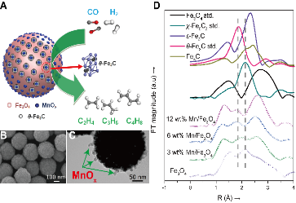
Figure 1 (A) Structural model for the Mn/Fe3O4 catalyst; (B) SEM images of the fresh Fe3O4 microspheres; (C) TEM images of the 6 wt % Mn/Fe3O4 catalyst after reduction; (D) Fourier transformed (FT) k3-weighted χ(k)-function of the EXAFS spectra. Solid lines denote reference samples of Fe3O4, χ-Fe5C2, ε-Fe3C, θ-Fe3C and Fe4C.
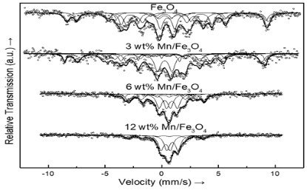
Figure 2 Mössbauer spectra of the iron-based catalysts after reduction.
4. Conclusions
The non-porous structure combined with dispersed manganese on the Fe₃O₄ microsphere surface contributes to enhancing the promotional effects of Mn and clarifying the different role of iron carbides. It was found that the θ-Fe₃C plays important role to enhance the selectivity of C₂-C₄ olefins during the FTS reaction.
References
[1] B. Hu, S. Frueh, H. F. Garces, L. Zhang, M. Aindow, C. Brooks, E. Kreidler, S. L. Suib, Appl. Catal. B, 2013, 132-133: 54.
[2] H. M. T. Galvis, J. H. Bitter, C. B. Khare, M. Ruitenbeek, A.I. Dugulan, K.P. de Jong, Science. 2012, 335: 835.
[3] S. Li, R. J. O’Brien, G. D. Meitzner, H. Hamdeh, B. H. Davis, E. Iglesia, Appl. Catal. A 2001, 219: 215.
[4] J. Liu, Z. K. Sun, Y. H. Deng, Y. Zou, C. Y. Li, X. H. Guo, L. Q. Xiong, Y. Gao, F. Y. Li, D. Y. Zhao, Angew. Chem. Int. Ed. 2009, 48: 5875.
[5] Y. Liu, J. F. Chen, J. Bao, Y. Zhang, ACS Catal. 2015, 5: 3905.
[6] K. S. W. Sing, Pure. Appl. Chem. 1985,57: 603.

