A new heterogeneous organocatalyst for Knoevenagel Reaction process intensified by microwaves
Lilivet UBIERA ¹, Isabelle POLAERT ¹, Chandrashekhar RODE ², Sanjay JADHAV ², Dominique SEGUIN¹
1 Normandie University, INSA Rouen, LSPC, Laboratoire de Sécurité des Procédés Chimiques, EA 4704 - INSA Rouen, Avenue de l'Université – Saint-Étienne-du-Rouvray cedex 76801 France
2 Chemical Engineering and Process Development Division, CSIR-National Chemical Laboratory, Dr. Homi Bhabha Road, Pashan, Pune 411008, India

*Corresponding author: E-mail address: Isabelle.polaert@insa-rouen.fr
Tel: (33)-2-32-95-66-68 Fax: (33)-2-32-95-66-96
Highlights
- Heterogeneus organocatalyst under microwave heating
- Comparison between conventional and microwave heating for knoevenagel reaction
- Reuse of organocatalyst

1. Introduction
Sustainability in chemical synthesis is one of the main objectives nowadays, meant to be addressed by maximizing the industry production efficiency and minimizing the environmental costs. In order to develop an eco-friendlier relationship with our planet, the society has created new legislations which encourage the design of organic reactions using greener strategies such as the combination of microwave heating with effective, low cost and reusable catalysts.
One powerful and commonly used reaction for the formation of carbon-carbon bonds is the Knoevenagel condensation, an addition of a carbanion to an electrophilic carbonyl group in the presence of a weak base. Several reaction methodologies have been reported so far in literature and the interest is mainly focused on the development of environmentally and economically friendly reaction protocols. In this work, the Knoevenagel reaction was tested using 1,4-diabycyclo [2.2.2] octane (DABCO) an organic molecular catalyst (organocatalyst) which is attractive due to its easy reproducibility and low cost.
Various experimental conditions have been tested in order to obtain a greener protocol. The major drawback found was the difficulty to recycle the organocatalyst used due to its inherent instability and miscibility with solvents (2). To facilitate the reuse of the catalyst, the immobilization of DABCO over the mesoporous silica MCM-41 was done. To the best of our knowledge this was done for the first time in literature.
In this investigation, the objective was not only limited to a cleaner protocol but also extended to energy efficiency. The latter was achieved by coupling the process with microwave heating which resulted in a significant reduction in reaction time, precise control of temperature and hence better energy efficient. The combination of these techniques promise to be an interesting way to intensify Knoevenagel condensation based processes.
2. Methods
The knoevenagel condensation using 4-chlorobenzaldehyde and malononitrile as reagents to obtain 4-chlorobenzilidene malononitrile as a product, was done using organocatalysts as DABCO and DABCO supported on mesoporous silica-MCM 41, allowing to have a homogenous and heterogeneous medium of reaction. The reaction was tested both in microwave and classical heating. For the identification and quantification of reagents and products a GC-FID (Gas Chromatography-Flame Ionization Detection) is used. The given results are used to calculate the reaction yield in time.
3. Results and discussion
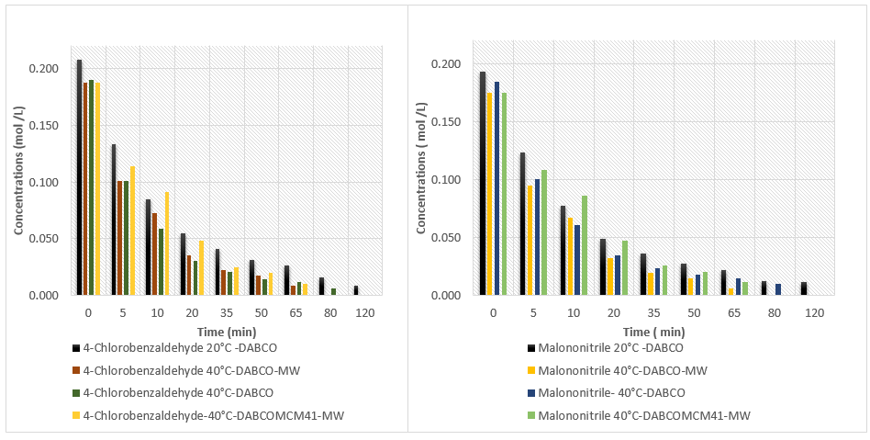
Graphic 1. Reagent’s Concentration evolution with time for different operational conditions (Malononitrile = 0,20 mol/L 4-Chlorobenzaldehyde=0,20 mol/L DABCO= 0,00217 mol/L Agitation = 8 Pressure: 1 atm) *MW= Microwave heating
This supported catalyst was tested under the conditions same as its homogenous analogue (DABCO), resulting in the same efficiency in addition to the fact that it could be recovered from the reaction mixture and reused without any significant loss of activity. Microwave heating was also compared to classical one.

4. Conclusions
A new heterogeneously supported DABCO catalyst has been developed for improving the Knoevenagel reactions. It allows easy recovery of the catalyst and its reuse, without any significant loss of activity which is a great improvement towards more sustainable processes. The combination of this type of catalysts with microwave heating is also promising by reduction of reaction time and cost, and by using a non-toxic and environmentally friendly reaction protocol.
References
[1] Bandala,et al. (2009). Optimized Methodologies in Asymmetric Organic Synthesis Applying Microwaves. J. Mex.Chem.Soc., 53(3), 147-154.
[2] Shaikh, I. R. (2014). Organocatalysis: Key Trends in Green Synthetic Chemistry, Challenges, Scope towards Heterogenization, and Importance from Research and Industrial Point of View. Journal of Catalysis(402860). doi:10.1155/2014/402860

