Experimental study and CFD simulation of a new reactor for hybrid catalysis.
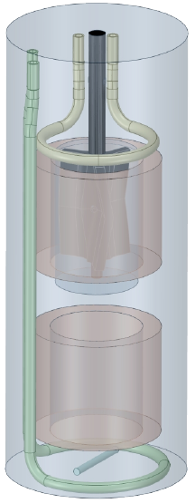
Figure 1: Scheme of the double-basket reactor

Myriam Frey¹, Léo Violet¹, Serge Simoëns², Dominique Richard^{1*}, Pascal Fongarland¹
1 LGPC UMR 5285 (CNRS, CPE Lyon, UCB Lyon 1), Université de Lyon, 3, rue Victor Grignard F-69616, Villeurbanne, cedex ; 2 LMFA UMR 5509 (CNRS, ECL, INSA Lyon, UCB Lyon 1), Université de Lyon, 36 av. G. de Collongues, F-69130 Ecully
*Corresponding author: dri@lgpc.cpe.fr
Highlights
- A new double-basket reactor for hybrid catalysis has been designed.
- A k_{L}.a of 0.035 s⁻¹ is achieved for O₂ gas-liquid transfer.
- Simulated flow field are compared with PIV derived experimental values.
- A.∆T of up to 15 K in the reactor is achieved through use of wall and coil T control.

1. Introduction
The use of enzymes in fine chemistry has been the subject of much research in the last decades. Among these works the concept of hybrid catalysis has recently emerged : the coupling of conventional chemical catalysis with enzymatic catalysis [1,2]. The aim of the GLYCYBRIDE project, on which this study is based, is to develop a synergy between enzymatic and heterogeneous catalysis in a one-pot reactor with the end-application of transforming glycerol into value-added chemicals.
The feasibility of a model one-pot reaction in three-phase hybrid catalysis, one step being an oxidation has been shown [3]. The model reaction proposed is a two-step reaction : an enzymatic catalyzed isomerization of fructose to glucose followed by a heterogeneously catalyzed oxidation of glucose to gluconic acid.
The aim of the present work is to study the design of a double-basket reactor allowing the implementation of the tri-phasic hybrid system. The main challenge lies in the optimal reaction conditions (temperature, hydrodynamics, substrate concentration) that differ between the different catalysis. The design of the reactor (Fig. 1) must thus allow the maintenance of some heterogeneity between the different reactive zones, while ensuring sufficient matter transfer between them.
2. Methods
The hydrodynamics of the reactor has been characterized by physical methods such as : kLa of O₂ measurement (dynamic method with O₂ probe), mixing time measurement and RTD (NaCl used as a tracer). PIV velocity measurements have also been performed to determine the velocity of the flow field in the different areas of the reactor.
A CFD modeling of the hydrodynamics and thermal behavior of the reactor has been carried out with the Fluent© software (Ansys) using the realizable k − ε turbulence model associated to Multiple Reference Frame model to deal with rotating parts [4].
3. Results and discussion
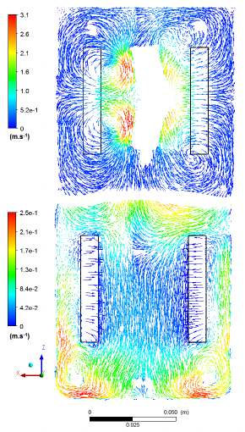
Figure 2: Flow fields on a vertical plane at y = 0 cm. Vector length is normalized. Stirring rates at 1100 rpm for the impeller, 300 rpm for the magnetic bar.
Values of kLa between 0.02 s⁻¹ and 0.035 s⁻¹ are measured, consistent with values of single basket reactor reported in the literature. Mixing times of 15 to 20 s are observed for stirring rates above 500 rpm, in good agreement with the one calculated by CFD simulation. RTD measurement showed a behavior very close to the one expected for an ideal CSTR.
The CFD simulation provided the values of velocities in the different parts of the reactor, with velocities reduced in the basket holding the catalysts as expected (Fig. 2). These values are discussed in relation with the experimental one derived from PIV measurements.
The simulation of the thermal behavior of the reactor showed that: (1) Influence of the coils is largely inferior compared to the reactor walls, (2) Magnetic bar stirring rate has a negative but very weak influence, (3) Impeller stirring rate has a negative influence, (4) A large temperature gap between cooling and warming temperatures is necessary (80-100 K) to obtain a gap of 10-15 K in the reactor.
4. Conclusions
A novel double-basket reactor designed for hybrid catalysis has been first characterized for its physical transfer properties such as k_{L}.a, mixing time and RTD and simulated using CFD. Values of k_{L}.a measured are consistent with values of single basket reactor reported in the literature. The CFD simulation provided the values of velocities in the different parts of the reactor which have been compared with PIV measurements. The mixing time obtained by simulation are similar to the experimental ones. The simulation of the thermal behavior of the reactor showed that it is possible to obtain two zones in the rector, a "cold" one and a "hot" one with a ∆T of up to15 K while keeping an efficient stirring allowing for good mass transfer.
References
- O, Långvik, T. Saloranta, D. Y. Murzin, R. Leino, ChemCatChem 7 (2015) 4004-4015
- F. R. Bisogno, M. G. López‐Vidal, G. de Gonzalo, Advanced Synthesis & Catalysis, 359 (2017) 2026-2049
- M. Frey, L. Seyidova, D. Richard, P. Fongarland, submitted to Catalysis Today, 2018
- V. Santos-Moreau, L. Brunet-Errard, M. Rolland, Chemical Engineering Journal, 207-208 (2012) 596-606

