A new combined theoretical and experimental approach for graphene driven membrane crystallization
Elena Tocci¹*, M. L. Perrotta¹, L. Giorno¹, F. Macedonio¹, E. Drioli¹, A. Gugliuzza¹
1 Istituto per la Tecnologia delle Membrane (CNR-ITM), via P. Bucci 17/C 87036 Rende (CS), Italy
*Corresponding author: e.tocci@itm.cnr.it
Highlights
- Crystal nucleation and growth of NaCl in membrane-assisted crystallization were investigated
- PVDF with graphene speeded up crystal nucleation in comparison to. pristine PVDF

1. Introduction
Membrane-assisted crystallization is an emerging membrane process with the capability to extract simultaneously fresh water and valuable components from various streams: crystal nucleation and growth are carried out in a well-controlled pathway by using a porous hydrophobic membrane. Successful application of crystallization for produced water treatment, seawater desalination and salt recovery has been demonstrated [‎1–2]. Nano-composite membranes enriched with two-dimensional (2D) materials are becoming promising in membrane technology because they can assist mass transfer through membranes under specific conditions [3]. The understanding of crystal nucleation is far from complete [4]. This is because the molecular details of the process appear in a very small length scale of the order of nanometers, and they are, by definition, unstable and therefore form only transiently, so they are quite challenging to probe even in real time. However, today, with state-of-the-art measurements, nucleation has also been observed at the molecular scale [5]. Computational modelling and in particular molecular dynamics (MD) provide exciting insights into the mechanisms of such phenomena and enable kinetic and thermodynamic quantities to be estimated [6]. Here, we present the results from molecular dynamics simulations of the crystal nucleation and growth of a sodium chloride solution in contact with hydrophobic polymer surfaces of polyvinylidene fluoride (PVDF) containing also graphene at 5% wt and at 10% wt. In parallel, membrane crystallization experiments were performed utilizing the same kind of polymeric membranes in order to compare the experimental findings with the computational data.
2. Methods
Unbiased molecular dynamics simulations using all atom were performed for the investigation of the feasibility of growing NaCl crystals. The initial amorphous PVDF model (density of 1.9 g/cc) was constructed using the amorphous cell module in the commercial software, Material Studio package (version 7.0) of BIOVIA Dassault Systemes [7] and the COMPASS force field [8]. All MD simulations were then performed using the GROMACS software package, version 5.1.4 [‎9]. After equilibration, production runs of 200 ns were carried out.
3. Results and discussion
Crystals obtained from crystallization experiments and simulations showed the characteristic cubic block-like form in accordance with the expected geometry of the NaCl crystals.
Lower nucleation time and crystal growth rate were observed for PVDF with Graphene at 5% and 10% wt systems in comparison with the pristine PVDF indicating that the aggregation of Na⁺ and Cl⁻ in crystals was faster for membrane systems containing Graphene that native PVDF (Figure 1).

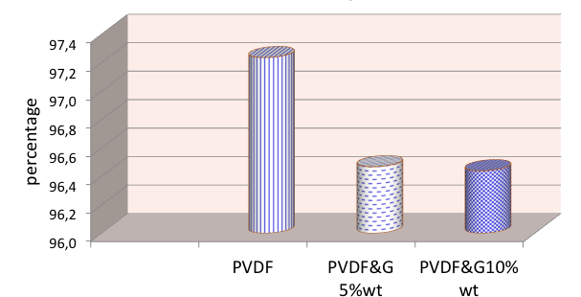

Figure 1. Percentages of ion in crystals after 200 ns of simulations.
4. Conclusions
Both experimental tests and MD simulations demonstrate that the chemical composition of the membrane surface affect the crystallization of salts in nucleation grow rate, crystal size and shape: the nanomaterials influence kinetics of crystal formation, reducing the nucleation times.

Aknowledgment: The Great Relevance International Project Italy (MAECI)-China (NSFC) 2018­2020 - New Materials, with particular reference to Two-dimensional systems and Graphene (Prot.MAE0088962) funded by Ministero degli Affari Esteri e della Cooperazione Internazionale, Direzione Generale per la Promozione del Sistema Paese is gratefully acknowledged.
References
- E. Curcio, A. Criscuoli, E. Drioli, Ind. Eng. Chem. Res. 40 (2001) 2679–2684.
- C.A. Quist-Jensen, F. Macedonio, E. Drioli, Crystals 6 (2016) 36-49.
- F. Macedonio, A. Politano, E. Drioli, A. Gugliuzza, Mater. Horiz. 5 (2018) 912–919.
- P.G. Vekilov, Nanoscale 2 (2010) 2346–2357.
- A.E.S. Van Driessche, N. Van Gerven, P.H.H. Bomans, R.R.M. Joosten, H. Friedrich, D. Gil-Carton; N.A.J.M. Sommerdijk, M. Sleutel, Nature 556 (2018) 89–94.
- J.-H. Tsai, M.L. Perrotta, A. Gugliuzza, F. Macedonio, L. Giorno, E. Drioli, K.-L. Tung, E. Tocci, Appl. Sci. 8(11) (2018) 2145-2161
- Materials Studio 7.0; Dassault Systèmes BIOVIA: San Diego, CA, USA, 2013.
- H. Sun, J. Phys. Chem. B 102 (1998) 7338–7364.
- B. Hess, C. Kutzner, D. Van der Spoel, E. Lindahl, J. Chem. Theory Comput. 4 (2008) 435–447.

