Flow Regimes in Slurry Bubble Columns.
Sandra Orvalho¹, Masaaki Hashida², Maria Zednikova¹, Petr Stanovsky¹, Marek C. Ruzicka¹, Akio Tomiyama²
1 Department of Multiphase Reactors, Institute of Chemical Process Fundamentals, Czech Academy of Sciences, Rozvojova 135, 16502 Prague, Czech Republic; 2 Department of Mechanical Engineering, Kobe University Graduate School of Engineering, Kobe, Japan
*Corresponding author: orvalho@icpf.cas.cz
Highlights
- Detailed experiments on slurry bubble columns hydrodynamics
- Flow regimes in slurry bubble column and their transitions: effect of liquid level and solid particles concentration
- Modelling slurry bubble columns hydrodynamics under HoR, TrR, HeR and PHeR

1. Introduction
Bubble columns and sparged gas-liquid systems have wide application in chemical industry and in biotechnology, being slurry bubble column (SBC) is a special case of three-phase gas-liquid-solid. In most applications, SBC are operated under pure heterogeneous hydrodynamic regime (non-uniform, churn turbulent). However, operation of slurry bubble columns (SBC) in homogeneous regime (uniform, laminar) may be preferred in some cases like in the intensification of catalytic reactors using special distributors [1] or to secure low level of shear stresses in some bioapplications [2]. Most of the research on SBC is however dedicated to pure heterogeneous regime (PHeR) and very little attention has been paid to HoR. In the present contribution we will present a systematic study of the hydrodynamic behavior of SBC equipped with “fine sparger”, able to give homogeneous and heterogeneous regime and transition between them.
2. Methods
This experimental study focused on the flow regimes and gas holdup behavior in a lab-scale slurry bubble column (vertical plexiglass cylinder, diameter 0.14 m, total height 2 m). The gas distributor was a fine perforated brass plate (orifices with 0.5 mm diameter, free plate area 0.19 %), producing both homogeneous (HoR) and heterogeneous (HeR) flow regimes, and the transition between them (TrR). The three-phase gas-liquid-solid mixture was composed of local air, tap water and fine porous silica particles (size 100 μm). The gas holdup e was measured by bed expansion method, using free layer height evaluated visually or by digital image analysis. Three experimental parameters were tested: gas input q, initial slurry layer height H and concentration of solid particles c.
3. Results and discussion
The gas holdup e depends on the gas input q, layer height H and solid content c. From the holdup data measured, flow regimes were identified and the transition points were determined. The reference system for our study is the two-phase system c = 0 % and 0.8 m layer height, presented in Fig 1 (a). In this system, the bubble column gives three regimes with two transition points, depending on the gas input q. Increasing the layer height and the solid load reduces the gas holdup and destabilizes HoR. At low solid load (c < 3%) all three regimes exist, depending on q. At solid load higher than c ≥ 3% only one regime exists, pure heterogeneous regime. The main findings are resumed in the flow regime map in Fig. 1 (b). Existing model equations, derived for two phase systems [3], were adapted to take in consideration the presence and concentration of the third phase (suspended particles). The parameters of the models have physically meaningful parameters such as terminal velocity or factor of flow non-uniformity and they can be proved by auxiliary visualization experiments.
(a) (b)

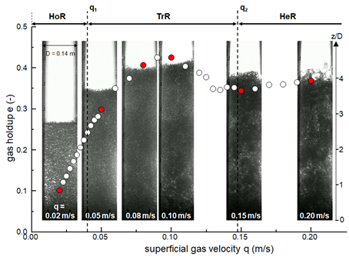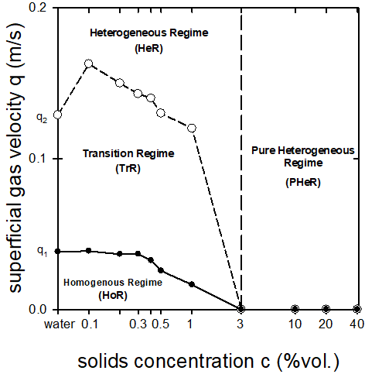
Figure 1. (a) Identification of flow regimes (HoR, TrR, HeR) and critical points (q1 and q2) of flow transition, based on images of bubble column and gas holdup data; (b) Flow regime map for slurry bubble column (SBC).
4. Conclusions
The present study is based on visualization experiments, for determination of gas holdup and flow regimes, and intends to improve our understanding of the dynamics of slurry bubble columns generated by “fine spargers”. The main result of the study is a flow regime map with three parameters, q, H and c.
The financial support by the Czech Science Foundation through project 19-09518S, and by the Graduate School of Engineering, Faculty of Engineering, Kobe University during Mr. Hashida work stay in Prague, are gratefully acknowledged.
References
- N. Hooshyar, P.J. Hamersma, R.F. Mudde, J.R. van Ommen, Can. J. Chem. Eng. 88 (2010) 533-542.
- A. Mota, A.A. Vicente, J. Teixeira, Chem. Eng. Sci. 66 (2011) 3350-3357.
- M.C. Ruzicka, J. Zahradnik, j. Drahos, N.H. Thomas, Chem. Eng. Sci. 56 (2001) 4609-4626.

