Incorporation of paper sludge in clay mixtures used for fired-clay bricks manufacturing: understanding the bleaching phenomena issue observed on industrial products
Noémie Courtois^{1,2}, Isabelle Pochard², Jean-Yves Hihn², Laurent Tourneret¹
1 Wienerberger, Laboratoire Central R&D, 25770 Franois, France; 2 Institut UTINAM, UMR6213CNRS, 25000 Besançon, France
*Corresponding author: noemie.courtois@wienerberger.com
Highlights
- Brick manufacturing recycles paper mill sludge produced by waste water treatment.
- Drying and thermal insulation brick properties are improved by PS incorporation.
- PS can be degraded over time by bacterial decomposition process.
- Degradation produce intermediate compounds responsible for bleaching of products.

1. Introduction
Paper manufacturing produces large amounts of sludge residue, which is the final product of their waste water treatment process. Incorporation in clay brick formulation is one of the recycling alternatives for these wastes. Using paper sludge (PS) in bricks manufacturing [1] has two major advantages: due to the hydrophilic effect of vegetal fibers present in sludge, the drying is optimized and porosity is created by the fibers combustion during firing process. However, the organic matter present in PS, particularly cellulosic fibers, can be degraded over time by bacterial decomposition. This can lead to problematic phenomena on brick products like surface bleaching.
2. Methods
Paper sludges used in brick manufacturing are produced by several paper mills, which leads to various properties and compositions. In order to investigate which PS parameters are responsible for surface bleaching, four PS with different compositions, namely PS-1 to PS-4, were studied. The PS composition, principally fiber and calcium hydroxide contents, were determined by loss-on-ignition measured at 400°C and 1050°C respectively. Then, five mixtures were studied: a pure clay mixture used as reference (MR-0) and four mixtures obtained by incorporating the four different PS (MR-PS1 to MR-PS4) in the clay mixture in 88:12 mass clay:paper proportions. The drying property was characterized by the diffusivity coefficient of the ceramic samples, representing the drying speed of the products. This coefficient was determined by measuring the mass and dimensions of the samples in wet state, during drying and in dried state. Porosity of the fired products was evaluated by determining the rate of water absorption by the samples after water immersion for 2h under vacuum at 500mmHg. The surface of the samples (with bleaching problematic or not) were analyzed by IR-ATR spectroscopy between 2000cm⁻¹ and 400 cm⁻¹.
3. Results and discussion
PS-2 has the highest fiber content and the lowest calcium hydroxide content, while PS-3 and PS-4 have the lowest fiber content and high calcium hydroxide content. PS-1 is intermediate (Fig 1). The analysis of the clay/PS mixtures shows that MR-PS2 and MR-PS4 have a particularly low diffusivity coefficient (1.8.10⁻⁹ against 2.10⁻⁹ m²/s). The porosity is significantly greater when PS is incorporated in clay phases (increase of 4 to 7% between reference mixture and MR-PS mixtures). MR-PS1 presents the greater porosity while the three other MR-PS blends have a similar porosity at 21-22%.
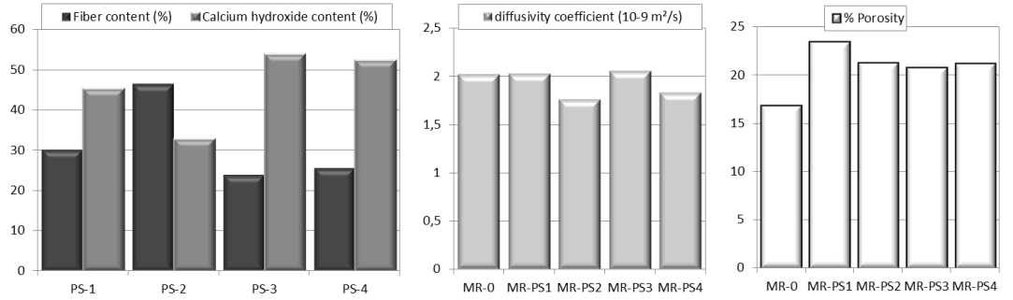
Figure 1. Compositions of the four paper sludges analyzed and properties of the five clay/PS mixtures.
A bleaching is observed on the MR-PS-2 and MR-PS-4 surfaces after drying (not shown). The FT-IR-ATR spectroscopy analysis reveals peaks at 1440 and 1560 cm⁻¹ and a small one at 1300cm⁻¹ (Fig 2). These vibration modes are absent on the other samples and thus, are characteristic of the compounds responsible for the bleaching.
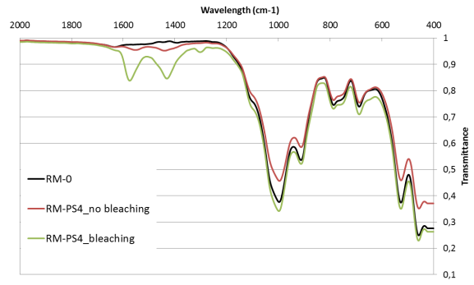
Figure 2. IR-ATR analyses of MR-0 and MR-PS4 with or without bleaching.
These characteristic peaks can be assigned to symmetric C-O stretching vibration, antisymmetric C-O stretching vibrations and symmetric methyl bending vibration of acetate anion respectively [2]. This means that bleaching at brick surfaces is due to the presence of organic compounds with carboxylate anion, like acetate salt. These organic compounds are formed during the bacterial anaerobic degradation of the cellulosic content of the PS [3].
4. Conclusions
The incorporation of PS in fired-clay brick formulation has several benefits. It also can lead to problematic phenomena like surface bleaching. This phenomenon is due to the presence of organic molecules in PS produced by cellulose degradation.
References
- V.Mymrim. Applied Clay Science, 2015, 107, 28-35.
- R.Frost, A.Musumeci. Spectrochimica acta Part A, 2007, 67 (3-4), 649-661.
- T.Meyer, E.Edwards. Water Research, 2014, 65, 321-349.

