CFD Analysis of Direct Contact Condensation (DCC) of Superheated Gas Jets into a Vertically Flowing Liquid Channel.
K N Jayachandran¹, Arnab Roy², Parthasarathi Ghosh¹
1 Cryogenic Engineering Centre, Indian Institute of Technology, Kharagpur, India-721302; 2 Department of Aerospace Engineering, Indian Institute of Technology, Kharagpur, India-721302
*Corresponding author: knjayachandran93@gmail.com
Highlights
- Two fluid model used for simulation of DCC in R123 gas-liquid flows.
- Mean bubble diameter correlation will be developed for low Jakob (Ja) number liquid flows.
- Numerical model will be validated with experimental data of Zhu et al., [1].

1. Introduction
In a typical staged combustion cycle based LOX/kerosene semi-cryogenic rocket engine, the liquid oxygen booster turbine is driven by the oxidizer-rich combustion products from the pre-burner [2,3]. The turbine driving gas comes in direct contact with the liquid oxygen stream from the booster pump after the booster turbopump exit and gets condensed [4]. Very few studies are reported in the above complicated case of direct contact condensation, which demands further investigation in this area [3]. The purpose of the present study is to understand the GOX-LOX DCC by exploring the DCC of R123 fluid with similar flow (low liquid Ja) and geometry configuration as reported in Zhu et al., [1] by the use of numerical methods.
2. Methods
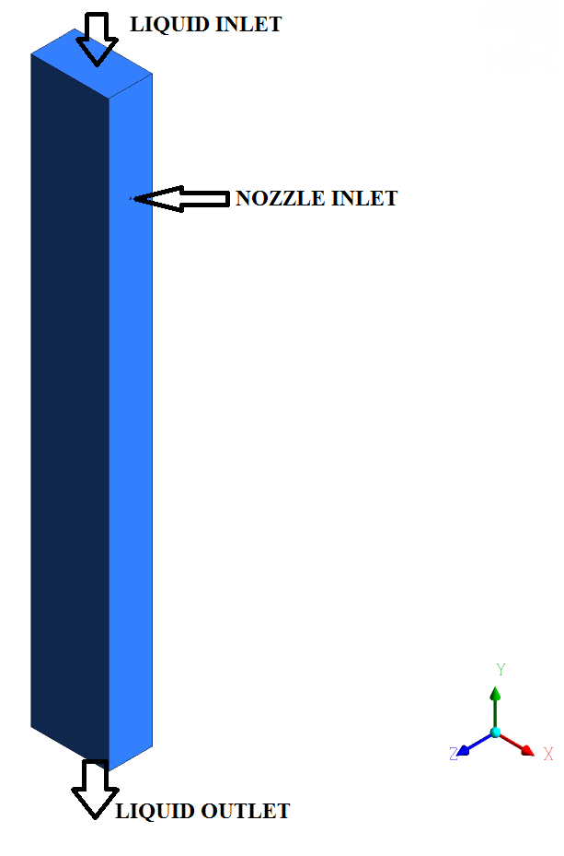

Table 1. Boundary conditions.

Parameter | Value
Nozzle inlet mass flow rate (g/s) | 1.22
Nozzle inlet temperature (K) | 346.98
Liquid inlet velocity (m/s) | 1
Liquid inlet temperature (K) | 311.98
Domain pressure (MPa) | 0.175

Figure 1. Geometry with gas and liquid boundaries.

A two-fluid model with thermal phase change model for predicting condensation effects has been implemented in the present study using the commercial CFD package ANSYS CFX®. The geometry has been taken from the experimental data of Zhu et al., [1] as shown in Fig. 1. The nozzle has a diameter of 2mm whereas the liquid domain is of dimensions 45mm x 80mm x 600 mm. The boundary conditions are reported in Table 1.
3. Results and discussion
Initially, steady state simulations are performed and the gas volume fraction contours are plotted as shown in Fig. 2. It can be observed that the gas exits through the nozzle and comes in contact with liquid R123. Further, transient simulations have to be performed to understand the dynamic condensation process.
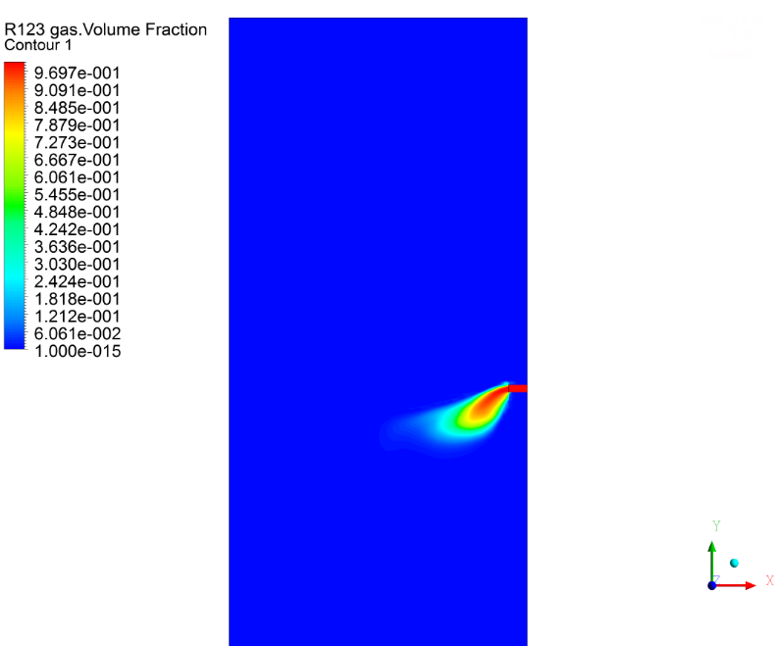
Figure 2. Gas volume fractions after steady state simulations.
4. Conclusions
A two-fluid model used to simulate the DCC of R123 gas-liquid flow. Further, the different sets of experimental data will be simulated to validate the numerical model. It has been observed by the authors in the previous works that the mean bubble diameter correlation by Anglart et al., [5] may not be applicable for all cases of DCC. Hence, based on the simulations, a correlation for mean bubble diameter will be developed.
References
- K. Zhu, L. Yanzhong, M. Yuan, J. Wang, L. Wang, C. Li, Exp. Therm. Fluid. Sci. 98 (2018) 1-11.
- Z. Kang, L. Yanzhong, L. Gang, W. Jiaojiao, X. Fushou, M. Yuan, Asia‐Pac. J. Chem. Eng. 13 (2018) 1-13.
- K. N. Jayachandran, A. Roy, P. Ghosh, Indian J. Cryogenics. 43 (2018) 124-130.
- K. N. Jayachandran, A. Roy, P. Ghosh, IOP Conf. Ser.: Mater. Sci. Eng. 171 (2017) 012052.
- H. Anglart, O. Nylund, Nucl. Eng. Des. 163 (1996) 81-98.

