A realistic vapour phase heat transfer model for the weathering of LNG stored in large tanks
Felipe Huerta^{1*}, Velisa Vesovic¹
1 Department of Earth Science and Engineering, Imperial College London, London SW7 2AZ, United Kingdom
*Corresponding author: f.huerta-perez17@imperial.ac.uk
Highlights
- A new model to predict the weathering of LNG in storage tanks is developed
- It dispenses with the assumption of vapour being at the same temperature as LNG
- It demonstrates that the vapour to liquid heat transfer is small
- It shows that the initial amount of LNG has a pronounced effect on weathering

1. Introduction
The global energy sector is changing unprecedently as it transitions from its reliance on fossil fuels to renewables. For the transition, natural gas will play an important role because of its competitive cost and lower emissions when compared to other fossil fuels [1]. Natural gas (NG) is predominantly a hydrocarbon mixture consisting mainly of methane and, in general, lower amounts of other n-alkanes and small inorganic molecules. It can be distributed to users directly from the source through pressurized pipelines or it can undergo a liquefaction process and then be distributed as liquefied natural gas (LNG), by marine transportation, to large storage facilities. LNG is becoming the preferred way to transport natural gas and it is finding an use as marine and heavy-vehicle fuel.
LNG is industrially stored in highly insulated tanks at cryogenic temperatures below -160°C, that are subject to heat ingress from the surroundings that leads to preferential evaporation of the most volatile components. The vapour produced is denominated boil-off gas (BOG), and it is typically removed to keep the tank pressure constant. The heat ingress and BOG removal produce weathering of the remaining LNG, as the concentration of the heavier components increases over time. This has major industrial implications, as it can induce safety hazards such as rollover and it limits the NG marketability. In this work, a new non-equilibrium model relevant to LNG weathering in large storage tanks has been developed.
2. Methods
The new model treats the heat influx from the surroundings into the vapour and liquid phases separately and allows for heat transfer between the two phases. The main heat transfer mechanisms in the vapour phase are assumed to be advection, due to upward flow of evaporated LNG, and conduction. The vapour heat ingress is included as a source term and the evaporative flow is approximated by an average vertical velocity. The numerical integration is based on adaptive time-steps to capture the strong transient behaviour at the beginning of weathering.
3. Results and discussion
It was observed that the vapour temperature increases monotonically as a function of the height, in agreement with recent experimental results [2] . For three typical LNG mixtures (Light LNG, Heavy LNG and N₂-rich LNG), we observed very similar temperature profiles and vapour to liquid heat fluxes as we observed for evaporation of pure methane. In all the simulations performed the vapour to liquid heat transfer was small and is estimated to contribute less than 0.3% to BOG rates. A strong transient dynamic was found at the beginning of weathering, until a pseudo-steady state is achieved when the vapour heat ingress is balanced with the vapour to liquid heat transfer and the advective flow. Figure 1 illustrates the BOG as a function of weathering for the LNG studied. For the light and heavy LNG mixtures the model predicts a decreasing BOG rate. In contrast, for the N₂-rich LNG mixture both models predict a local maximum because of the interplay between the decreasing liquid heat ingress and decreasing enthalpy of vaporization. For all mixtures the BOG rates were between 1 and 4 % lower than in previous work [3] because of lower vapour to liquid heat ingresses.
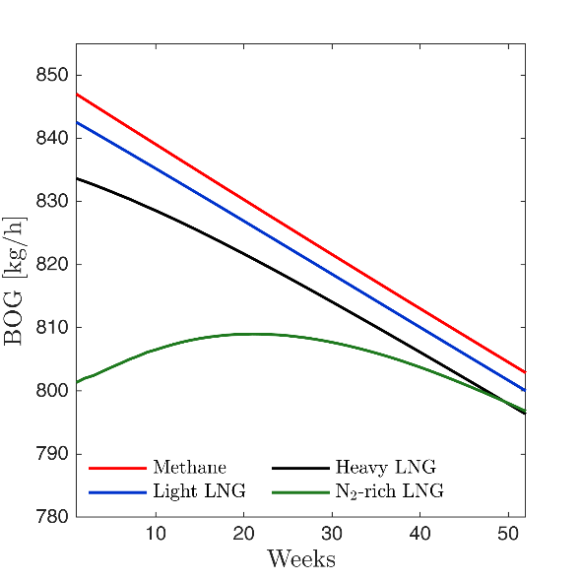
Figure 1. BOG rates as a function of time for three different LNG mixtures
The initial liquid filling has a pronounced effect, leading to a decrease in vapour and boil-off gas temperatures and an increase in boil-off rates. For a storage tank initially filled with 30% of light LNG, using previous non-equilibrium and equilibrium models [3, 4] would overestimate BOG rates by 26% and 100%, respectively. The transient time strongly depends on the initial filling of the LNG tank, with the nearly full tanks taking least time to reach the steady-state.
4. Conclusions
The results of this work indicate that the heat transfer by the advective upward flow dominates the energy transfer within the vapour, while the natural convection, in the body of the vapour, can be neglected. The developed model allows for the optimization of LNG storage tank operations and different scenario planning taking into account the initial liquid filling and nitrogen content.
References
[1] World Energy Outlook 2017. France: International Energy Agency; 2017.
[2] Kang M, Kim J, You H, Chang D. Experimental investigation of thermal stratification in cryogenic tanks. Exp Therm Fluid Sci 2018;96:371-82.
[3] Migliore C, Salehi A, Vesovic V. A non-equilibrium approach to modelling the weathering of stored Liquefied Natural Gas (LNG). Energy 2017;124:684-92.
[4] Migliore C, Tubilleja C, Vesovic V. Weathering prediction model for stored liquefied natural gas (LNG). Journal of Natural Gas Science and Engineering 2015;26:570-80.

