Improving product specificity of whole-cell alkane oxidation in non-conventional media: A multivariate analysis approach
Frank Baganz¹*, Johannes F Kolmar¹, Oliver Thum²
1 Advanced Centre for Biochemical Engineering, Department of Biochemical Engineering, University College London, Gower Street, London WC1E 6BT, United Kingdom; 2 Evonik Creavis GmbH, Paul-Baumann-Straße 1, 45772 Marl, Germany
*Corresponding author: f.baganz@ucl.ac.uk
Highlights
- Polarity of co-solvents determines product specificity.
- Accumulation of alcohol over acid using more polar solvents.
- PLS model showed defining factors are solubility parameters

1. Introduction
Two-liquid phase reaction media have long been used in bioconversions to supply or remove hydrophobic organic reaction substrates and products to reduce inhibitory and toxic effects on biocatalysts [1]. In case of the terminal oxyfunctionalisation of linear alkanes by the AlkBGT monooxygenase the excess alkane substrate is often used as a second phase to extract the alcohol, aldehyde and acid products [2]. However, the selection of other carrier phases or surfactants is complex due to the large amount of parameters that are involved, such as: biocompatibility, substrate bioavailability and product extraction selectivity.
This study investigates co-solvents of different polarities and structures as secondary solvents for the whole-cell alkane bio-oxidation by AlkBGT. Initially, the impact of six co-solvents at two concentrations is studied. Particular focus is on the overall product yield and specificity of the bio-oxidation of four linear alkane substrates. In order to efficiently screen this wide range of experimental conditions, a high-throughput microwell platform specifically customised for non- conventional media is used [3]. In a second step experimental data is combined with estimated physicochemical properties of the co-solvents in a multivariate Partial least squares projections to latent structures (PLS) regression analysis. This allows the identification of key properties of co-solvents that specifically affect the AlkBGT reaction in terms of product specificity and yields.
2. Methods
Materials and methods for whole cell bioconversion in customized microwell plates and analysis of the reaction products by gas chromatography has been described in detail in Kolmar et al 2018 [3]. For data analysis physicochemical properties i.e. Hansen and logP parameters were estimated for co-solvents and reaction substrate and products using COMSOquick software. PLS regression analysis was performed (SIMCA 13.0.3, Umetrics) for analysing multiple variables in one model.
3. Results and discussion
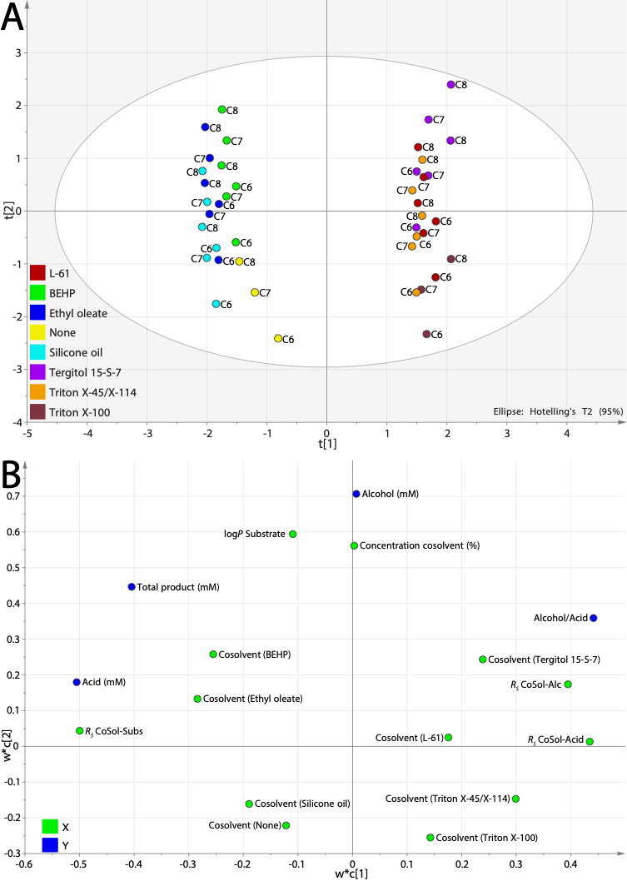
Partial least square regression showed that the defining factors for product specificity are the solubility properties of reaction substrate and product in the co-solvent, as measured by Hansen solubility parameters. Thus the polarity of co-solvents determines the accumulation of either alcohol or acid products. Whereas usually the acid product accumulates during the reaction, by choosing a more polar co-solvent the 1-alcohol product can be accumulated. Especially with Tergitol as co-solvent, a 3.2 fold improvement in 1-octanol yield to 2.4 g l⁻¹ was achieved relative to the control reaction without co-solvents (Figure 1).

Figure 1. PLS model M2 score scatter plot of response data showing X-scores (t) of the first component along the x-axis and X-scores of the second along the y-axis (A) Co-solvent screening with octane substrate after 24h at 30°C and 250rpm, at varying co-solvent percentages in substrate indicated below x-axis (C).

4. Conclusions
The application of co-solvents is a promising strategy to influence whole-cell alkane oxidations. Further work needs to investigate efficient downstream processing options for the most promising candidates to fully leverage their advantages.

References
- P.-Y. Kim, D. J. Pollard, J. M. Woodley, Biotechnology Progress 2007, 23, 74– 82.
- C. Grant, J. M. Woodley, F. Baganz, Enzyme and Microbial Technology 2011, 48, 480–486.
- J. F. Kolmar, O. Thum, F. Baganz, Microbial Cell Factories 2017, 16, 174.

