Acid gas removal in waste-to-energy plants via high temperature reaction with calcined dolomite
Alessandro Dal Pozzo*, Giacomo Antonioni, Valerio Cozzani
LISES – DICAM, Alma Mater Studiorum - Università di Bologna, via Terracini n.28, 40131 Bologna, Italy
*Corresponding author: alessandro.dalpozzo3@unibo.it
Highlights
- The furnace injection of calcined dolomite was tested as acid gas removal method
- The test run campaign demonstrated high reactivity towards both HCl and SO₂
- A model for HCl and SO₂ removal was calibrated on test run data
- Adding furnace injection can reduce the overall cost of flue gas treatment

1. Introduction
Acid gases like HCl and SO₂ are typical pollutants arising from the combustion of municipal or industrial waste fractions having Cl and S content. The upcoming revision of the BAT (Best Available Techniques) for waste incineration sets high standards for the emission control of these contaminants [1]. Old waste-to-energy (WtE) plants might require retrofitting to obtain a renewal of their environmental permits. In this framework, the injection of calcined dolomite (CD) in the combustion chamber, as solid reactant for acid gas abatement, has been proposed recently as a simple approach to retrofitting, with minimal investment cost and without the need for additional equipment [2]. The current study aims to investigate the cost-effectiveness of CD injection.
2. Methods
The performance of CD as high temperature reactant for acid gas removal was tested in two WtE plants. Both plants adopted the injection of sodium bicarbonate at low temperature (180 °C) as acid gas abatement stage, as commonly performed in several European WtE plants [3]. As sketched in Fig. 1a, the tested configuration consisted in the introduction of CD as an additional acid gas abatement stage directly in the combustion chamber (T ~ 1000 °C). The concentration of HCl and SO₂ in the flue gas was measured downstream of the furnace (point SMP). Therefore, in order to assess the effect of CD injection on the acid pollutants, “on/off tests” were performed by alternating periods of injection and interruption of the CD feed rate, as shown in Fig. 1b. The removal efficiency of CD towards HCl or SO₂ at different feed rates was calculated considering the reduction in acid gas concentration at point SMP compared to the periods without injection of reactant. A previously formulated model for dry acid gas removal [4] was calibrated on the experimental data. The calibrated model was used to simulate the operation of the WtE acid gas removal line (furnace injection of CD + downstream bicarbonate injection) at different feed rates of CD. The simulations allowed to identify the operating point of the plant that minimizes the operating costs of acid gas removal.
3. Results and discussion
The results of the test run campaign are summarized in Fig. 3c, where the acid gas removal efficiency (for HCl and for SO₂) is plotted as a function of the stoichiometric ratio (SR) of reactant. Dolomite appeared particularly reactive towards SO₂: at SR = 1 (i.e. reactant feed rate without stoichiometric excess), the removal efficiency for SO₂ and HCl was 81 % and 29 %, respectively. Calibrating a performance model (continuous lines in Fig. 1c) on the experimental data (dots) allowed to study the process optimization of the two-stage acid gas removal system (dolomite stage + bicarbonate stage). The performance model for bicarbonate was obtained through a dedicated analysis as in [4]. A typical flue gas composition (HCl = 800 mg/Nm³, SO₂ = 200 mg/Nm³) resulting from municipal waste combustion was considered as reference case. The overall operating costs of the two-stage line (cost of the reactants plus disposal of process residues) were assessed as a function of HCl conversion in the CD stage, as shown in Fig. 1d, while keeping constant the overall acid gas conversion in the two-stage system. The minimum of operating costs was found for a 25 % HCl conversion in the CD stage, which realizes a 14 % cost reduction compared to the single-stage sodium bicarbonate acid gas removal system without dolomite injection.
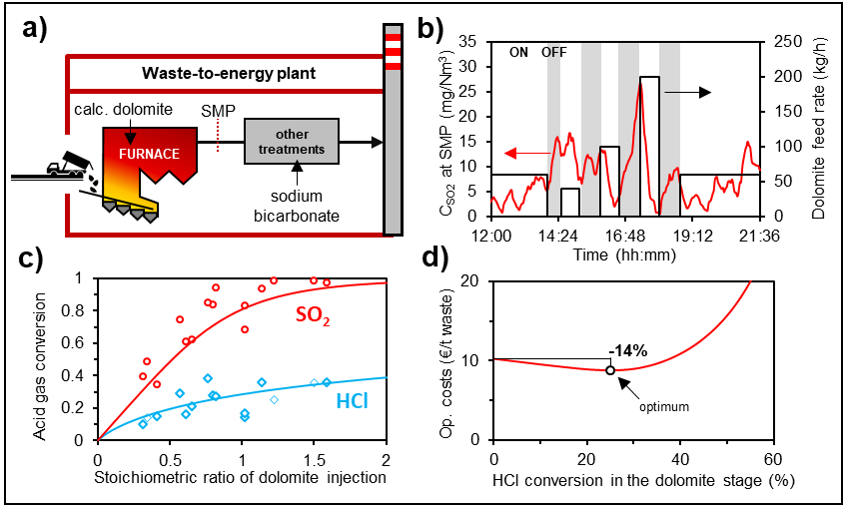
Figure 1. Framework of the study: a) sketch of the WtE plant configuration (dolomite + bicarbonate two-stage acid gas removal system); b) dolomite feed rate and SO₂ concentration over time during a typical test run; c) removal efficiency of calcined dolomite for HCl and SO₂; d) operating costs of the two-stage acid gas removal system as a function of HCl conversion in the dolomite stage.
4. Conclusions
The test run campaign conducted in WtE facilities demonstrated the cost-effectiveness of acid gas removal via the high temperature reaction with CD. Retrofitting a plant equipped with a sodium bicarbonate treatment stage with an additional dolomite stage as furnace injection can reduce the overall operating cost of acid gas treatment, if the feed rate of dolomite is properly optimized.
References
- European Commission, BREF Waste Incineration (draft), Dec 2018. Available at: https://bit.ly/2UTDHhl
- L. Biganzoli, G. Racanella, L. Rigamonti, R. Marras, M. Grosso, Waste Manage. 36 (2015) 98-105.
- J. Vehlow, Waste Manage. 37 (2015) 58-74.
- A. Dal Pozzo, M. Giannella, G. Antonioni, V. Cozzani, Chem. Eng. Trans. 67 (2018) 463-468.

