Use of salinity gradients for the recovery of valuable components from wastewater
Marie-Charlotte Sparenberg, Israel Ruiz Salmón, Patricia Luis¹
1 UCLouvain, Materials & Process Engineering (iMMC-IMAP), Place Sainte Barbe 2, 1348 Louvain-la-Neuve, Belgium
*Corresponding author: patricia.luis@uclouvain.be
Highlights
- Osmotic membrane distillation-crystallization allowed the recovery of target salts from synthetic wastewater.
- The economic evaluation showed the potential benefit of recovery.
- Optimal operation conditions are essential to achieve economic viability.

1. Introduction
Osmotic membrane distillation-crystallization is a novel technology that makes use of salinity gradients as the driving force to concentrate solutions until reaching the saturation concentration and thus, allowing the crystallization of target components. In this study, osmotic membrane distillation-crystallization is applied to recover sodium carbonate, potassium nitrate and sodium sulphate from synthetic industrial wastewater solutions. The technical viability of the process [1], discussed in terms of transmembrane fluxes, mass transfer coefficients and crystals purity, is completed with an economic study. The key operation conditions that determine the economic viability of the crystallization process are evaluated for each recovered salt [2].
2. Methods
The osmotic membrane distillation−crystallization contactor used in this study was the hollow ﬁber membrane contactor 2.5 × 8 Extra-Flow Module from LiquiCel (Membrana GmbH, Germany). The feed solution (i.e., aqueous solution of pure Na₂CO₃, Na₂SO₄, KNO₃, or mixtures) was pumped to the membrane through the lumen side (inside of the hollow ﬁbers) of the membrane. The osmotic stream (NaCl) circulated in counter-current mode through the shell side (outside of the hollow ﬁbers). The inﬂuence of concentrations of the feed and osmotic solutions as well as the ﬂow rates on the process performance was studied. In order to assess the economic viability of the process, the annual costs and salt sale profits were evaluated and the final benefit of salt recovery was determined as a function of the operation conditions.
3. Results and discussion
The experimental results showed that varying the concentration of the osmotic solution was the main parameter affecting the transmembrane flux. The concentration of the three salts in the feed had slight influence while no significant effect was observed when flow rates in both the feed and the osmotic side were varied. High purity crystals of Na₂CO₃.10H₂O, Na₂SO₄.10H₂O and KNO₃ was obtained (Figure 1).

- b) c)
Figure 1. Crystals of a) Na₂CO₃.10H₂O; b) Na₂SO₄.10H₂O; and c) KNO₃

Figure 2 illustrates the influence of the initial osmotic concentration (ranging from 100 to 300 g L⁻¹) on the economics of the process for the three salts, with initial feed concentration and flow rate of 100 g L⁻¹ and 500 L h⁻¹ respectively and initial osmotic flow rate of 27 L h⁻¹. It can be clearly seen that the osmotic concentration has a major impact on the economic viability of the process. Increasing this concentration leads to a higher driving force hence a higher flux, less membrane area and lower costs.
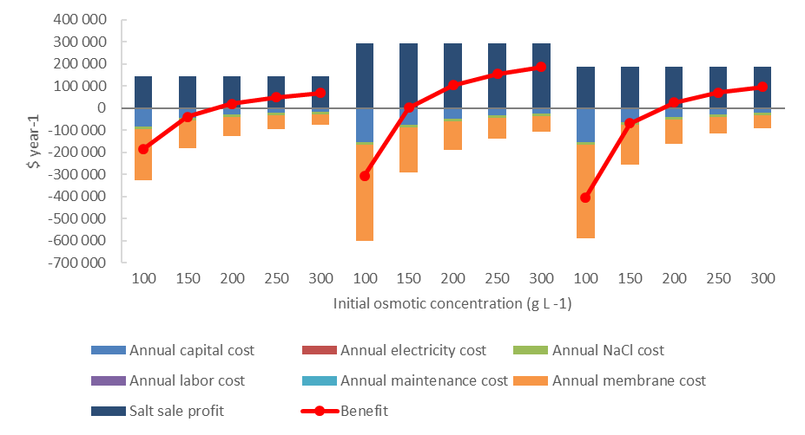
Figure 2. Costs, salt sale profit and benefit for the crystallization of the three salts. Initial feed concentration and flow rate are 100 gL⁻¹ and 500 Lh⁻¹ respectively and osmotic flow rate is 27 Lh⁻¹.
4. Conclusions
High purity crystals of Na₂CO₃.10H₂O, Na₂SO₄.10H₂O and KNO₃ were obtained using osmotic membrane distillation-crystallization in synthetic wastewater. Using the highest possible concentration of osmotic solution (limited by the solubility of the salt i.e. 358 g L⁻¹ at room temperature for NaCl) is desired because of its marginal costs and high impact on the economics.
References
[1] I. Ruiz Salmón, K. Simon, C. Clérin, P. Luis, Salt recovery from wastewater using membrane distillation-crystallization, Crystal Growth & Design 18 (2018) 7275–7285.
[2] M-C. Sparenberg, I. Ruiz Salmón, P. Luis, Economic evaluation of salt recovery from wastewater via membrane distillation-crystallization, Desalination, submitted.

