Light activated dehydrogenation of Liquid Organic Hydrogen Carriers.
Alexander Wunsch¹, Michel Bartsch¹, Marek Grzelczak², Roland Dittmeyer¹, Peter Pfeifer¹, Alexander Navarrete¹
1 Institute for Micro Process Engineering, Karlsruhe Institute of Technology, Eggenstein-Leopoldshafen, Germany;
2 Donostia International Physics Center (DIPC), Paseo Manuel de Lardizabal 4, Donostia – San Sebastián 20018, Spain
*Corresponding author: alexander.navarrete@kit.edu
Highlights
- Renewable energy has great potential but fluctuation and storage are always a challenge.
- Long-term storage of hydrogen can connect high-energy potential with demand.
- We propose a process to release hydrogen from LOHCs using solar energy.
- Concept and initial results are introduced.

1. Introduction
Potential for renewable energy based society is big but it cannot achieved without an appropriate energy storage infrastructure that copes with the fluctuating nature of the renewable sources [1-3].
Long-term hydrogen storage by means of Liquid Organic Hydrogen Carriers (LOHCs) is based on cycles of hydrogenation- dehydrogenation. This provides an option, which is potentially cheap, safe and easy to handle in order to connect regions with high-energy generation potential to regions with large energy demand. The sustainability of the process requires to recover the hydrogen using a heat source that do not emit CO₂ [4]. Solar light is an abundant resource that can be used for this purpose. Nevertheless the technology is not yet developed.
We make use of a plasmonic composite in order to capture the light energy and locally activate the dehydrogenation of LOHCs. For this, we have developed a dedicated reaction system, which will be described here.
2. Methods
2.1. Reaction setup and catalyst integration:
The reactor allows the illumination of the plasmonic composite while the flow and temperature of the LOHC is controlled. The plasmonic catalyst is deposited on the transparent slides by means of a layer-by-layer method. Optical profilometry and UV-Vis spectroscopy are used to characterize the surface. Electronic microscopy is used to study the catalytic nanostructure.
2.2. Reaction test:
The reactor is tested under white light with different flow rates. The production of hydrogen is followed by the degradation of the LOHC by means of refractometry.

3. Initial results

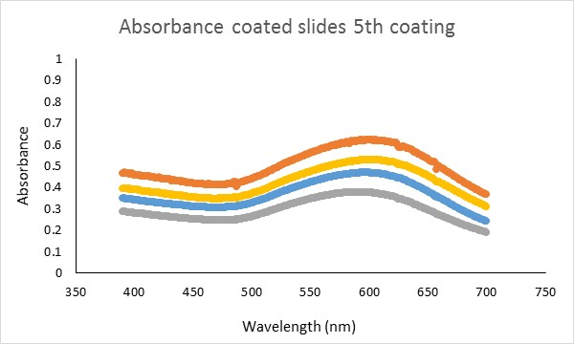
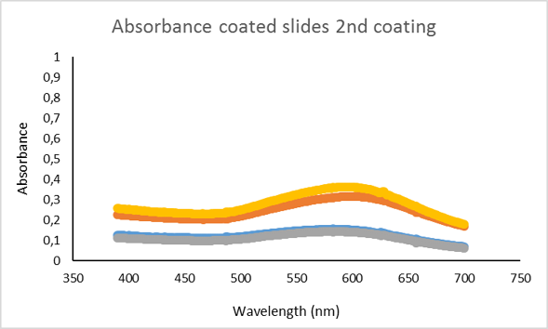
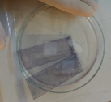

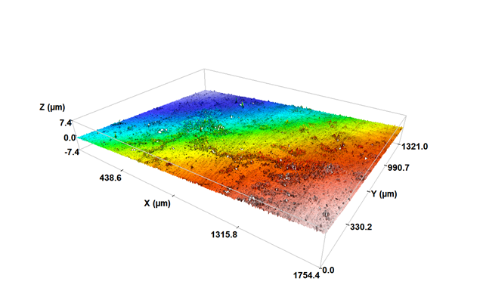

Figure 1. Catalyst deposition evolution.
The layer-by-layer method is appropriate to deposit catalyst with controlled optical characteristics that allow to absorb solar energy. This work provides evidence on the possibility of storing and releasing hydrogen using renewable energy during the storage-supply cycle. In particular, hydrogen could be recovered using solar energy in future processes based on LOHCs.
References
- K. F. Kalz, R. Kraehnert, M. Dvoyashkin, R. Dittmeyer, R. Gläser, U. Krewer, K. Reuter, J.-D. Grunwaldt, ChemCatChem. 9 (2017) 17-29.
- P. Lanzafame, S. Abate, C. Ampelli, C. Genovese, R. Passalacqua, G. Centi, S. Perathoner, ChemSusChem, 10 (2017) 4409-4419.
- A. Navarrete, G. Centi, A. Bogaerts, Á. Martín, A. York, G. D. Stefanidis, Energy Technol. 5 (2017) 796-811.
- M. Niermann, S. Drünert, M. Kaltschmitt, K. Bonhoff, Energy Environ. Sci. (2019) accepted.
DOI: 10.1039/C8EE02700E.

