Avoiding cross-reactivities in multi-step biocatalysis by light-induced enzyme deactivation
Tim Gerlach^{1*}, Simone Söltl¹, Thomas Drepper², Dörte Rother^{1,3}
¹Institute of Bio- and Geosciences: Biotechnology (IBG-1), Forschungszentrum Jülich GmbH, Jülich, Germany ²Institute of Molecular Enzyme Technology (IMET), HHU Düsseldorf, Campus Jülich, Germany
³Aachen Biology and Biotechnology (ABBt), RWTH Aachen University, Aachen, Germany
*Corresponding author: ti.gerlach@fz-juelich.de
Highlights
- The cloning and production of photosensitiser fusion enzymes was successful.
- Enzymes were produced soluble or as catalytically active inclusion bodies.
- The activity of the fusion enzymes was compared to the untagged enzymes.
- Photensitiser fusion enzymes show inactivation after light exposure.

1. Introduction
Cross-reactivity in complex enzyme cascades is a major challenge in the field of multi-step biocatalysis. To eliminate cross-reactivity in one-pot reaction systems, a novel strategy is followed: enzymes prone to side-reactivities are coupled to genetically encoded photosensitisers, which are able to produce reactive oxygen species upon irradiation with a distinct wavelength^{[1]}. The resulting fusion enzymes can be added to the corresponding reaction step enabling the catalyst activity to be switched off after successful transformation. The three-step enzyme cascade starting from 3-hydroxy benzaldehyde and pyruvate to a trisubstituted tetrahydroisoquinoline has been chosen as a test system. This cascade encompasses a carboligation step, a transamination step and a final cyclisation^{[2]}. It is a suitable target as in a one-pot reaction approach cross-reactivity especially of the transaminase occurs and dominant side-products are formed (Fig. 1), which has to be avoided.
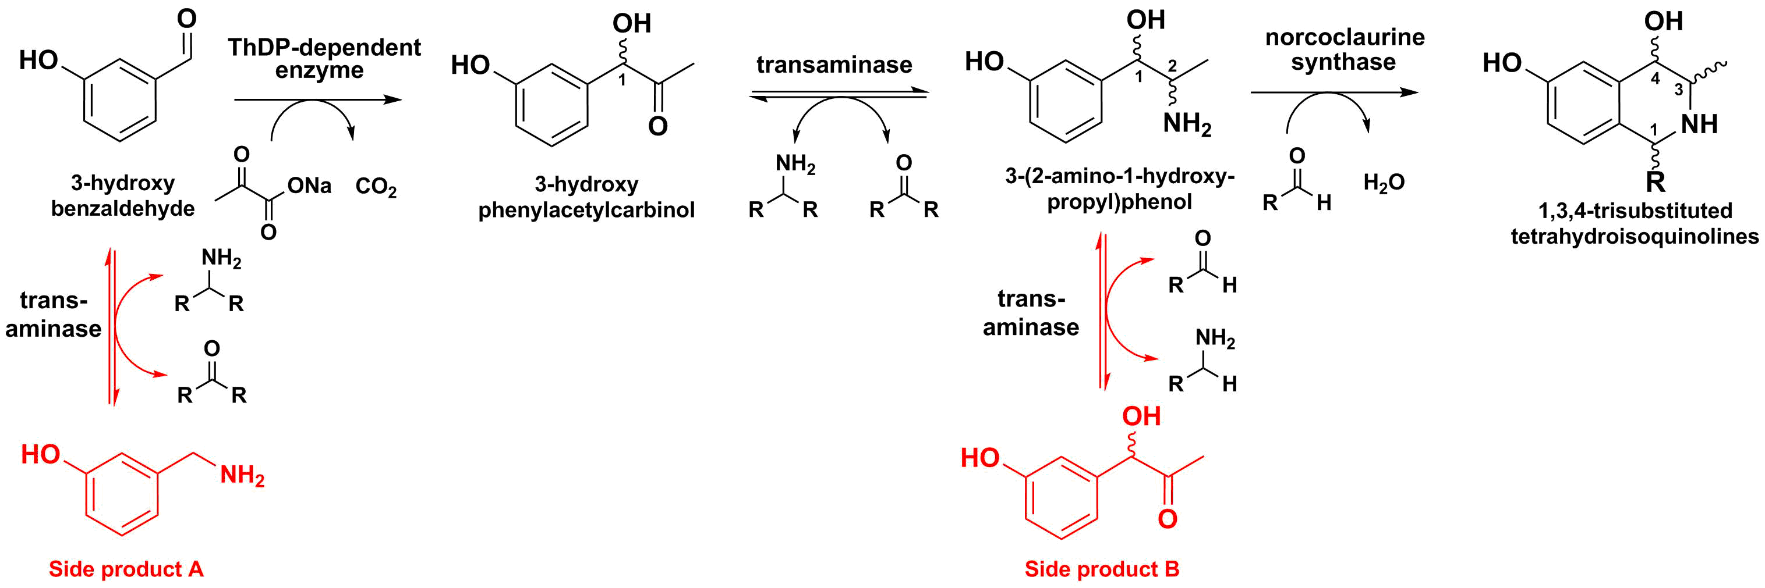

Figure 1. Three-step enzyme cascade starting from 3-hydroxy benzaldehyde and pyruvate to a trisubstituted tetrahydroisoquinoline. Possible side products are implied.
2. Methods
The flavin-binding fluorescent protein from Bacillus subtilis was genetically coupled to the pyruvate decarboxylase variant E469G/W543H from Acetobacter pasteurianus (Fp-ApPDC-2v) and to the Chromobacter violaceum transaminase (Fp-Cv2025). The untagged enzymes as well as the fusion enzymes were produced in Escherichia coli BL21(DE3). The protein solubility was checked via SDS-PAGE and the proteins were purified using an ÄKTA chromatography system. The activity of the Cv2025 variants was measured spectrophotometrically for the reaction from alpha-methylbenzylamine to acetophenone. The activity of the ApPDC-2v variants was determined via HPLC for the reaction from 3-hydroxybenzaldehyde to (S)-3-hydroxyphenylacetylcarbinol.
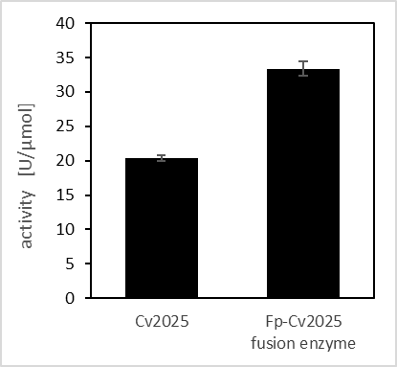
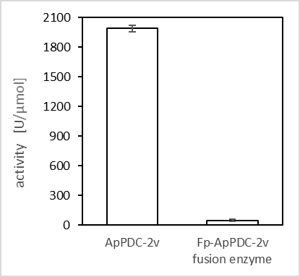
3. Results and discussion
B
A

Figure 2. Activities of the photosensitiser fusion variants of ApPDC-2v (A) and Cv2025 (B) compared to the respective untagged enzymes.
The Fp-ApPDC-2v shows only 2.5 % of activity compared to the untagged enzyme, while the activity of the Fp-Cv2025 is even 30 % higher. The lower activity of Fp-ApPDC-2v is likely to be caused by the structural properties of this enzyme because it is produced as catalytically active inclusion body. Depending on the structure of the untagged enzyme, multimeric photosensitisers seem to mediate the formation of a multi-enzyme network.
Furthermore, a light experiment with Fp-Cv2025 revealed, that 10 min of light exposure is sufficient to inactivate the enzyme completely.
4. Conclusions
The characterisation of two photosensitiser fusion enzymes was completed regarding their production and activity. Light experiments have shown that the photosensitiser tags are able to facilitate a fast inactivation of the fusion enzymes. Enzyme inactivation will now be analysed in detail.
References
- S. Endres, M. Wingen, J. Torra, R. Ruiz-Gonzáles, T. Polen, G. Bosio, N.L. Bitzenhofer, F. Hilgers, T. Gensch, S. Nonell, K.E. Jaeger, T. Drepper, 2018, Sci. Rep. 8(1), 15021.
- V. Erdmann, B.R. Lichman, J. Zhao, R.C. Simon, W. Kroutil, J.M. Ward, H.C. Hailes, D. Rother, 2017, Angew. Chemie - Int. Ed. 56: 12503–12507.

