A microfluidic approach for bioprocess development
Raquel Aires-Barros and Ana Azevedo
iBB – Institute for Bioengineering and Biosciences, Instituto Superior, Lisbon, Portugal *Corresponding author: rabarros@ist.utl.pt
Highlights
- Microfluidic toolbox to expedite the development of downstream processes
- Miniaturization of Aqueous Two-Phase Systems (ATPS
- Chip Chromatography for screening of adsorption/elution conditions

1. Introduction
The number of biotechnology-based pharmaceuticals in the late-stage pipeline has been increasing more than ever in particular monoclonal antibodies (mAbs) representing a quarter of all biopharmaceuticals in clinical trials. As a result, there is an enhanced demand for more efficient and cost-effective processes. Here, the potential of miniaturization as a high-throughput screening tool to speed up process development is explored, considering optimization of antibody extraction conditions with aqueous two-phase systems and chromatographic conditions optimization regarding the capture of an antibody, using a multimodal ligand.
2. Methods
The ATPS-microfluidic setup allowed the screening of a wide range of concentrations inside the microchannel by varying the flow rates of the solutions while using sub-mL volumes for each ATPS-forming system. The partition of molecules between two co-flowing liquid streams confined within a microchannel was demonstrated by the on-line extraction of a fluorescein isothiocyanate (FITC) labeled immunoglobulin G (IgG) from a salt rich flow to a PEG rich flow.
The setup for screening adsorption and elution conditions- Micro- columns on a chip-contains 30 micro-columns in a 15 x 40 mm chip (Resin Volume ∼ 35 nL). Fluorescence emission of the packed beads was continuously monitored to obtain the adsorption and elution kinetic profiles.
3. Results and discussion
The ATPS-microfluidic developed setup (Figure 1a) allowed the screening of up to 8 extraction conditions simultaneously, while a second microfluidic structure allows the integration of multi-step extraction steps. The chip chromatography(Figure 1b) microfluidic developed platform allowed the effective screen of multiple adsorption and elution conditions within a few minutes for early stage multimodal chromatography optimization. Both techniques can be used with any target molecule or resin assuming a previous labeling procedure with a proper fluorophore.
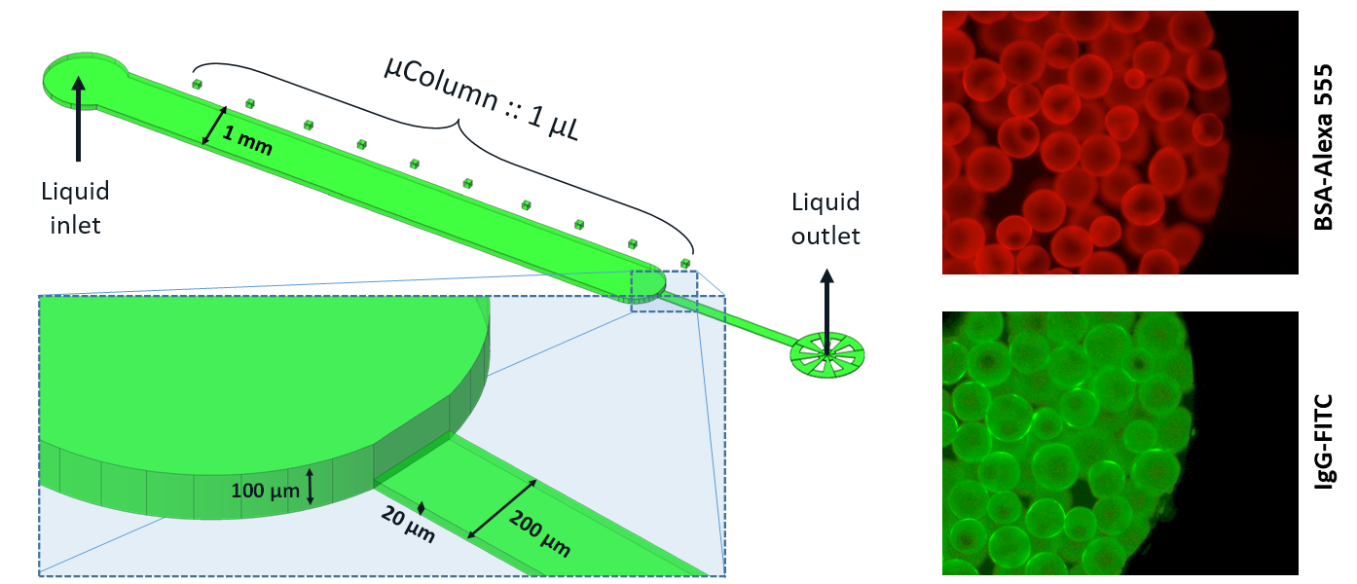
Figure 1. a) Microfluidic-ATPS toolbox; b) Chip chromatography

4. Conclusions
A microfluidic approch was sucessfuly stablished to expedite the development of dsp of biopharmaceuticals using reduced volumes of reagents and shorter experimental times
References
Ruben R. G. Soares, Daniel F. C. Silva, Pedro Fernandes, Ana M. Azevedo, Virginia Chu, João P. Conde and M. Raquel Aires-Barros Biotechnol. J. 2016, 11, 1-15
Ines F. Pinto, Ruben R. G. Soares, Sara A. S. L. Rosa, Maria Raquel Aires-Barros,Virginia Chu, João P. Conde and Ana M. Azevedo Anal. Chem. 2016, 88, 7959−7967

