Chaotic Mixing in the NETmix Reactor
Joana Matos¹, Ricardo Santos¹, Madalena M. Dias¹, José Carlos B. Lopes^{1*}
1 LA LSRE-LCM. Rua Dr. Roberto Frias, 4200-465 Porto, Portugal
*Corresponding author: lopes@fe.up.pt
Highlights
- NETmix is an industrial reactor constituted by chambers and channels.
- The ratio between chamber diameter and channel width is crucial on mixing.
- Different structures of strange attractors can be related with mixing in chambers.

- Introduction
NETmix is a novel static mixer reactor composed by a meso or micro sized network of mixing chambers interconnected by channels (Figure 1a) [1]. The NETmix network can be obtained by the repetition of the NETmix Unit Block (NUB) (Figure 1b). NETmix is used in industry for continuous production of nanoparticles [2] and other applications are being developed, namely: continuous production of CO2 hydrates [3] and photo-oxidation processes in water treatment [4]. Mixing in NETmix depends on the reactor geometry which influences the flow dynamics. Mixing will be evaluated using particles injections: the best mixture occurs when the particles out fraction is 0.5. The ratio between chambers diameter and channels width, D/d, (Figure 1b) is studied along with the vorticity history dynamics from phase diagrams that show different structures of strange attractors which are related to the degree of mixing in NETmix.
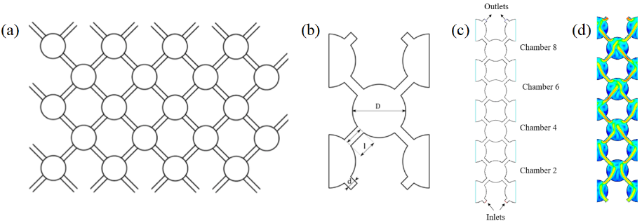
Figure 1. (a) NETmix network, (b) NUB, (c) ExtendedNUB, (d) velocity magnitude contour.
2. Methods
2D CFD simulations (time step, $∆t$ = 1.14$×{10}^{-4}$ m/s) with water were performed for Re = 300, using the ExtendedNUB geometry in Figure 1c. The channel width is d = 1.00 mm and the chamber diameter varied from D = 5.75 to 7.25 mm. The simulated velocity flow-fields (e.g. for D/d = 6.55 in Figure 1d) were used for particle tracking with Lagrangian Mixing Simulation (LMS). LMS is an algorithm developed by Matos et al. [5] where the mixing interface between two fluids is tracked. Blue particles were positioned at left inlet and red particles at right over the initial velocity field of chamber 6. Along with the flow-time, the particles change their position: Figure 2a for 8.00$×{10}^{-4}$ s and Figure 2b for 3.50$×{10}^{-3}$ s. Note that in LMS, the number of particles in each series (blue and red) increases to represent accurately the mixing dynamics.
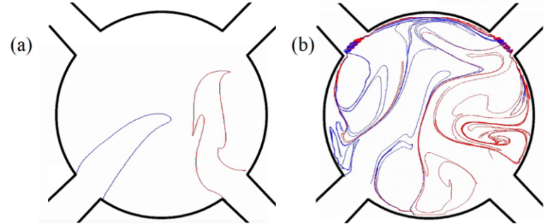
Figure 2. Particles injection in chamber 6 with LMS at different flow-times: (a) 8.00$×{10}^{-4}$ s and (b) 3.50$×{10}^{-3}$ s.

To study the mixing inside the chamber, the fraction of blue and red particles that leave chamber 6 through right or left channel was recorded using batch particles injections, i.e., maintaining the initial number of particles.
3. Results and discussion
For D/d = 5.75 to 5.95, the fraction of particles that go out through the same side from where they were injected is 0.9. This shows that only 10% of the particles are advected to the opposite side of the chamber. When D/d is between 6.55 and 6.95, the particles outlet distribution is 0.5 which represents complete mixture between the inlet streams. For larger D/d the particles out fraction grows apart from 0.5 again, e.g., at D/d = 7.25 the fraction is 0.8, i.e. only 20% of the particles are advected to the opposite side. Phase diagrams show different structures of strange attractors which can be related to the mixture inside the chamber. Figure 3 shows that a good mixture is associated to a strange attractor while a poor mixture is represented by a disorganized structure. The structures clearly show the transition between turbulent (D/d = 5.75 and 7.25) and chaotic (D/d = 6.55 and 6.78) laminar flows and the best mixing in NETmix (50/50 outlet distribution) is obtained with chaotic flows.
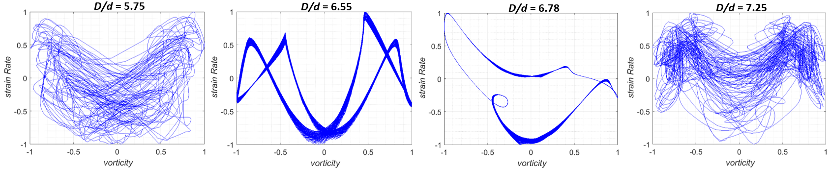
Figure 3. Normalized Strain Rate vs Vorticity for D/d = 5.75, 6.55, 6.78 and 7.25 in the centre of chamber 6.
4. Conclusions
The ratio D/d has an optimal range from 6.55 to 6.95 for mixing in NETmix. The optimal degree of mixing is represented by strange attractors.
Acknowledgements
Financed by: NORTE-01-0145-FEDER-000006 - funded by NORTE2020 through PT2020 and ERDF; Associate Laboratory LSRE-LCM - UID/EQU/50020/2019 - funded by national funds through FCT/MCTES (PIDDAC).
References
- P. E. Laranjeira, NETMIX Static Mixer, PhD Thesis of University of Porto, 2005.
- V. Silva, P.A. Quadros, P.E. Laranjeira, M.M. Dias, J.C.B. Lopes, J. Disper. Sci. Technol. 29 (2008) 542-547.
- M. F. Costa, The NETmix® Technology, Applied to Gas Hydrates Production. PhD Thesis of U. Porto, 2017.
- M. J. Lima, A.M.T. Silva, C.G. Silva, J.L. Faria, J.C.B. Lopes, M.M. Dias, Chem. Eng. J. 287 (2017) 419-424.
- J. Matos, M.S.C.A. Brito, M.M. Dias, J.C.B. Lopes, R.J. Santos, Chem. Eng. Sci. 192 (2018) 199-210.

