CO₂-Reforming for production of CO rich synthesis gas at low steam to carbon ratio in industrial scale
Kim Aasberg-Petersen*, Peter Mølgaard Mortensen, Marené Rautenbach, Peter Seier Christensen
1: Haldor Topsøe A/S, Haldor Topsøes Allé 1, DK-2800 Lyngby, Denmark
*Corresponding author: kap@topsoe.com
Highlights
- New process for CO₂-reforming
- Uses traditional Nickel catalysts
- Reduces size of steam reformer
- Almost any H₂/CO-ratio can be produced

- Introduction
Many bulk chemicals such as methanol are produced in a multiple step process. The first step is normally conversion of natural gas or similar feedstock to produce hydrogen or synthesis gas (a mixture with mainly hydrogen and carbon monoxide) followed by the actual synthesis and purification. The synthesis gas production is often carried out by steam reforming of the feedstock with steam and carbon dioxide (in the following referred to as CO₂-reforming). Carbon dioxide reforming is an environmentally interesting process as it in theory offers a way of using CO₂, which in many industries is considered as a waste product and is a polluting greenhouse gas. Overall, CO₂-reforming is one of few chemical processes which can be designed with an overall negative CO₂-emission, as the process can be designed to utilize more CO₂ than what is produced from the process. The process could therefore play an important role in combination with CO₂ capture technologies, which are receiving much attention currently.
CO will make up a significant fraction of the produced synthesis gas when CO₂ is imported to the plant. Depending upon the process and amount of imported CO₂, synthesis gas with H₂/CO ratios in the range from 0.5-3 can be produced. Large amounts of CO are used within the chemical industry for example for production of higher alcohols, synthetic fuels, or acetic acid. There are also needs for carbon monoxide in especially the polymer industry in production of polycarbonates and polyurethane, among others.
A key challenge in the development of CO₂-reforming is to define (economical) operating conditions in combination with a suitable catalyst to avoid carbon formation. Carbon formation in a steam reformer is largely dictated by thermodynamics. In Fig. 1 the carbon limits are illustrated for various feed feed compositions with methane, steam, and CO₂. In the typical design of a reformer, it is a requirement that there is no affinity for carbon formation anywhere in the catalyst bed. This means that a sufficient amount of steam must be added to the process feed gas to avoid potential for carbon formation. In the case of the classical fired reformer, the process gas may enter the reformer at 450-600°C while leaving the reformer at an average temperature often in the range 850-950°C. Hence, when designing a steam reformer, there must not be an affinity for carbon formation anywhere between 400°C and ca. 1000°C.

Fig. 1: Thermodynamic evaluation of carbon limit as a function of normalized H₂O/CH₄ (S/C), CO₂/CH₄, and temperature. A point placed below a curve in the graph will have a potential for carbon formation
In most cases, Nickel-based catalysts are used in a steam reformer. Nickel is relatively cheap compared to the alternative noble metals based catalyst. On the other hand, noble metals based catalysts have a lower affinity for carbon formation and a higher activity for steam and CO₂-reforming. However, very high raw material prices of these material makes them unattractive for extensive use in industrial scale. Consequently, nickel based catalyst are established as the preferred catalyst for industrial use for CO₂-reforming although the needed steam to avoid carbon formation is excessive compared to optimal design. This makes the process plants relatively expensive and there is an incentive to develop an improved concept still allowing for use of Nickel based catalysts.
- New high temperature reactor for CO production
In the current work, a new reactor configuration is presented where hot CO₂ is added directly downstream a reformer and equilibrated in an adiabatic reactor. One possible configuration is illustrated in Fig. 2. This concept utilizes the high temperature of the reformer product gas and detailed understanding of the underlying thermodynamic and kinetic mechanisms to circumvent the carbon formation area. This allow for a method to tailor the product toward practically any H₂/CO ratio without the risk of carbon formation, while still using a cost-efficient nickel based catalyst. The adiabatic reactor may in principle be added downstream any reformer type and be used both for grassroot and revamp cases. Experiments have been carried out to demonstrate carbon free operation with the new reactor concept at significantly lower steam-to-carbon ratios than is possible with stand-alone CO₂-reforming. In Fig. 3 the gas composition profiles in the adiabatic reactor are provided illustrating significant conversion of CO₂ to CO and the resultant low H₂/CO-ratio in the product gas.

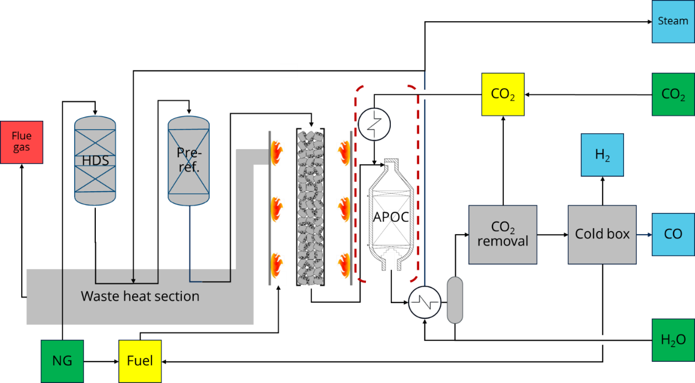
Fig. 2: Process concept with new technology utilizing an adiabatic reactor (APOC) downstream the steam reformer in a plant for producing CO and H₂.

Fig. 3: Gas composition profiles in the adiabatic reactor (APOC) downstream the steam reformer
A series of process economic calculations have been carried out to illustrate the benefits of the new technology. Selected results include:
- The size of a steam reformer can be reduced by up to ca. 25%. Alternatively, the plant capacity can be boosted accordingly.
- The carbon for the CO product originates to a large extent from the CO₂ in the feed and the plant consequently has a large net use of CO₂.
- Practically any H₂/CO ratio can be supplied in the product synthesis gas.
- Conclusion
In conclusion, the new high temperature CO production reactor is a promising technology for producing synthesis gas with a high content of CO at a low steam to carbon ratio. The technology can for example be used to retro-fit an existing production towards more CO production or included in new projects. In the presentation, the new technology will be described and the benefits will be illustrated with specific examples.

