Techno-economic analysis of xanthan production from liquid wastes of food processing
Bojana Bajić*, Siniša Dodić, Damjan Vučurović, Vladimir Puškaš, Jelena Dodić
University of Novi Sad, Faculty of Technology Novi Sad, Department of Biotechnology and Pharmaceutical Engineering, Bulevar cara Lazara 1, Novi Sad 21000, Serbia
*Corresponding author: baj@uns.ac.rs
Highlights
- Xanthan production process and cost model was developed using simulation software
- Results represent a basis for preliminary project design of the suggested bioprocess
- Results can be used for further development of xanthan production bioprocess

1. Introduction
Cleaner production through improved material utilization, reduced energy consumption and lower emission levels represents an effective step towards making any production process sustainable. Utilizing waste streams generated from one production process as raw materials for another is just one option for reaching the aforementioned goal. Since large amounts of waste effluents are generated by the food industry, the biotechnological production of xanthan from these effluents could become a solution for re-using wastewater as well as obtaining a valuable product. By modelling the experimental results through a bioprocess simulation software, additional data can be obtained in order to facilitate further research and lead towards the ultimate goal, which is constructing a plant for xanthan production from liquid wastes of food processing [1-3]. Therefore, the aim of this research was to improve the process and cost model of xanthan production on different wastewaters.
2. Methods
Based on the previously published research [3] and in order to improve the xanthan production process, experiments were designed and carried out under optimized conditions for xanthan production on glucose (G) and three different food processing wastewaters (from the production of: biscuits - W1, ethanol from molasses - W2 and sugar - W3) as a basis of the cultivation medium. Experimental data obtained from these experiments has been incorporated into kinetic models, which have been used to simulate a xanthan production bioprocess by the SuperPro Designer simulation software. Figure 1 represents the simplified process flowsheet for xanthan production.
Economic parameters, such as unit production costs, operating costs, total revenues, have been used to compare and evaluate the simulated xanthan production process with the examined wastewaters.
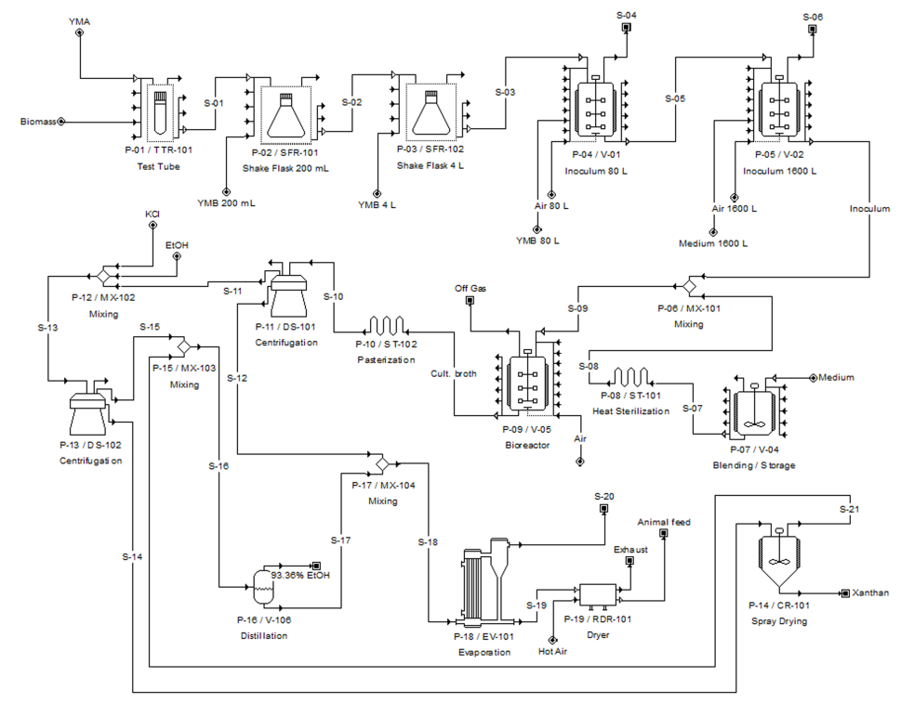
Figure 1. Process flow diagram of xanthan production
3. Results and discussion
As a result of simulated experimental data, table 1 shows the economic analysis of the xanthan production bioprocess model in media based on used wastewaters as well as glucose.
Table 1. Economic analysis of the xanthan production process model
Medium | Working capital [$] | Operating cost [$/year] | Production rate  [kg /year] | Unit production cost [$/kg] | Total revenues [$/year]
G | 16000 | 183000 | 44556.06 | 4.10 | 224000
W1 | 16000 | 183000 | 40816.34 | 4.48 | 206000
W2 | 16000 | 183000 | 42028.69 | 4.35 | 212000
W3 | 16000 | 183000 | 35066.72 | 5.21 | 177000
Although xanthan production is the most cost-effective on semi-synthetic glucose based media, the obtained results show that when using different liquid wastes of food processing as a basis of cultivation media, similar values are obtained. Therefore, these wastewaters have great potential to be used as raw materials in this bioprocess.
4. Conclusions
The results obtained through this research showed that the developed process of xanthan production from liquid wastes of food processing is economically and ecologically viable.
Acknowledgement: These results are part of the project TR31002, financed by the Ministry of Education, Science and Technological Development of the Republic of Serbia.
References
- M. Golušin, S. Dodić, S. Popov, Sustainable Energy Management, first ed., Academic Press, 2013.
- B. Bajić, D. Vučurović, S. Dodić, J. Grahovac, J. Dodić, J Environ Manage. 203 (2017) 999-1004.
- B. Bajić, D. Vučurović, S. Dodić, Z. Rončević, J. Grahovac, J. Dodić,, Chem. Ind. Chem. Eng. Q. 24 (2018) 127-137.

