Experimental and analytical study of heat transfers in granular media
Viet Dung NGUYEN, Christophe MARIE

Laboratoire des Eco-PRocédés, Optimisation et Aide à la Décision, EPROAD EA 4669,
IUT de l’Aisne, 48 rue d’Ostende, Saint Quentin 02100, France

*Corresponding author: christophe.marie@u-picardie.fr
Highlights
- Thermal transfers in granular media
- Experimental data
- Analytical study

1. Introduction
Granular media are generally biphasic or triphasic, with a solid phase and a gaseous or/and liquid phase, and are characterized by their porosity. Particle size, shape, distribution, and pore size are parameters that characterize the microstructure of a granular medium and have a consequent impact on fluid flow, fluidization behavior or mechanism of heat transfers... The present paper aims at presenting an experimental and analytical study of heat transfers in granular medium which have an important impact for many industrial processes as well as powder metallurgy, chemical reactors, food technology, thermal insulation or even simply storing particles in a silo after drying. However, few studies in the literature are interested in the understanding of heat transfers across contact area between particles or particle/wall (conductance). In this research, we firstly present an experimental campaign. Then, an analytical approach is proposed by using the iterative procedure of energy balance. Finally, the experimental data coupled with the analytical results is used to identify the thermal conductance.
2. Method
The experimental setup, as shown schematically in figure 1, consisted of a column of 11 steel spheres of same diameter of 20 mm arranged vertically in a insulated tube. The first sphere is heated at 50°C and the temperature evolution of other spheres are measured.
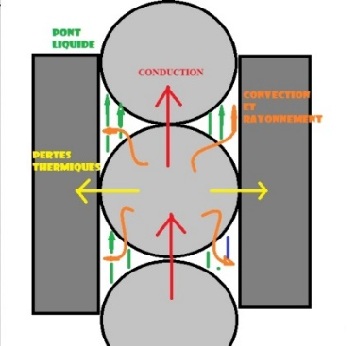
In the literature, the models for calculating the thermal conductivity of condensed or loose granular media have been developing for a few decades now. Most of the models proposed are generally simple models of the type series, parallel, or combination of the two, which do not take into account the constriction of thermal flux lines. We have therefore developed a theoretical model for calculating the thermal conductivity of a stack of identical spherical particles by their diameter and composition. The principle of this model is the determination of the evolutions of the apparent thermal conductance according to the power and the heating time, and the stabilization of the transfer regime. This assessment, based on the obtaining of an analytical solution that binds thermal and mechanical behavior over time, allowed us to make comparisons between analytical and experimental measures.
3. Results
The following results present the comparison between experimental and analytical temperatures propagating through a pile of 5 heated spheres (among 11) under mechanical stress.

Figure 1. Experimental and numerical comparison of the temperature increase of a pile of spheres under mechanical stress

The graph shows that the numerical curves of spheres 4 and 5 (far from heat source) are confusing. The numerical curves of spheres 1, 2 and 3 are quite distinct, and are nearly superimposed with their experimental counterparts. While the experimental variations are clearly visible in the graph, the analytical variations are less and less precise and confirm the existence of a limit to the numerical model. However, these first results are promising, and will be completed by a Discrete Elements Method (DEM) comparison.
References
[1] Heat transfer in a granular media modeled by a coupled DEM-finite difference method: application to fluidized bed processes, VD Nguyen, K Benhabib, C Marie, P Coorevits, Procedia Engineering 42, 824-832, 2012

[2] Discrete modeling of granular flow with thermal transfer: application to the discharge of silos, VD Nguyen, C Cogné, M Guessasma, E Bellenger, J Fortin, Applied Thermal Engineering 29 (8-9), 1846-1853, 2009.

