UV/Vis Computed Tomography based 3D Concentration Measurement in Bubble Columns
Jajnabalkya Guhathakurta¹, Günter Rinke ², Manfred Kraut², Sven Simon¹
1 Institute for Parallel and Distributed Systems (IPVS), Department of Parallel Systems, Universitätsstr. 38, 70569 Stuttgart; 2 Institute for Micro Process Engineering (IMVT), Karlsruhe Institute of Technology, Hermann-von-Helmholtz-Platz 1, 76344 Eggenstein-Leopoldshafen, Germany
*Corresponding author: jajnabalkya.guhathakurta@ipvs.uni-stuttgart.de
Highlights
- In-situ concentration measurement in bubble columns.
- Measurement based on UV/VIS computed tomography.
- High spatial and temporal resolution.
- Selectivity measurement for Fe(edta)NO system.

1. Introduction
Bubble columns play a crucial role in the chemical industry for two phase systems and are primarily relevant for reactions like oxidation, hydrogenation, alkylation etc. However, a realistic description and prediction of the reaction kinetics and mass transfer are still a major bottleneck in industrially relevant reactive bubble columns. Furthermore, localized concentration measurement are difficult to achieve due to the fast reactions and reduced access. This work aims at developing a spatially and temporally resolved 3D concentration measurement technique in reactive bubble columns using UV/Vis computed tomography.
Another important challenge for chemical and process engineers is determining the selectivity in a two phase reaction system. This is considered as a primary design goal in our measurement technique. The system utilizes multiple wavelengths and fast switching light sources to simultaneously and separately measure the concentration of both the products in a competitive consecutive reaction and deduce the selectivity of the reaction from it.
2. Experimental Setup
The developed UV/Vis computed tomography system accumulates absorption projections from different angles around the bubble column (Blue circle in Fig. 1 middle). These directional absorption projections are then fed into an iterative reconstruction algorithm to obtain a 2D concentration field perpendicular to the direction of flow. The measurement technique can be applied to any chemical system having distinct peak for products in the absorption spectrum e.g. Fe(edta)NO system represented by the spectrum in Fig 1 (left). In this system one wavelength (472 nm) is used for measuring the first product P, another wavelength (696 nm) is used for measuring the consecutive product S and a reference wavelength (540 nm) is used at the isosbestic point. Projection data from all the wavelengths are captured within 1 ms and the process is repeated to get high temporal resolution of the 2D concentration field one after the other.
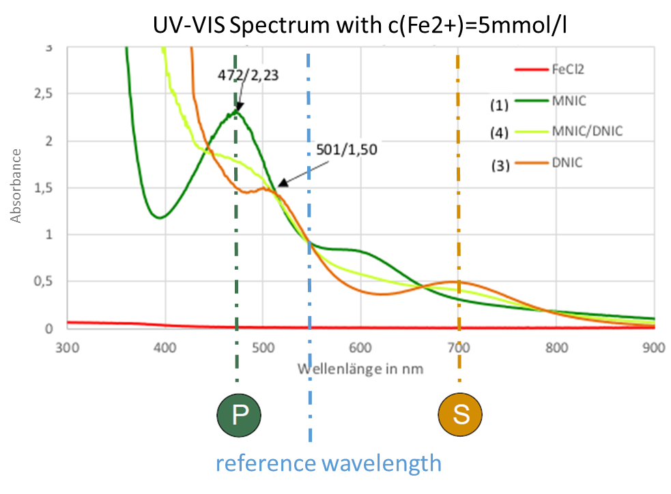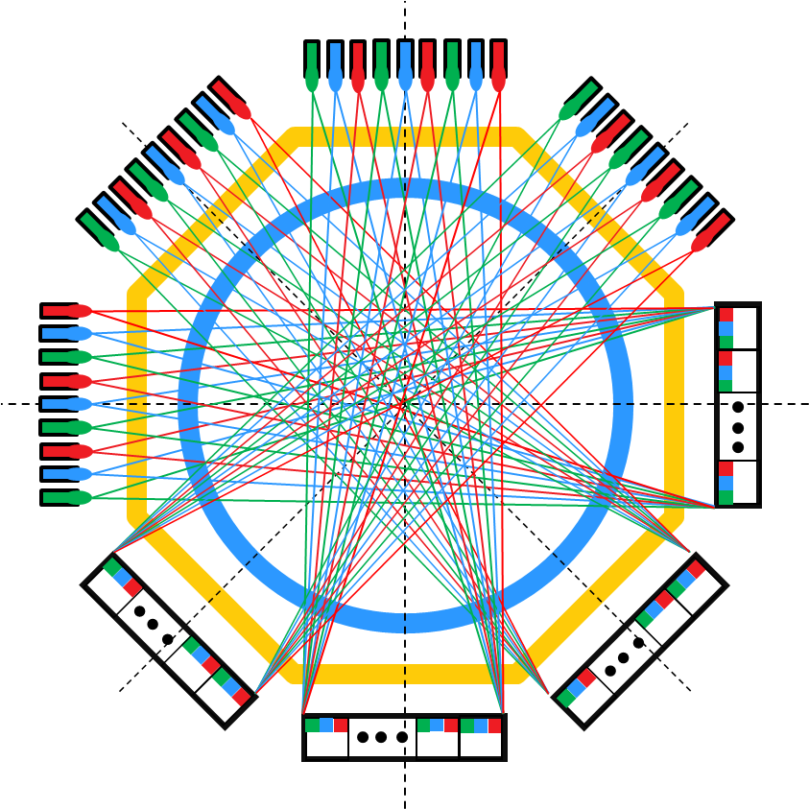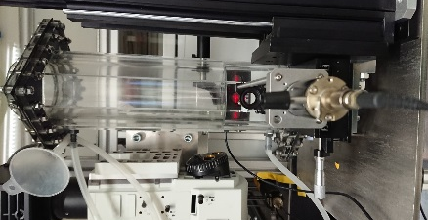

Figure 1. (left) UV/Vis spectrum for Fe(EDTA)NO system [1], (middle) cross section of 75mm diameter bubble column with octagonal refractive index matching mantle showing directional projections, (right) actual bubble column

3. Results and discussion
The setup was optically simulated with Zeemax ray tracing software in order to verify the setup (Fig. 2 left). A collimated laser beam directed by a polygon scanner meets a micro cylindrical lens array which generates the fan beam that is made to travel through the bubble column. The absorption of this fan beam is captured by line sensors on the other end to get the directional projection of the corresponding product. These projections are fed to an iterative reconstruction algorithm uses total variation which performs the best in case of extremely low number of projections as needed by our setup. The functionality of algorithm is verified in simulation where a simulated concentration field in a bubble column is used and the reconstructed field is compared with the original data (Fig 2. right). It can be seen from the cross section that the reconstructed data plot (orange) approximately follows the original data.
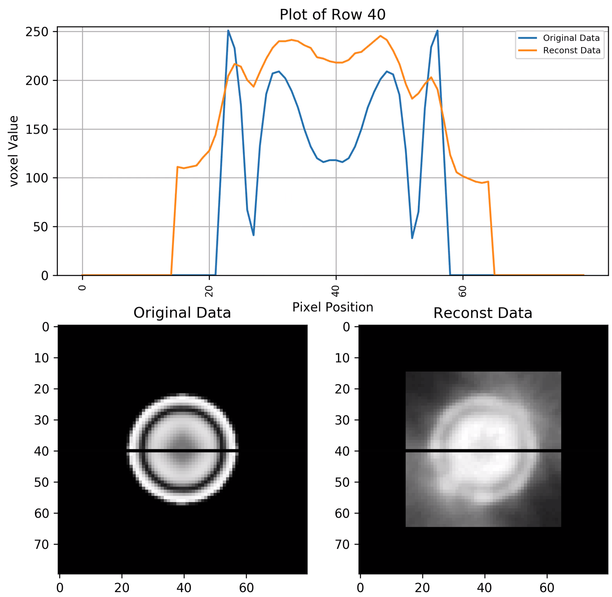
Figure 2. (left) Zeemax ray tracing simulation for each projection [1], (middle) Reconstructed concentration field on simulation data in bubble columns.

4. Conclusions
A novel technique to measure 3D concentrations in bubble columns has been proposed in this work based on UV/Vis computed tomography. The experimental setup along with the iterative reconstruction results and simulations have been presented. Obviously the reconstructed CT data correspond to the ground truth sufficiently with respect to the considered cases.

