MEMBRANE (MF and UF) APPLIED IN THE 2,3-BUTANEDIOL PURIFICATION PROCESS
Beal, Lademir Luiz¹; Beux, Assis Reinaldo Dariva²
1 and 2 University of Caxias do Sul; Address: Francisco Getúlio Vargas 1130, Caxias do Sul, Brazil
*Corresponding author: llbeal@ucs.br
Highlights
- The pressure is strongly correlated with the resistance
- The pressure was not a determinant effect to increase the permeate flux.
- There were no significant differences between the flux of permeate in MF and UF.

1. Introduction
In an effort to reduce global dependence on fossil fuels, biofuels have been gaining more space. Biodiesel can partially or completely replace diesel. A byproduct of biodiesel is glycerol, a substrate that can be exploited in the chemical industry and produce other biofuels such as biohydrogen and biomethane. Among its uses is the production of 2,3-butanediol, which can be obtained by fermentative processes, especially using Klebsiela pneumoniae. The production of 2,3-butanediol is well established for batch processes. Some difficulties inherent to fermentative processes with pure cultures, such as contamination, prevent the effective use of obtaining this compound in CSTR. The use of membranes can be interesting as a step of the purification process or used in continuous processes (MBR), reducing the risks of contamination, and providing a greater reduction. Gupta et al. (2005) using flat sheet cellulose acetate MF membrane obtained results where the increase of permeate flux were from 54% to 146% for different gas flow rate. The main goal of this paper is to discuss the different hydraulic behavior using MF and UF membrane, both with hollow fiber configuration, to separate Klebsiella pneumoniae cells and macromolecules compounds.

2. Methods
Two modules of PVDF membranes (UF and MF), in hollow fiber configuration, of asymmetric morphology, contact angle with water of 66º, moderate hydrophobicity and filter area of 0.047 m² were used. The membranes of UF were made in porous support medium, since MF membranes are extruded integrals. Before each cycle of tests, the membranes were subjected to compaction and hydraulic characterization. Total resistance during the fermented assay was assayed at pressures of -400, -250, -150 and 60 mbar for MF and -400, -250, -150 mbar for UF. The test pilot was set at 30 ° C with air injection at the base of the module for cleaning. The flow was measured for 3 hours. The total resistance to filtration was obtained through Equation J = ΔP / (μ x R_{tot}), where J is the flow, μ is the absolute viscosity of the permeate and R_{tot} is the total resistance to filtration.

3. Results and discussion
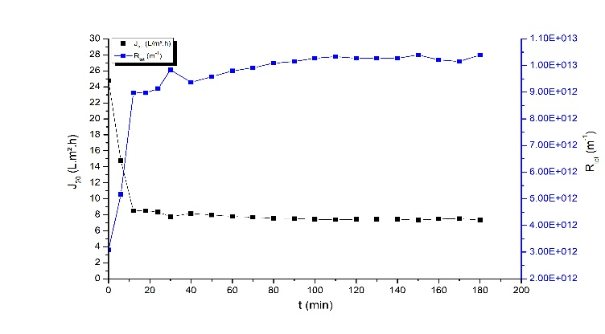
The partial result obtained had showed that both membrane, MF and UF, have a good and similar behavior when is compared the permeate flux. The permeate flux in 20 minutes decrease almost 60 % and after this moment is practically stable as shown in the Figure 1 (an example of the graphic obtained).

Figure 1 – Flux in MF250.

Analyzing the results presented in Table 1 to MF tests it is possible to conclude that the pressure was not a determinant effect to increase the permeate flux, since from 60 to 250 mbar the values were very similar, but when is analyzed the results to 400 mbar the percentage of the permeate flux reduction was higher than the others and the resistance increase percentage was higher than other as well.

Table 1: Behavior of MF and UF modules.
 | P (mbar) | Jo (L.h⁻¹.m⁻²) | Ju (L.h⁻¹.m⁻²) | % decrease | Ro (m⁻¹) | Ru (m⁻¹) | % increase
MF | 60 | 21.6 | 7.10 | 67 | 8.3E+11 | 2.6E+12 | 216
 | 150 | 30.8 | 8.20 | 73 | 1.5E+12 | 5.6E+12 | 277
 | 250 | 24.8 | 7.30 | 71 | 3.1E+12 | 1.0E+13 | 238
 | 400 | 73.9 | 6.70 | 91 | 1.6E+12 | 1.8E+13 | 997
UF | 50 | 10.9 | 6.80 | 22 | 1.5E+12 | 2.2E+12 | 68
 | 150 | 25.3 | 5.60 | 78 | 1.8E+12 | 8.2E+12 | 353
 | 250 | 36.5 | 5.40 | 85 | 2.1E+12 | 1.4E+13 | 579
 | 400 | 59.9 | 6.40 | 89 | 2.0E+12 | 1.9E+13 | 841

The reduction of the permeate flux in the UF tests were higher than the MF tests and the increase of the resistance was higher than MF as well. The permeate flux (Ju) values were very similar but the pressure effect was more significant for the increasing of resistance than the flux.
4. Conclusions
It is possible conclude that the pressure is strongly correlated with the resistance (r=0.992 to MF and r=0.980 to UF). It is not interesting to use high pressure in this process since there is not positive effect on the permeate flux. The permeate flux is higher in the MF membrane than the UF membrane but without significant differences.

References [Calibri 10]
[1] B. Sen Gupta, M. A. Hashin, K. B. Ramachandran, I Sen Gupta, and Z. F. Cui. Eng. Life Sci. 5 (2005) 54-57.
[2] Y. Satyawali, K. Vanbroekhoven, and W. Dejonghe Biochemical Engineering Journal 121 (2017) 196-223.
[3] X. Ji, H. Huang, and P. Ouyang. Microbial 2,3-butanediol production: A state-of-the-art review Biotechnology Advances 29 (2011) 351–364.

