**Continuous reactive distillation for the esterification between glycolic acid and butan-1-ol**

Carole Mutschler1, Clémence Nikitine1, Pascal Fongarland1

*1 Laboratoire de Génie des Procédés Catalytiques, Université Claude Bernard Lyon 1, CPE Lyon, CNRS,43 bd du 11 novembre 1918, B.P. 82077, 69616 Villeurbanne cedex, FRANCE*

*\*Corresponding author: cmu@lgpc.cpe.fr*

**Highlights**

* Characterization of a reactive distillation column
* Reaction between glycolic acid and butanol in a continuous reactive distillation in the transient state

**1. Introduction**

The production of bio-based carboxylic acids have aroused considerable interest in industrial field as intermediate products. By oxidizing glycerol in aqueous phase, formic acid, oxalic acid and alpha hydroxy acids such as lactic, glycolic, glyceric and tartronic acids were obtained [1,2]. These acids have low volatility with each other, and some of them are subject to thermal degradation at higher temperature (tartronic acid, glycolic acid …). Hence, their separation tend to be difficult by simple distillation. To overcome that issue it has been decided to esterify those acids with an alcohol. Using reactive distillation to esterify alpha hydroxy acids has already been developed in order to remove water and then shift the chemical equilibrium [3,4].

In first instance, it has been decided to focus our research on the esterification of glycolic acid with butan-1-ol by reactive distillation in order to get butyl glycolate and water as presented in Figure 1



Figure 1 : Esterification between glycolic acid and butan-1-ol

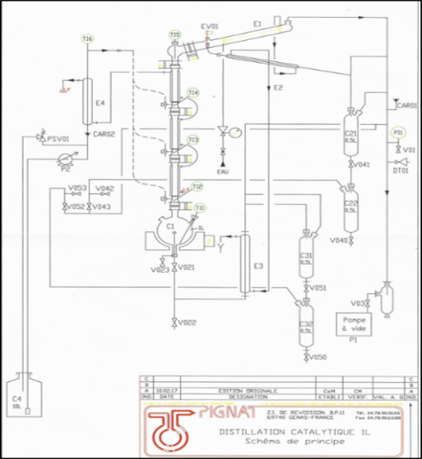**2. Methods**

A preliminary study was carried out in order to evaluate the feasibility of producing butyl glycolate through reactive distillation. A model of reactive residue curve maps was developed on Matlab®. In these reactive residue curve maps, the butyl glycolate is a stable node. A residue highly concentrated in butyl glycolate can therefore be obtained. However, a distillation boundary split the area into two regions. In order to get a residue of mainly butyl glycolate the feed should be in large excess of butanol.

Experiments were conducted in a laboratory distillation column of 1m high and with an internal diameter of 32mm designed by Pignat® (Figure 2). The column is divided into three different sections filled with random packing (glass bead of 7 mm) or foam. Catalysts (amberlyst36 or TiO2-WOx) used are directly filled in those sections or coated on a foam.

**Figure 2** : Catalytic distillation column designed by Pignat®

The column was first characterize. The number of theoretical plates of the column was determined by a mixture of isopropanol and ethanol at atmospheric pressure and infinite reflux in batch mode. Three theoretical plates are counted (4 if the boiler is considered). The heat supplied to the boiler was determined by the evaporation of pure water with no reflux a nd is about 71 W. Simulations with Prosim Plus® have given the same results as the characterization.

Esterification experiments were conducted continuously at 390mbar with a feed composed of glycolic acid and butanol 1:10 wt./wt. The boiler was first filled with pure butan-1-ol.  
The analysis of both distillate and residue was operated by HPLC with a Phenomenex® Kinetex XB-C18 column, equipped with a Refractive Index (RI) and an UV detector.

**3. Results and discussion**

Results shown in Figure 3 correspond to a reaction carried out without any catalyst. After 3h of reaction, the steady state is not achieved as the composition of the residue is still evolving, but the mass balance has been established. However, the ester is produced through the operation even without any catalyst. In order to get the steady state quicker, it will be needed to start the reactive distillation with a composition at the boiler close to the steady-state composition of the residue.

Figure 3 : Composition at the residue in butan-1-ol, glycolic acid and butyl glycolate

In one hour batch distillation, 22% and 88% of acid conversion have been observed without and with catalyst respectively. Moreover, simulations with Prosim Plus© showed that acid conversion is close to 100 % after one theoretical plate. So, it is possible to obtain a residue concentrated in butyl glycolate by using catalysts in one section of the column. Hydrodynamic and liquid-gas contact with foam or glass bed packing are similar. Hence, foam coated on TiO2-WOx is a proper catalyst for this reaction in this process.

**4. Conclusions**

To conclude, our column has been characterized and first tests for the esterification of glycolic acid with butan-1-ol in reactive distillation have been performed. It shown that the production of butyl glycolate through reactive distillation is feasible without any by-product. Different catalytic packing (Amberlyst 36 beds, TiO2-WOx pellets or coated on foam) are tried which represent a commonly known issue in reactive distillation as it needs to be efficient in both distillation (G/L contact, pressure drop) and reaction (good conversion). Results in simulation always show a good conversion (more than 90%) and separation of the products.

**References**

[1] SKRYNSKA E., DUMEIGNIL F., CAPRON M. et DUHAMEL L. WO2014199256 A1, 2014.

[2] CAPRON M., DUMEIGNIL F. et SKRZYNSKA E. WO2015055942 A3, 2015.

[3] HILDEBRANDT R., VOLLMER H-J., ALSCHER A., HOLTMANN W. US20050096481 A1, 2004.

[4] TERRILL D. L., MORAN K. M., FALLING S. N. US20130310598 A1, 2013